Republic of the Philippines
Department of Education
Region IX, Zamboanga Peninsula
Dipolog City Schools Division
Zamboanga del Norte National High School
General Luna Street, Estaka, Dipolog City
___________________________________________________________________________

ENGLISH 8
Module 1
First Quarter Summative Test
and Performance Task
School Year 2021-2022

Name:_________________Section:_____________Date:___________Score:____
Test I Summative Test
Direction: Each given sentence contains a boldfaced word which is probably new to you. Guess the meaning of these words Choose and encircle the letter of the best answer.

1. Alice felt some remorse of her action to her classmate.
A. guilt B. shame C. regret D. sorrow

2. An egregious mistake might not be forgivable.
A. glaring B. scandalous C. grevious D. nasty

3. The dophin leaped up high during the show.
A. jumped B. skipped C. ran D. squatted

4. She tried to rekindle the relationship of her family.
A. revive B. exhaust C. dissuade D. ruin

5. It is an awful for her to join the competition.
A. fearful B. happy C. foul D. nasty

6. Art is long, and Time is fleeting, And our hearts, though stout and brave,
Still, like muffled drums, are beating, Funeral marches to the grave.
A. constant B. long C. Endless D. sudden

7. His ambitious promise: to end COVID-19 once and for all.
A. curse B. disaster C. disease D. plague

8. He said, ”I came back to help our country recover faster from this pandemic.”
A. wide spread B. predicament C. circumstance D. situation

9. A healthy man is a happy man.
A. fresh B. safe C. clean D. fit

10. She felt very conspicuous in her evening gown.
A. evident B. reserved C. distinct D. silent

Test II Performance Task
A. Instruction: Read carefully the excerpt from the story.
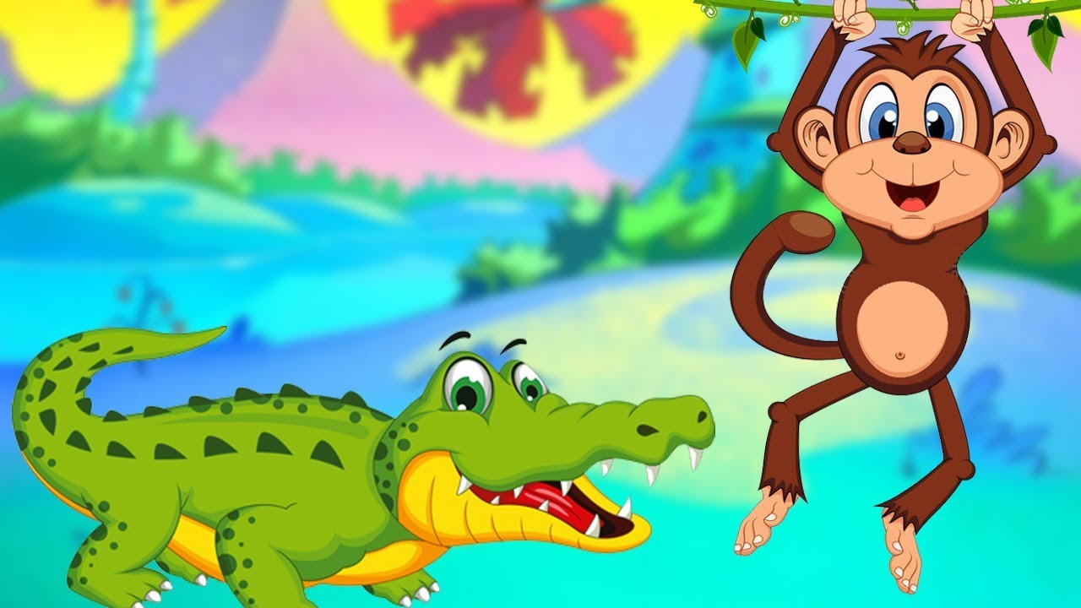
The Monkey and the Crocodile
The crocodile was aghast. He was in a dilemma on the other hand, he loved his friend but he cannot possibly let his wife die. The crocodile’s wife threatened him saying that if he did not get her the monkey’s heart, she would surely die.
So, the crocodile went to the rose apple tree and invited the monkey to come home to meet his wife. He told the monkey that he could ride across the river on crocodile’s back. The monkey happily agreed. As they reached the middle of the river, the crocodile began to sink. The frightened monkey asked him why he was doing that. The crocodile explained that he would have to kill the monkey to save his wife’s life.
The clever monkey told him that he would gladly give up his heart to save the life of the crocodile’s wife, but he had left his heart behind in the rose apple tree. He asked that to make hast and turn back so that the monkey could get his heart from the apple tree.
The silly crocodile quickly swam back to the rose apple tree. The monkey scampered up the tree for safety. He told the crocodile to tell his wicked wife that she had married the biggest fool in the world.

B. Instruction: Fill in the table below with 5 unfamiliar words found in this story and define each using a dictionary (1 point for the unfamiliar word and 1 point for the definition a total of 2 points of each number).
Unfamiliar Words | Definition
1.
2.
3.
4.
5.

Prepared by: Checked and Reviewed by: Approved by:

JULIET Z. CARMEN MAY P. BROBO LUZ D. CORTEZ
Teacher III Master Teacher I Department Head III
English Department English Department English Department

Recommending Approval by: Approved by:

VIRGINIA E. TAGAB JOSELITO S. TIZON,EMD
Assistant Principal II Secondary School Principal IV
ZNNHS-Junior High ZNNHS

