Republic of the Philippines
Department of Education
Region IX,Zamboanga Peninsula
Division of Dipolog City
Zamboanga del Norte National High School
Dipolog City 7100
________________________________________________________________________

ENGLISH 10
First Quarter Summative Test (Modules 7 and 8)

Name: ______________________________Grade and Section: _______________________
School:______________________________Date:____________________Score:_________

Part 1: Multiple Choice
Instruction: Read each question carefully and choose the correct answer. Write the letter of your answer on the space provided before the number.

________ 1. All the people, animals, or creatures that take part in the story are called:
- Themes
- Antagonists
- Characters
- Protagonists

________ 2. The message that the author wants to share to the reader is called:
- Themes
- Antagonists
- Characters
- Protagonists

________ 3. What is the purpose of persuasive writing?
- To inform
- To convince
- To tell a story
- To tell how to

________ 4. What are the components of persuasive essay?
- Argument, details, thesis
- Topic sentence, details, concluding sentence
- Introduction, thesis, body, paragraph, conclusion
- Who cares

________ 5. Which two paragraphs are the most similar?
- Introduction and conclusion
- None of the paragraphs are similar
- Conclusion and body
- Introduction and body paragraph
________ 6. Listening is the same as hearing.
- True
- False
- Not certain
- None of the above

________ 7. Tone is the message from the story read.
- True
- False
- Not certain
- None of the above

________ 8. This is the ability to identify and comprehend what others are saying.
- Correctness
- Cohesion
- Fluency
- Listening

________ 9. It refers to the excellent flow of words and ideas that are easy to understand.
- Listening
- Fluency
- Cohesion
- Tone

________ 10. It refers to speaking smoothly, reasonably fast, and without having to stutter, stop, or pause a lot.
- Listening
- Fluency
- Tone
- Correctness

Part 2: Performance Task
Instruction: Choose a news article from a local or national newspaper and then rate its content using the rubric below. Justify your rating by writing two or three sentences feedback about the news article.
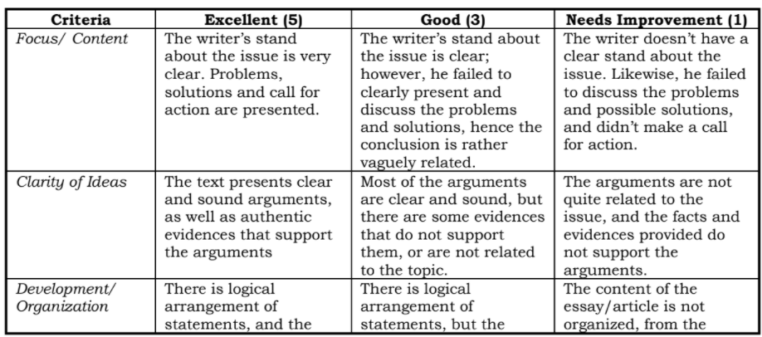
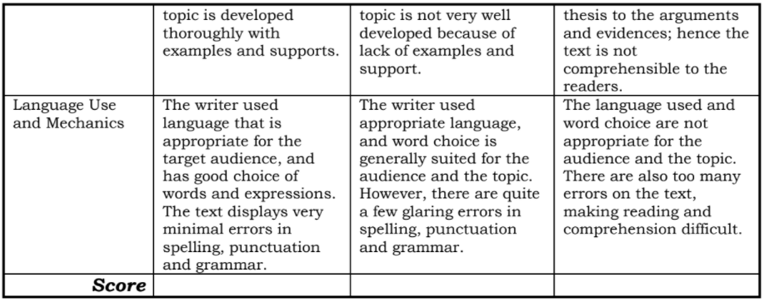

Prepared by: Checked and Reviewed by: Approved by:

ELEONOR S. TAMONAN LUZ D. CORTEZ JOSELITO S. TIZON,EMD
Master Teacher I Head Teacher III Secondary School Principal IV
English Department

