

**ZAMBOANGA DEL NORTE NATIONAL HIGH SCHOOL**

Main Campus, Estaka, Dipolog City

**ENGLISH 7**

**QUARTER 2 – SUMMATIVE TEST 2 and PERFORMANCE TASK 2**

**(Modules 3 & 4)**

**Name:** ________________________________________________ **Part I - Score: ______________ Part II - Score: _________________**

**Grade and Section:** _____________________**_____________ Parent/Guardian’s Name and Signature:** ___________________

**Part I - Summative Test**

Directions: Read each item carefully. Write the letter that best answers each question on the space provided before the number.

_____ 1. A program that searches for and identifies items in a database that corresponds to keywords or characters specified by the user is called _____?

A. search engine B. website C. internet D. Google

_____ 2. What search engine allows users to upload, view, rate, share, report, comment on videos, subscribe to other users and offers a wide variety of user-generated and corporate media videos?

A. Bing B. Yahoo! C. Google D. YouTube

_____ 3. What is the second step in searching for a topic using a search engine?

A. Make sure the device/computer is connected to the internet.

B. Click on the topic you’re interested in

C. Turn on the device/computer.

D. Type the topic for which you want to search.

_____ 4. A _____ is a set of related web pages located under a single domain name, typically produced by a single person or organization.

A. Google B. internet C. website D. search engine

_____ 5. What button will you use if you want to create a blank tab?

A.  B.  C.  D. 

_____ 6. This button is used to close the tab.

A.  B.  C.  D. 

_____ 7. To navigate a web, you have to type the URL into the browser’s _____?

A. refresh button

B. navigation buttons

C. links

D. address bar

_____ 8. Jungkook wants to go back to the previous page in searching for a topic for his class presentation. What part of the webpage should he use?

A. forward button B. back button C. refresh button D. reload button

_____ 9. What is the function of the refresh button?

A. takes you to the last page C. loads the page again

B. creates a new blank tab D. moves you forward to another webpage

_____ 10. When you want to close the webpage, what button are you going to click?

A. navigation buttons B. refresh buttons C. exit tab/exit button D. home button

**Part II - Performance Task**

**Task 1**

Directions: Using the web page bellow, provide answers to the following questions.

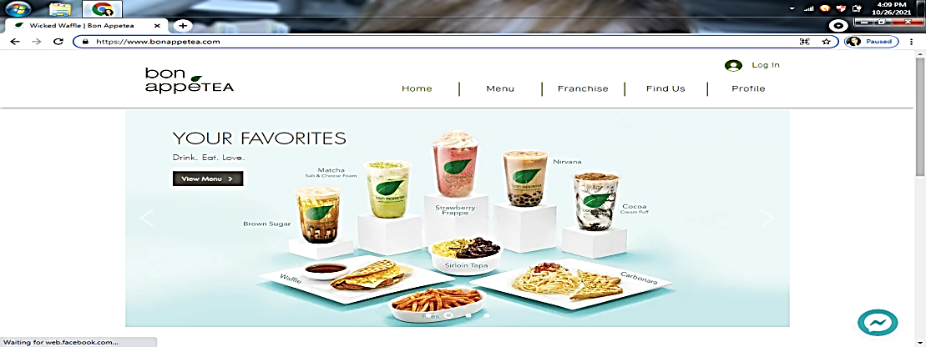

1. What is the name of the tea house? _________________________________________

2. Give the store’s web address (URL). _________________________________________

3. Is there a button where you can search for the tea house’s menu? ______________________________

4. The web browser used in searching the store’s website. **_____________________________________**

5. Is there a button where you can search for the tea house’s location? ________________________________

**Task 2**

Directions: Label the parts of the webpage. Choose your answer from the box and write it on the blanks provided.

back button new blank tab close tab

address bar refresh button



**6.**

**10.**

**9.**

**7.**

**8.**

----------------------------------------------------------------------------------------------------------------------------------

Prepared by: Checked/Reviewed by: Noted by:

**CHRISTINE ARLYN A. LAURIE** **ELEONOR S. TAMONAN LUZ D. CORTEZ**

Teacher III Master Teacher I Head Teacher III

Recommending Approval: Approved by:

**VIRGINIA E. TAGAB** **JOSELITO S. TIZON, EMD**

Assistant School Principal II, JHS School Principal IV