Republic of the Philippines
Department of Education
Region IX, Zamboanga Peninsula
Dipolog City Schools Division
Zamboanga del Norte National High School
General Luna Street, Estaka, Dipolog City
_________________________________________________________________________

ENGLISH 8
Module 1 - 2
3rd Quarter Summative Test
and Performance Task
School Year 2021-2022

Name:_________________Section:_____________Date:___________Score:____
Test I Summative Test
Activity I
Directions: Read the texts and fill the gaps. Choose the answer from the words inside the box. Write your answer on the blank provided for.
EVALUATING OPINION OR PREJUDICE AUTHOR’S DICTION

TELLING SKILLED READER NON-FICTION

BIAS COMLETELY NEUTRAL FICTION

EVIDENCE AUTHOR’S BIAS OPINION

The important part of 1.______an author’s ethos is identifying the 2.______.
3._______is any opinion that influences a person’s thoughts, feelings or actions. A person can be biased against something or have a bias for something. An author’s bias is an 4.__________that affects the author’s writing. It prevents the author from being 5._____about the topic or issue about which she/he is writing.

The author’s bias is the preference or opinion that prevents on from approaching something with a neutral point of view. It is not always bad, but it does not belong in some types of 6._____ when a statement reflects as partiality preference or prejudice for or against a person, object or idea.

The author may state some of his her biases directly by 7.___ the reader his/her opinions or certain topics or admitting that he/she has a conflict of interest or preference. But when the author’s does not acknowledge his/her own bias, 8.______ca infer what an author’s bias maybe by looking at the 9. _____and 10. _______.

Test II Performance Task
A. Instruction: Read the two different passages from the stories carefully.
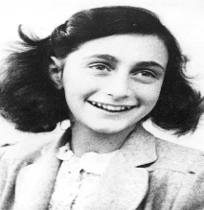
ANNE FRANK STORY
Anne Frank's The Diary of a Young Girl is among the most enduring documents of the twentieth century. Since its publication in 1947, it has been read by tens of millions of people all over the world. It remains a beloved and deeply admired testament to the indestructable nature of the human spirit.

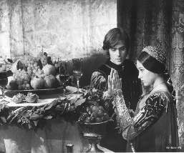
ROMEO AND JULIET
O Romeo, Romeo, wherefore art thou Romeo? Deny thy father and refuse thy name, Or, if thou wilt not, be but sworn my love, And I’ll no longer be a Capulet.
B. Instruction: Venn Diagram 1. Analyze either DRAMA or NOVEL on the given two different story passages of Romeo and Juliet and Anne Frank and write it on the box inside the Venn Diagram for 2 points. 2. Differentiate each characteristic of the given passages by writing according to the given placement, 3 points for Romeo and Juliet and 3 points for Anne Frank and 2 points for their similarities with a total of 10 points.

Prepared by: Checked and Reviewed by: Approved by:

JULIET Z. CARMEN MAY P. BROBO LUZ D. CORTEZ
Teacher III Master Teacher II Department Head III
English Department English Department English Department

Recommending Approval by: Approved by:

VIRGINIA E. TAGAB JOSELITO S. TIZON,EMD
Assistant Principal II Secondary School Principal IV
ZNNHS-Junior High ZNNHS

