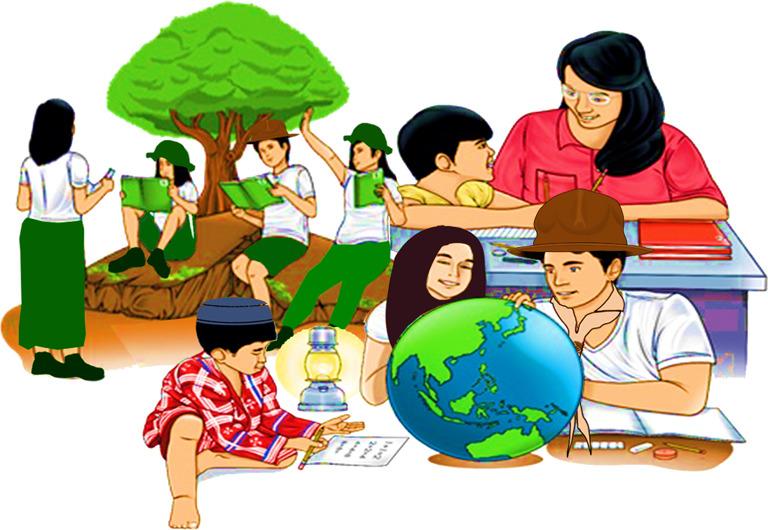
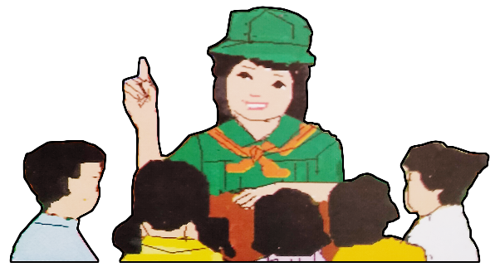
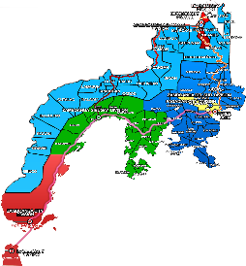

Quarter 4 – Module 1
Grammatical Signals
ENGLISH
Name of Learner: ___________________________
Grade & Section: ___________________________
Name of School: ___________________________
8

Zest for Progress
Zeal of Partnership
Republic of the Philippines
Department of Education
Regional Office IX, Zamboanga Peninsula

What I Need To Know KKKKKKKKKKkkkkkkknKNOW

This module was designed and written to help you master the skills in using appropriate grammatical signals or expressions suitable to each pattern of idea development. The activities are arranged to follow the standard sequence of the lesson, but the order in which you read them can be changed to correspond with the textbooks you are now using.

In this module, you are expected to develop your knowledge and skills in using appropriate grammatical signals or expressions in writing general to specific compositions.

At the end of this module, the learners are expected to:

- Use appropriate grammatical signals or expressions suitable to each pattern of idea development (general to particular, claim and counterclaim, problem-solution, cause-effect and others.) UNCODED
  - identify appropriate grammatical signals suitable for general to particular pattern;
  - use appropriate grammatical signals in constructing sentences and paragraphs suitable for general to particular pattern.
What I Know

In your journey as a learner, you may have already encountered lessons on grammatical
signals. The activity that follows will serve as a pre-test to determine your knowledge about these
expressions.

Activity 1: Fill in the Gap

Directions: Fill in the blanks with the appropriate grammatical signals in each of the sentences below.
Circle the letter of the correct answer.

- Walking can make people become more aware of their surroundings, __________, the cleanliness of the environment, and the friendliness of the neighborhood.
- consequently
- despite
- unfortunately
- such as

- A lot of people ignored the reminder of the government to stay at home to avoid exposure to the disease. __________, the number of cases increased.
- In fact
- Such as
- As a result
- In addition

- There are many things one can do at home to be productive. __________, one can listen to music while doing household chores, do gardening, read books, watch TV shows, and the like.
- Because
- In fact
- In addition
- For example

- Grocery stores and wet markets require a quarantine pass to control the number of shoppers. __________, wearing of a face mask is enforced.
- Because
- In fact
- In addition
- For example

- The Department of Education came up with a plan on how to continue the education of the learners __________ from the different modalities proposed for this school year.
- at this point
- in this regard
- as can be seen
- with this in mind

- Residents complain bitterly about the trash thrown anywhere, __________ these same people are the ones doing it.
- although
- and
- moreover
- yet

- The plan of a city-wide lockdown gained many reactions from the people; __________, positive and negative opinions were expressed.
- despite
- however
- that is
- in addition

- Teleconferencing is widely used nowadays to establish communication among those who are in the work from home modality; __________, this allows the participants to hear or see each other in a meeting.
- after
- although
- during
- moreover

- The month of October marked the opening of classes. It was speculated that only a few would enroll due to fear of the virus. __________, it turned out to be the other way around.
- Frequently
- Furthermore
- In addition
- On the contrary

- As education faces the ‘new normal’, learners are very eager to start the school year. __________, they are excited to explore new learning modalities.
- Although
- Despite
- Furthermore
- Yet

What’s In

Activity 2: Find Me!
Directions: Find the hidden words or phrases in the puzzle.
Hidden Words

FOR INSTANCE MOREOVER SECOND IN FACT
IN ADDITION FINALLY FIRST FURTHERMORE
LASTLY IN OTHER WORDS NEXT THIRD

What’s New

Activity 3: Read Me
Directions: Read the paragraphs and answer the questions that follow.

Paragraph 1
Reading requires comprehension. For instance, one can read a long text but cannot understand what he or she is reading. In fact, many students get low scores in the exam because they cannot comprehend what they read. This problem must be addressed by proper authorities.

Paragraph 2
Students nowadays are fond of playing online games, such as Mobile Legends, PUBG, DOTA and the like. These affect their study habits; in other words, they give more focus in playing these games rather than reading their lessons. Parents need to limit their children’s screen time, for example, students should only be given three hours a day to use their gadgets. This is one of the many strategies we can adopt to control students’ addiction in these mobile games.

Questions:

- What is the first paragraph all about?

____________________________________________________________________________________________________________________________________________________________________________________________________________________________________________________________________________________________________________.

- Give a comment on the ideas presented in the second paragraph.

____________________________________________________________________________________________________________________________________________________________________________________________________________________________________________________________________________________________________________.

- What do the underlined words suggest? What do you call them?

____________________________________________________________________________________________________________________________________________________________________________________________________________________________________________________________________________________________________________.
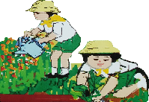
What Is It

What are Grammatical Signals or Expressions?

Grammatical signals or expressions are writing devices that serve to maintain text coherence or unity of ideas. They signal relationship between sentences. They can be words or phrases that connect ideas of sentences and paragraphs for coherence. They also indicate building up new idea or thought or compare ideas or draw conclusions.

Grammatical signals or expressions are used in idea development for each pattern, namely:

- general to particular
- claim and counterclaim
- problem – solution
- cause – effect

In this module, we are going to focus only in developing ideas following the general-to-particular pattern.

What is general–to–particular pattern?

It is a method of writing a composition that discusses the broad topic using specific details that support the topic.

It is a pattern of developing ideas that begins with a general idea or statement. This is followed by specific details to support and explain the general idea. We use grammatical signals or expressions to connect the general idea or statement and the specific details.

Here are some of the grammatical signals that are used to express ideas from general to particular:
for example namely in fact
such as for instance like
in other words that is indeed
specifically in particular including

Study the following sentences:

- I can play quite a few musical instruments.

- I can play quite a few musical instruments, such as the flute, the guitar, and the piano.

Notice that both sentences have the same idea. However, we can say that the second sentence is more specific than the first sentence. This is because the second sentence contains supporting details and uses the grammatical signal such as to connect the general idea “I can play quite a few musical instruments” with the supporting details “the flute, the guitar, and the piano.”

What’s More

Activity 4: Fill the Gap

Directions: Complete the statements by filling in the blanks with the correct grammatical signals
from the box to connect the general idea to its supporting details.

specifically namely in fact
such as for instance like
in other words that is indeed

- When I go camping, I bring lots of things, _______________ a fishing rod, a match and a sleeping bag.

- Do you have any hobbies _______________ reading or writing?

- Korea has many beautiful cities _______________ Seoul and Busan.

- Three students were mentioned, _______________ John, Sarah and Chris.

- He’s not all exciting, _______________ he’s really rather ordinary.

- Martin has a bad eyesight, the doctor advised him to wear corrective lenses, _______________ eyeglasses.

- My grandfather loves collecting shiny stuffs, __________, when he sees anything shiny he would automatically approach that thing.

- All requests for foreign purchases of a property must be routed through an authorized dealer, _______________ a registered banker.

- I was annoyed, _______________ furious, over what happened.

- She said the movie was a bit predictable. _______________, she didn’t like it.

Activity 5: Note Me

Directions: Read the sentences carefully and circle the grammatical signal used in each item.

- My father loves eating salty foods. For example, last week he made some home-made salted eggs.

- Joyce has studied many Asian languages, for instance Korean, Chinese Mandarin, and Thai.

- Matthew invited some of his friends to join the outing, namely, John and Christian.

- The city government officials are responsible for most local services, such as local planning, social services and local roads.

- He pretended not to know her, in fact they were classmates in elementary.

- When you cook soup with leafy vegetables such as moringga, spinach and chinese cabbage, don’t forget to remove the stalks.

- People think that the investigation was independent, in fact a lot of political manipulations went on.

- The nurses identified the postcode areas of the locally stranded individuals and categorized them into three groups, namely, urban, rural, or mixed.

- There have been many leaders in history who have tried to rule the entire world, for instance, Julius Caesar and Alexander the Great.

- Shakespeare influenced novelists such as Thomas Hardy, William Faulkner, and Charles Dickens.

What I Have Learned

Let us sum up what you have learned in this lesson.
Activity 6: Construct Me
Directions: Share your learning on this module by constructing sentences using the suggested grammatical signals that follow the general to particular pattern. Write your responses in them boxes provided.
for example like in other words specifically namely

Sentence 1

Sentence 1

Sentence 2

Sentence 3

Sentence 4

Sentence 5

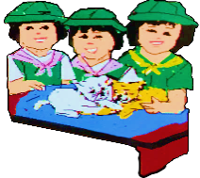
What I Can Do

Activity 7: Think and Write
Directions: Construct a paragraph of not more than 200 words about a topic you are familiar with. It should contain a general statement and use the different grammatical signals to add specific statements to support the topic. Underline the grammatical signals used in your composition. This activity will be rated through a rubric.

Point Value | 10 | 8 | 5
Topic | Interesting, original topic, reflecting thought and insight; focuses on one interesting main idea. | Clearly states topic; presents one main idea. | Acceptable topic; presents one idea.
Supporting Details | Interesting, concrete and descriptive examples and details with explanations that relate to the topic. | Examples and details relate to the topic and some explanation is included. | Sufficient number of examples and details related to the topic.
Grammatical Signals | Uses 8 or more grammatical signals. | Uses 5 to 7 grammatical signals. | Uses less than 5 grammatical signals.
Mechanics | Consistent standard English usage, spelling, and punctuation. No errors. | Some errors, but no major error in usage, spelling or punctuation. | A few errors in usage, spelling or punctuation.

(TITLE)

________________________________________________________________________________________________________________________________________________________________________________________________________________________________________________________________________________________________________________________________________________________________________________________________________________________________________________________________________________________________________________________________________________________________________________________________________________________________________________________.____________________________________________________________________________________________________________________________________________________________________________________________________________________________________________________________________________________________________________________________________________________________________________________________________________________________________________________________________________________________________________________________________________________________________________________________________________________________________________________________________________________________________________________________________________________________________________________________________________________________________________________________________________________________________________________________________________________________________________________________________________________________________________________________________________________________________________________

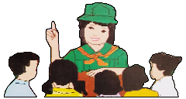
Assessment

Directions: Fill in the blanks with the appropriate grammatical signal in each sentence below. Write the letter of the correct answer in the space provided for.

_____ 1. I love eating desserts, __________, leche flan, salad and cake.

- namely
- in fact
- indeed
- that is

_____ 2. Exercising helps us to become healthy, __________, jogging early in the morning or just
walking in the park is a great exercise.

- indeed
- for example
- that is
- namely

_____ 3. Leo did not study for the exam, __________, he was not ready to take it.

- namely
- that is
- in other words
- like

_____ 4. Reading books is one of my favorite hobbies, __________ I finished reading all
Harry Potter books.
- in fact
- namely
- for example
- indeed

_____ 5. Our family has a lot of traditions, __________, cooking cassava cake during Lenten season
and during Christmas we always cook ginger bread cookies.

- namely
- in fact
- such as
- like

_____ 6. The Philippines is divided into three main groups, __________ Luzon, Visayas and
Mindanao.

- for example
- like
- namely
- indeed

_____ 7. Four students topped the exam, __________, Rico, Claire, Jenny and Natalie.

- namely
- like
- such as
- indeed

_____ 8. If you need any help, don’t be afraid to ask for assistance, __________, you can’t
understand your homework just call me.

- indeed
- like
- for instance
- namely

_____ 9. It rained cats and dogs, __________, everyone in the neighborhood stayed at home.
- in fact
- such as
- that is
- for example

_____ 10. There are lots of things we can do in the beach, _____ playing beach
volleyball, camping and swimming.

- in other words
- in fact
- indeed
- such as
Additional Activity

Activity 8: Internalize It
Read the story below then do the activity that follows.
MAKATO AND THE COWRIE SHELL
(A Summary)
By Supannee Khanchanathiti

Once upon a time, there was an orphan whose name was Makato. He didn't have any ways to support himself, so he did every kind of work such as, carrying heavy things, clearing away forest, and even feeding pigs. Although he was paid only a small wage, he never idled and was satisfied of everything. As a result, people around him noticed his hard work and were very pleased of him.

Makato dreamed of going on an adventure to a far and bigger place where the land was fertile, and the people were kind. He left his village and set out into the wide world. He walked along cheerfully, enjoying new insights and talking to the people he met on the way. After a long month's journey, he reached a village on the boundary of the Kingdom of Sukhotai. He met an old woman who helped her. He told her that he had come from a far place and he wanted to see the king, who he had heard was kind. He worked with the king's elephants and he started working for her. After some time working, he finally met with the king. During the encounter, he picked up a cowrie shell that was lying on the road and offered it to the king (Cowrie shells were used for money, but just one was practically worthless).

When Makato offered the shell to the King, the King said he could keep it. Makato was wondering what he could repay to honor the king's gift. He saw some lettuce seeds at a stall in the market and thought that he could grow them. He asked the woman about them, and she let him have as many as would stick to his finger in return for his treasured cowrie shell. He made the lettuces grow abundantly. The next time he saw the king, he gave one to him and told him he grew them from the shell that he had given him. The king was very impressed and gave him a job in the castle. Eventually, Makato grew up and married the daughter of the king.

Directions: Read the lines taken from the story. Identify the transition signals used in each sentence. Write your answers on a separate sheet of paper.

  - Although Makato was paid only a small wage, he never idled and was satisfied of everything.
  - Fortunately, he met an old woman who helped her.
  - As a result, people around him noticed his hard work and were very pleased of him.
  - After a month's journey, he reached a village on the boundary of the Kingdom of Sukhotai.
  - So he did every kind of work such as carrying heavy things, clearing away forest, and even feeding pigs.

Answer Key
WHAT I KNOW
Activity 1
- D
- C
- D
- C
- C
- D
- C
- D
- D
- C
WHAT’S IN
Activity 2
PUZZLE

WHAT’S NEW
Activity 3
- Answers may vary
- Answers may vary
- Answers may vary

WHAT’S MORE
Activity 4
- such as
- like
- such as
- namely
- in fact
- specifically
- for instance
- that is
- indeed
- in other words

Activity 5
- for example
- for instance
- namely
- such as
- in fact
- such as
- in fact
- namely
- for instance
- such as

WHAT I HAVE LEARNED
Activity 6
- Answers may vary
- Answers may vary
- Answers may vary
- Answers may vary
- Answers may vary

WHAT I CAN DO
Activity 7
Answers may vary

ASSESSMENT
- A
- B
- C
- A
- C
- C
- A
- C
- A
- D

ADDITIONAL ACTIVITY
Activity 8

- Although
- Fortunately
- As a result
- After
- such as

References:

Textbooks
Anama, Gina A.; Anna Lea A. Davide; Ricardo Ador Dionisio; Lerma L. Flandez; Armi Victoria A. Fiangaan; Marcelino E. Ibaňez; Gizelle V. Laud; Jovelyn A. Lita; Roselyn D. Mujal; Christine H. Pepito; Prudencia M. Sanoy; Grace Annette B. Sariano; Peter S. Tentoco III; Riza R. Zuňiga. Voyages in Communication: Learning Material-Grade 8 English. Pasig City: Department of Education, 2013, 148, 151.

Bermudez, Virginia F., Ed. D.; Josephine M. Cruz, Ph. D.; Milagros A. San Juan, Ph. D; and Remedios F. Nery. English Expressways II. Quezon City: SD Publications, 2010.

Online
Department of Education. “Using Transition Signals.” Accessed on January 22, 2021. https://commons.deped.gov.ph/grades/7c7ce2ae-000a-4b90-8828-ff72d20aad12

Slide Share. “English 8 – Pattern of Idea Development (General to Particular).” Accessed on January 27, 2020. https://www.slideshare.net/jmpalero/english-8-pattern-of-idea-development-general-to-particular

DEVELOPMENT TEAM

Writers: Gem Clouwin M. Ajon, Basilan National High School
Lovely Rose Alvarez, Malamawi National High School
Editor:

Language Editor:
Proofreader: Sayana S. Hasan, EPS
Illustrators: Gem Clouwin M. Ajon, Lovely Rose Alvarez
and Christianvil T. Garcia
Layout Artist: Christianvil T. Garcia, Basilan National High School
Management Team:
Julieto H. Fernandez, Ed. D., CESO VI
SDS-Isabela City
Maria Laarni T. Villanueva, Ed. D., CESE
ASDS-Isabela City
Henry R. Tura, CID Chief
Elsa A. Usman, LR Supervisor
Helen De Leon, EPS-English, Module Coordinator

Region IX: Zamboanga Peninsula Hymn – Our Eden Land
Here the trees and flowers bloom  Here the breezes gently Blow,  Here the birds sing Merrily,  The liberty forever Stays,  Here the Badjaos roam the seas  Here the Samals live in peace  Here the Tausogs thrive so free  With the Yakans in unity | Gallant men And Ladies fair  Linger with love and care  Golden beams of sunrise and sunset  Are visions you’ll never forget  Oh! That’s Region IX  Hardworking people Abound,  Every valleys and Dale  Zamboangueños, Tagalogs, Bicolanos, | Cebuanos, Ilocanos, Subanons, Boholanos, Ilongos,  All of them are proud and true  Region IX our Eden Land  Region IX  Our..  Eden...  Land...

My Final Farewell
Farewell, dear Fatherland, clime of the sun caress'd  Pearl of the Orient seas, our Eden lost!,  Gladly now I go to give thee this faded life's best,  And were it brighter, fresher, or more blest  Still would I give it thee, nor count the cost.  On the field of battle, 'mid the frenzy of fight,  Others have given their lives, without doubt or heed;  The place matters not-cypress or laurel or lily white,  Scaffold or open plain, combat or martyrdom's plight,  T is ever the same, to serve our home and country's need.  I die just when I see the dawn break,  Through the gloom of night, to herald the day;  And if color is lacking my blood thou shalt take,  Pour'd out at need for thy dear sake  To dye with its crimson the waking ray.  My dreams, when life first opened to me,  My dreams, when the hopes of youth beat high,  Were to see thy lov'd face, O gem of the Orient sea  From gloom and grief, from care and sorrow free;  No blush on thy brow, no tear in thine eye.  Dream of my life, my living and burning desire,  All hail ! cries the soul that is now to take flight;  All hail ! And sweet it is for thee to expire ;  To die for thy sake, that thou mayst aspire;  And sleep in thy bosom eternity's long night.  If over my grave some day thou seest grow,  In the grassy sod, a humble flower,  Draw it to thy lips and kiss my soul so,  While I may feel on my brow in the cold tomb below  The touch of thy tenderness, thy breath's warm power.  Let the moon beam over me soft and serene,  Let the dawn shed over me its radiant flashes,  Let the wind with sad lament over me keen ;  And if on my cross a bird should be seen,  Let it trill there its hymn of peace to my ashes. | Let the sun draw the vapors up to the sky,  And heavenward in purity bear my tardy protest  Let some kind soul o 'er my untimely fate sigh,  And in the still evening a prayer be lifted on high  From thee, 0 my country, that in God I may rest.  Pray for all those that hapless have died,  For all who have suffered the unmeasur'd pain;  For our mothers that bitterly their woes have cried,  For widows and orphans, for captives by torture tried  And then for thyself that redemption thou mayst gain  And when the dark night wraps the graveyard around  With only the dead in their vigil to see  Break not my repose or the mystery profound  And perchance thou mayst hear a sad hymn resound  'T is I, O my country, raising a song unto thee.  And even my grave is remembered no more  Unmark'd by never a cross nor a stone  Let the plow sweep through it, the spade turn it o'er  That my ashes may carpet earthly floor,  Before into nothingness at last they are blown.  Then will oblivion bring to me no care  As over thy vales and plains I sweep;  Throbbing and cleansed in thy space and air  With color and light, with song and lament I fare,  Ever repeating the faith that I keep.  My Fatherland ador'd, that sadness to my sorrow lends  Beloved Filipinas, hear now my last good-by!  I give thee all: parents and kindred and friends  For I go where no slave before the oppressor bends,  Where faith can never kill, and God reigns e'er on high!  Farewell to you all, from my soul torn away,  Friends of my childhood in the home dispossessed!  Give thanks that I rest from the wearisome day!  Farewell to thee, too, sweet friend that lightened my way; Beloved creatures all, farewell! In death there is rest!

I Am a Filipino, by Carlos P. Romulo
I am a Filipino–inheritor of a glorious past, hostage to the uncertain future. As such I must prove equal to a two-fold task–the task of meeting my responsibility to the past, and the task of performing my obligation to the future.  I sprung from a hardy race, child many generations removed of ancient Malayan pioneers. Across the centuries the memory comes rushing back to me: of brown-skinned men putting out to sea in ships that were as frail as their hearts were stout. Over the sea I see them come, borne upon the billowing wave and the whistling wind, carried upon the mighty swell of hope–hope in the free abundance of new land that was to be their home and their children’s forever.  I am a Filipino. In my blood runs the immortal seed of heroes–seed that flowered down the centuries in deeds of courage and defiance. In my veins yet pulses the same hot blood that sent Lapulapu to battle against the first invader of this land, that nerved Lakandula in the combat against the alien foe, that drove Diego Silang and Dagohoy into rebellion against the foreign oppressor.  The seed I bear within me is an immortal seed. It is the mark of my manhood, the symbol of dignity as a human being. Like the seeds that were once buried in the tomb of Tutankhamen many thousand years ago, it shall grow and flower and bear fruit again. It is the insignia of my race, and my generation is but a stage in the unending search of my people for freedom and happiness. | I am a Filipino, child of the marriage of the East and the West. The East, with its languor and mysticism, its passivity and endurance, was my mother, and my sire was the West that came thundering across the seas with the Cross and Sword and the Machine. I am of the East, an eager participant in its spirit, and in its struggles for liberation from the imperialist yoke. But I also know that the East must awake from its centuried sleep, shake off the lethargy that has bound his limbs, and start moving where destiny awaits.  I am a Filipino, and this is my inheritance. What pledge shall I give that I may prove worthy of my inheritance? I shall give the pledge that has come ringing down the corridors of the centuries, and it shall be compounded of the joyous cries of my Malayan forebears when first they saw the contours of this land loom before their eyes, of the battle cries that have resounded in every field of combat from Mactan to Tirad Pass, of the voices of my people when they sing:  “I am a Filipino born to freedom, and I shall not rest until freedom shall have been added unto my inheritance—for myself and my children and my children’s children—forever.”

