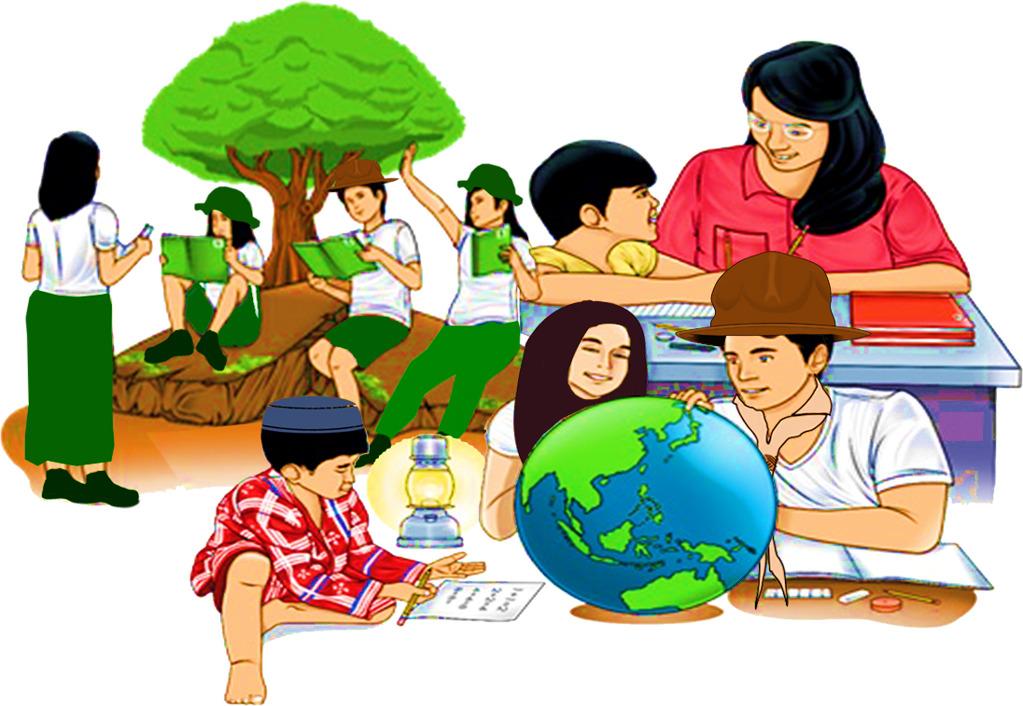
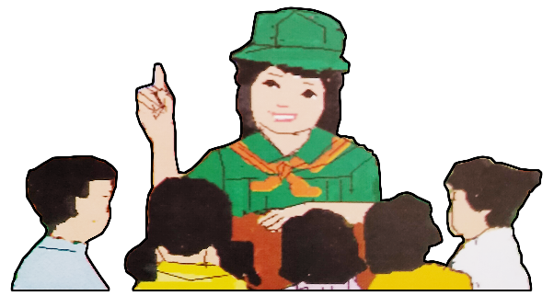
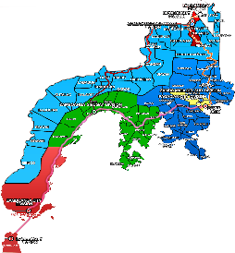

Quarter 4 – Module 2
Use of Grammatical Signals
ENGLISH
Name of Learner: ___________________________
Grade & Section: ___________________________
Name of School: ___________________________
8

Zest for Progress
Zeal of Partnership
Republic of the Philippines
Department of Education
Regional Office IX, Zamboanga Peninsula

What I Need To Know KKKKKKKKKKkkkkkkknKNOW

This module was designed and written with you in mind. It is here to help you how to use grammatical signals to each pattern of idea development. The scope of this module permits it to be used in many different learning situations. The language used recognizes the diverse vocabulary levels of students. The lessons are arranged to follow the standard sequence of the course. But the order in which you read them can be changed to correspond with the textbook you are now using.

At the end of this module, the learners are expected to:
- Use appropriate grammatical signals or expressions suitable to each pattern of idea development (general to particular, claim and counterclaim, problem-solution, cause-effect and others.) UNCODED
  - use grammatical signals correctly;
  - write sentences using grammatical signals suitable to each pattern of idea development:
    - claim and counterclaim
    - problem-solution
    - cause-effect
    - signal emphasis; and
- compose a paragraph using grammatical signals.

What I Know

Activity 1: Guess What
Directions: Complete the sentences below with the best transition signals. Circle the letter of the correct answer.

- I lost my keys. __________, I later found them under the table.
- In fact
- For example
- However
- In short

- I didn’t have time to eat breakfast. __________, I’m really hungry now.
- Additionally
- To illustrate
- As a result
- Meanwhile

- Tamaraw is one of the endangered species in the Philippines. The __________ to this problem is to educate the natives about the conservation of the animal.
- that is
- no doubt
- in addition
- proposed solution

- The storm was severe. __________, many homes were destroyed.
- In contrast
- Indeed
- Next
- Likewise

- Our teacher is present __________, she’s sick.
- even though
- likewise
- finally
- as a result

What’s In

Activity 2: Match me
This activity will give you an opportunity to review your past lesson in using grammatical signals.
Directions: Study the paragraph below. Underline the general and specific expressions.

Tsuzuki decided that papermaking was one way of providing a means of self-reliance to children with physical disabilities. After she informed the Dominican Rehabilitation Association about her plan, she met the people involved in the activity. First, she requested the center’s wood work section to prepare sieve frames used for papermaking. Next, she had the students and other teachers collect banana leaves and stalks on their way to classes. Then, she prepared the chemicals needed for pulping and a liquidizer for turning the leaves into a gel solution. Finally, she briefed the students on who would do the papermaking job.

What’s New

Activity 3: Read me
Directions: Read the following statements and observe the highlighted words.

- There was no rain for two months. Because of this, all the crops died.

- Students are addicted to technology. To avoid worsening, one solution is to engage them in outdoor activities.

- Mercury is a small planet indeed, it is only slightly larger than our moon.

- Einstein was born in Germany, however he became a US citizen in 1940.
- Learning a new language is fun, on the other hand it takes a lot of time.

Questions:
- What are the highlighted words in the sentences?
______________________________________________________________________
______________________________________________________________________

- What are these words and phrases called?
_______________________________________________________________________
_______________________________________________________________________

- How are these words in the sentences used?
_______________________________________________________________________
_______________________________________________________________________

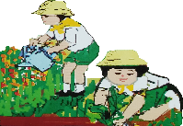
What Is It

There are many ways to develop and connect ideas with the use of transition signals or expressions. Transition signals create powerful links between sentences and paragraphs to improve the flow of information across the whole text. They also help to carry over a thought from one sentence to another, from one idea to another and from one paragraph to another. These are joined by a period or semicolon, and are followed by a comma.

Grammatical signals on claim and counterclaim
These are expressions used when the idea of the sentence or the paragraph signifies argument where there is more than one side to a debate.

The following expressions are used in making claims and counterclaims.

however otherwise
but nevertheless
on the contrary on the other hand
in contrast nonetheless
Examples:

- You can come with us if you are ready; otherwise you will have to ride the bus.
- James and his team didn’t finish the project; however they did work hard.
- The bullet ant is a small creature. Nonetheless, its bite is extremely painful.

The highlighted words or expressions in the above examples are used to express claims and counterclaims.

Grammatical signals on cause and effect

These are words used to describe how an action or event is caused by another event or action.

therefore so

consequently due to

as a result for this reason

because thus

hence

Examples:

- It was raining; therefore, I stayed at home.
- Because of the rain I stayed at home.
- I stayed at home due to the rain.

The highlighted words or expressions in the above examples signal cause and effect.

Grammatical signals on problem-solution
These are words that are used to present and explain a problem. When you use these expressions, you propose a possible solution to solve the problem. If there is no solution, only the problem is presented.

problem the dilemma is
solved one answer is
to solve this so that
to address this proposed solution

Examples:

- Many students have difficulty in answering their modules. To address this, parents are asked to assist their children in accomplishing the activities.
- The number of students who have no gadgets for their online education is high. A proposed solution is to give them modules.

The highlighted words or expressions in the above examples are used to signal problem-solution.

Grammatical signals on emphasis
These are words or expressions used to show that something is important and therefore, should be noted.

above all most importantly
indeed an important factor
in fact truly
certainly as a matter of fact
besides

Examples:

- The storm was severe indeed, many homes were destroyed.
- I know how to do many things; in fact, I am a working student.
- Certainly, you may borrow my book in English 8.

The highlighted words or expressions in the above examples are used to signal emphasis.

What’s More

Activity 4: Fill in the gap
Directions: Read each item carefully and fill in the blanks by choosing the appropriate grammatical signal provided inside the box.

for this reason however because
as a result otherwise so that

- Summer in the Philippines can be very hot . ___________, many people experience heat stroke.
- Mrs. Cruz can be grumpy sometimes; _____________, we should help her whenever we can.
- The student submitted his essay late. ___________, he failed.
- Juan wakes up early _____________ his class starts at seven o’clock in the morning.
- Essays must be handed in by due date ____________ they will not be accepted.

Activity 5: Complete me
Directions: Complete the sentences about you using the given grammatical signals.

- I usually study hard for quarterly exam. As a result,...

______________________________________________________________________________

- I always try to be kind. Nevertheless, ...

______________________________________________________________________________

- I like to study Filipino. However,...

______________________________________________________________________________

- Sometimes I skip breakfast. Therefore,...

______________________________________________________________________________

- I can speak Yakan. In fact,..

______________________________________________________________________________

What I Have Learned

Activity 6: Think and Write
Directions: Write sentences using the following grammatical signals provided below.
- However
_________________________________________________________________________________

- So that
_________________________________________________________________________________

- Because
_________________________________________________________________________________

- Otherwise
_________________________________________________________________________________

- Therefore
_________________________________________________________________________________

- To solve this
_________________________________________________________________________________

- In fact
_________________________________________________________________________________

- Certainly
_________________________________________________________________________________

- To address this
_________________________________________________________________________________

- Due to
_________________________________________________________________________________

Activity 7: Fill in the Gap
Directions: Complete the paragraph by filling in the blanks with the correct transition signals.
hence of course nonetheless

specifically however

Bullet Ants
The bullet ant is a small creature. (1)________________, its sting is extremely painful, and victims compared that terrible, burning pain to be in shot with a gun; (2) ______________, its name: the “bullet” ant. In Venezuela, (3) _____________, it is not known as the bullet ant, but as the “24-hour ant” because this is how long a victim will experience pain after being stung. Worker ants of this species are quite large. (4)___________, they measure between 18 and 30 millimeters (0.7 to 1. 2 inches) and are said to look like a large, wingless wasps. When encountered in the wild, it is a good idea, (5) _____________, to avoid close contact with them.

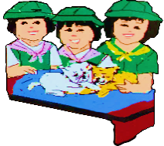
What I Can Do

Activity 8: Choose and Expand
Directions: Write a paragraph from any of the topics provided below. Then, underline the transition signals used. Be guided by the rubric in writing the composition.
Topics:
- Distance Learning in the Time of COVID-19 Pandemic
- Advantages and Disadvantages of Using Gadgets
- Keeping a Healthy Mind and Body

 | 10 | 8 | 5
Use of Transition Signals | The learner uses 7-10 transition signals. | The learner uses 4-6 transition signals. | The learner uses 1-3 transition signals.
Mechanics and Spelling | The composition is free from errors. | The composition has 1-3 errors in spelling and mechanics. | The composition has 4 or more errors in spelling and mechanics.
Readability of entries | The learner’s output is clear and has no erasures. | The learner’s output has 1-3 erasures. | The learner’s output has 4 and more erasures and is not readable.

________________________________________________
(Title)
_______________________________________________________________________________________________________________________________________________________________________________________________________________________________________________________________________________________________________________________________________________________________________________________________________________________________________________________________________________________________________________________________________________________________________________________________________________________________________________________________________________________________________________________________________________________________________________________________________________________________________________________________________________________________________________________________________________________________________________________________________________________________________________________________________________________________________________________________________________________________________________________________________________________________________________________________________________________________________________________________________________________________________________________________________________________________________________________________________________________________________________________________________________________________________________________________________________________________________________________________________________________________________________________________________________________________________________________________________________________________________________________________________________________________________________________________________________________________________________________________________________________________________________________________________________________________________________________________________________________________________________________________________________________________________________________________________________________________________________________________________________________________________________________________________________________________________________________________________________________________________________________________________________________________________________________________________________________________________________________________________________________________________________________________________________________________________________________________________________________________________________________________________________________________________________________________________________________________________________________________________________________________________________________________________________________________________________________________________________________________________________________________________________________________________________________________________________________________________________________________________________________________________________________________________________________________________________________________________________________________________________________________________________________________________________________________________________________________________________________________________________________________________________________________________________________________________________________________________________________________________________________________________________________________________________________________________________________________

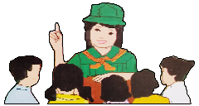
Assessment

Directions: Read the following questions and circle the letter of the correct answer.

- Which of the following is NOT a grammatical signal on emphasis?

- Certainly
- Indeed
- So that
- In fact

- Why do we use transition signals or expressions?

- To improve the flow of information
- To confuse the learners in reading
- To limit connections between texts
- To present data or information

- What is the importance of grammatical signals on cause-effect?

- It is used when the idea of the sentence or the paragraph signifies argument.
- It is used to describe how an action or event is caused by another event or action.
- It is used to present and explain a problem.
- It is used to show that something is important and therefore, should be noted.

- Which word/s in the sentence below is/are an example of grammatical signal?

Because of the rain I stayed at home.
1 2 3 4
- 1
- 2
- 3
- 4

- Which of the following uses transition signal on cause and effect correctly?

- Better varieties of rice and corn are produced. As a result, many scientific studies and experiments are being carried out.
- Farmers are producing more food with modern equipment, meanwhile scientists have also exploited new sources of food production.
- Techniques and skills need to be supported by market demand to take root, otherwise the concern is that they may fall by the wayside.
- Next, she had the students and other teachers collect banana leaves and stalks on their way to classes.

- The underlined word is a grammatical signal on __________.

“You can come with us if you are ready; otherwise you will have to ride the bus.”

- Cause-effect
- Claim-counterclaim
- Problem-solution
- Emphasis

- Why do we use grammatical signals on problem-solution?

- We use these words when the idea of the sentence or the paragraph signifies argument.
- We use these words to describe how an action or event is caused by another event or action.
- We use these words to present and explain a problem.
- We use these words to show that something is important and therefore, should be noted.

- Which sentence is correct about gramatical signal on emphasis?

- These are words used when the idea of the sentence or the paragraph signifies argument.
- These are words used to describe how an action or event is caused by another event or action.
- These are words used to present and explain a problem.
- These are words used to show that something is important and therefore, should be noted.

- Read the sentences below and answer the question that follows.

“Many students have difficulty in answering their modules. To address this, parents are asked to assist their children in accomplishing the activities.”

What does the underlined transition signal express?

- Cause-effect
- Claim-counterclaim
- Problem-solution
- Emphasis

- What expression should be used to complete the sentence below?

“Next, she decided that papermaking can help them. __________ , she realized the children can be self-reliant individuals.”

- Due to
- One answer is
- To address this
- Moreover

Additional Activities
- Discussion Questions
Directions: Reflect and answer each of the following questions.
- What are grammatical signals or transition signals?
______________________________________________________________________
______________________________________________________________________
______________________________________________________________________
______________________________________________________________________
______________________________________________________________________

- Give the importance of using transition signals in writing your composition.
______________________________________________________________________
______________________________________________________________________
______________________________________________________________________
______________________________________________________________________
______________________________________________________________________

- How do we use grammatical signals on?

- claim and counterclaim
___________________________________________________________________
___________________________________________________________________
___________________________________________________________________

- cause and effect
___________________________________________________________________
___________________________________________________________________
___________________________________________________________________

- problem-solution
___________________________________________________________________
___________________________________________________________________
___________________________________________________________________

- emphasis
___________________________________________________________________
___________________________________________________________________
___________________________________________________________________

- Paragraph Writing

Directions: Practice your writing skill by composing paragraphs that use transitional signals discussed in this module. Don’t forget to underline the grammatical signals used.

__________________________________________________________________________________
_________________________________________________________________________________________
_________________________________________________________________________________________
_________________________________________________________________________________________

__________________________________________________________________________________
_________________________________________________________________________________________
_________________________________________________________________________________________
_________________________________________________________________________________________
_________________________________________________________________________________________
_________________________________________________________________________________________
_________________________________________________________________________________________
_________________________________________________________________________________________
_________________________________________________________________________________________
_________________________________________________________________________________________
_________________________________________________________________________________________
_________________________________________________________________________________________

__________________________________________________________________________________
_________________________________________________________________________________________
_________________________________________________________________________________________
_________________________________________________________________________________________
_________________________________________________________________________________________

Answer Key

WHAT I KNOW
Activity 1 ASSESSMENT
- C 1. C
- C 2. A
- D 3. B
- B 4. A
- D 5. A
WHAT’S IN
Activity 2 6. B
- First 7. C
- Next 8. D
- Then 9. C
WHAT'S NEW 10. D
Activity 3
Answers may vary ADDITIONAL ACTIVITIES
WHAT’S MORE A. Answers may vary
Activity 4 B. Answers may vary
- For this reason
- However
- As aresult
- Because
- Otherwise
Activity 5
Answers may vary
WHAT I HAVE LEARNED
Activity 6
Answers may vary
Activity 7
- Nonetheless
- Hence
- However
- Specificically
- Of course
Activity 8
Answers may vary

References:

Textbooks
Bermudez, Viginia E., Ed.D.; Josephine M. Cruz, Ph.D.; Remedios F. Nery; and Milagros A. San Juan, Ph.D. English Expressways II. Quezon City: SD Publications, Inc., 2007, 268-269.

Anama, Gina A.; Anna Lea Davide; Ricardo Ador Dionisio; Lerma L. Flandez; Armi Victoria A. Fiangaan; Marcelino E. Ibañez; Giselle V. Laud; Jovelyn A. Lita; Roselyn D. Mujal; Christine H. Pepito; Prudencia M. Sanoy; Grace Annette B. Soriano; Peter S. Tentoco III; Riza R. Zuñiga. Voyages in Communication: Learnng Material Grade 8 English. Pasig City: Department of Education, 2013, 40-41.

Online
Akademia. “Signal Words: Types, Functions and Examples.” Accessed on January 28, 2021.
https://akademia.com.ng/signal-words-types-functions-and-examples/

DEVELOPMENT TEAM

Writers: Leslie Anne M. Dindin, Basilan National High School
Nikki P. Mana-ay, Caro National High School
Editor:

Language Editor:
Proofreader: Sayana S. Hasan, EPS
Illustrators: Leslie Anne M. Dindin, Nikki P. Mana-ay
and Christianvil T. Garcia
Layout Artist: Christianvil T. Garcia, Basilan National High School
Management Team:
Julieto H. Fernandez, Ed. D., CESO VI
SDS-Isabela City
Maria Laarni T. Villanueva, Ed. D., CESE
ASDS-Isabela City
Henry R. Tura, CID Chief
Elsa A. Usman, LR Supervisor
Helen De Leon, EPS-English, Module Coordinator

Region IX: Zamboanga Peninsula Hymn – Our Eden Land
Here the trees and flowers bloom  Here the breezes gently Blow,  Here the birds sing Merrily,  The liberty forever Stays,  Here the Badjaos roam the seas  Here the Samals live in peace  Here the Tausogs thrive so free  With the Yakans in unity | Gallant men And Ladies fair  Linger with love and care  Golden beams of sunrise and sunset  Are visions you’ll never forget  Oh! That’s Region IX  Hardworking people Abound,  Every valleys and Dale  Zamboangueños, Tagalogs, Bicolanos, | Cebuanos, Ilocanos, Subanons, Boholanos, Ilongos,  All of them are proud and true  Region IX our Eden Land  Region IX  Our..  Eden...  Land...

My Final Farewell
Farewell, dear Fatherland, clime of the sun caress'd  Pearl of the Orient seas, our Eden lost!,  Gladly now I go to give thee this faded life's best,  And were it brighter, fresher, or more blest  Still would I give it thee, nor count the cost.  On the field of battle, 'mid the frenzy of fight,  Others have given their lives, without doubt or heed;  The place matters not-cypress or laurel or lily white,  Scaffold or open plain, combat or martyrdom's plight,  T is ever the same, to serve our home and country's need.  I die just when I see the dawn break,  Through the gloom of night, to herald the day;  And if color is lacking my blood thou shalt take,  Pour'd out at need for thy dear sake  To dye with its crimson the waking ray.  My dreams, when life first opened to me,  My dreams, when the hopes of youth beat high,  Were to see thy lov'd face, O gem of the Orient sea  From gloom and grief, from care and sorrow free;  No blush on thy brow, no tear in thine eye.  Dream of my life, my living and burning desire,  All hail ! cries the soul that is now to take flight;  All hail ! And sweet it is for thee to expire ;  To die for thy sake, that thou mayst aspire;  And sleep in thy bosom eternity's long night.  If over my grave some day thou seest grow,  In the grassy sod, a humble flower,  Draw it to thy lips and kiss my soul so,  While I may feel on my brow in the cold tomb below  The touch of thy tenderness, thy breath's warm power.  Let the moon beam over me soft and serene,  Let the dawn shed over me its radiant flashes,  Let the wind with sad lament over me keen ;  And if on my cross a bird should be seen,  Let it trill there its hymn of peace to my ashes. | Let the sun draw the vapors up to the sky,  And heavenward in purity bear my tardy protest  Let some kind soul o 'er my untimely fate sigh,  And in the still evening a prayer be lifted on high  From thee, 0 my country, that in God I may rest.  Pray for all those that hapless have died,  For all who have suffered the unmeasur'd pain;  For our mothers that bitterly their woes have cried,  For widows and orphans, for captives by torture tried  And then for thyself that redemption thou mayst gain  And when the dark night wraps the graveyard around  With only the dead in their vigil to see  Break not my repose or the mystery profound  And perchance thou mayst hear a sad hymn resound  'T is I, O my country, raising a song unto thee.  And even my grave is remembered no more  Unmark'd by never a cross nor a stone  Let the plow sweep through it, the spade turn it o'er  That my ashes may carpet earthly floor,  Before into nothingness at last they are blown.  Then will oblivion bring to me no care  As over thy vales and plains I sweep;  Throbbing and cleansed in thy space and air  With color and light, with song and lament I fare,  Ever repeating the faith that I keep.  My Fatherland ador'd, that sadness to my sorrow lends  Beloved Filipinas, hear now my last good-by!  I give thee all: parents and kindred and friends  For I go where no slave before the oppressor bends,  Where faith can never kill, and God reigns e'er on high!  Farewell to you all, from my soul torn away,  Friends of my childhood in the home dispossessed!  Give thanks that I rest from the wearisome day!  Farewell to thee, too, sweet friend that lightened my way; Beloved creatures all, farewell! In death there is rest!

I Am a Filipino, by Carlos P. Romulo
I am a Filipino–inheritor of a glorious past, hostage to the uncertain future. As such I must prove equal to a two-fold task–the task of meeting my responsibility to the past, and the task of performing my obligation to the future.  I sprung from a hardy race, child many generations removed of ancient Malayan pioneers. Across the centuries the memory comes rushing back to me: of brown-skinned men putting out to sea in ships that were as frail as their hearts were stout. Over the sea I see them come, borne upon the billowing wave and the whistling wind, carried upon the mighty swell of hope–hope in the free abundance of new land that was to be their home and their children’s forever.  I am a Filipino. In my blood runs the immortal seed of heroes–seed that flowered down the centuries in deeds of courage and defiance. In my veins yet pulses the same hot blood that sent Lapulapu to battle against the first invader of this land, that nerved Lakandula in the combat against the alien foe, that drove Diego Silang and Dagohoy into rebellion against the foreign oppressor.  The seed I bear within me is an immortal seed. It is the mark of my manhood, the symbol of dignity as a human being. Like the seeds that were once buried in the tomb of Tutankhamen many thousand years ago, it shall grow and flower and bear fruit again. It is the insignia of my race, and my generation is but a stage in the unending search of my people for freedom and happiness. | I am a Filipino, child of the marriage of the East and the West. The East, with its languor and mysticism, its passivity and endurance, was my mother, and my sire was the West that came thundering across the seas with the Cross and Sword and the Machine. I am of the East, an eager participant in its spirit, and in its struggles for liberation from the imperialist yoke. But I also know that the East must awake from its centuried sleep, shake off the lethargy that has bound his limbs, and start moving where destiny awaits.  I am a Filipino, and this is my inheritance. What pledge shall I give that I may prove worthy of my inheritance? I shall give the pledge that has come ringing down the corridors of the centuries, and it shall be compounded of the joyous cries of my Malayan forebears when first they saw the contours of this land loom before their eyes, of the battle cries that have resounded in every field of combat from Mactan to Tirad Pass, of the voices of my people when they sing:  “I am a Filipino born to freedom, and I shall not rest until freedom shall have been added unto my inheritance—for myself and my children and my children’s children—forever.”

