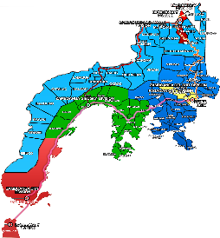
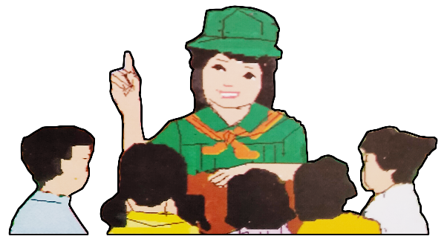
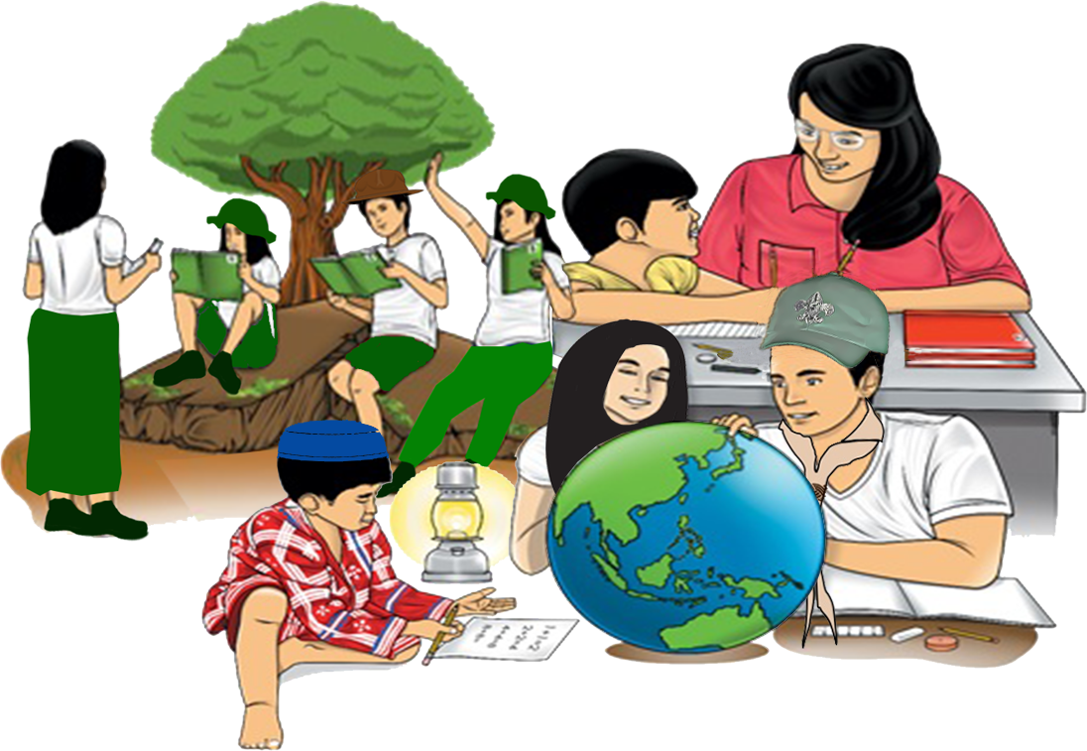
Quarter 4 – Module 2:
Soundness of Reasoning

English
Name of Learner: ___________________________
Grade & Section: ___________________________
Name of School: ___________________________
9
Zest for Progress
Zeal of Partnership
Republic of the Philippines
Department of Education
Regional Office IX, Zamboanga Peninsula

What I Need to Know

A lot of new things are emerging in our ever changing world. It is our responsibility to discern what to follow and what to believe in. While we enjoy the changes the world has to offer, we should still be grounded on the values that shaped our being. These will guide us in our journey through life and our quest for a better future for ourselves and for others.
This module contains texts that will help you better understand the world you are in, thus, guiding you to judge author’s reasoning as a basis in making life’s decision.

In charting the course of your journey in this module, you are expected to:
- Judge the relevance and worth of ideas, soundness of author’s reasoning, and the effectiveness of the presentation (EN9RC-IVf-2.22)
- Analyze author’s soundness of reasoning as a means of understanding the text presented.

What I Know

Activity 1: PRE-TEST
Directions: Read the sentences. Choose the letter of the correct answer and write it on the space provided for.

________ 1. “Philippines is an island country of Southeast Asia in the Western Pacific
Ocean.” What type of information is this?
A. Factual C. Subjective
B. Analytical D. Objective
________ 2. The following statements are factual information, EXCEPT:
A. The government seeks to act in the best interests of its citizens.
B. The Philippines is a republic with a presidential form of government.
C. The President can veto laws passed by Congress.
D. President Emilio Aguinaldo is the best president in history.
________ 3. Which of the following statements is a subjective information?
A. The Philippines is composed of Luzon, Visayas and Mindanao.
B. The capital of the Philippines is located in Luzon.
C. The most beautiful beach is found in Mindanao.
D. Bohol is found in Visayas.
________ 4. “Davao should be the capital of the Philippines.” Why is this sentence an
example of a subjective information?
A. It is based on opinion. C. It is proven in research.
B. It is based on facts. D. It is based on evidence.
________ 5. Why do we need to analyze the type of information used by the author in giving
reasons and evidence in his text?
A. To understand the purpose of the text C. To lay critical judgements
B. To give arguments D. To create a debate
What’s In

Activity 2: Determine Relevance
Directions: Read the statements below and answer the questions that follow.

Statement #1: A volcano is a mountain that opens downward to a pool of molten rock below
the surface of the earth.
Statement #2: An erupting volcano can trigger tsunamis, flash floods, earthquakes, mudflows
and rock falls.
Statement #3: Plants that may be found on mountains include conifers, oak, and chestnut.
Statement #4: When pressure builds up, eruptions occur.
Statement #5: The danger area around a volcano covers about a 20-mile radius.

Which statement/s above is/are not related? Why do you say so?
_________________________________________________________________________________________________________________________________________________________________________________________________________________________________
_________________________________________________________________________________________________________________________________________________________________________________________________________________________________

What’s New

Activity 3: Observing the Text
Directions: Read the following selections, then answer the questions that follow.

(Reading Selection A) Obama: ‘There Were No Winners In This’ Government Shutdown

Hi everybody. This week, because Democrats and responsible Republicans came together, the government was reopened, and the threat of default was removed from our economy.
There’s been a lot of discussion lately of the politics of this shutdown. But the truth is, there were no winners in this. At a time when our economy needs more growth and more jobs, the manufactured crises of these last few weeks actually harmed jobs and growth. And it’s understandable that your frustration with what goes on in Washington has never been higher.
The way business is done in Washington has to change. Now that these clouds of crisis and uncertainty have lifted, we need to focus on what the majority of Americans sent us here to do – grow the economy, create good jobs, strengthen the middle class, lay the foundation for broad-based prosperity, and get our fiscal house in order for the long haul.
It won’t be easy. But we can make progress. Specifically, there are three places where I believe that Democrats and Republicans can work together right away.

First, we should sit down and pursue a balanced approach to a responsible budget, one that grows our economy faster and shrinks our long-term deficits further. There is no choice between growth and fiscal responsibility – we need both. So we’re making a serious mistake if a budget doesn’t focus on what you’re focused on: creating more good jobs that pay better wages. If we’re going to free up resources for the things that help us grow – education, infrastructure, research – we should cut what we don’t need, and close corporate tax loopholes that don’t help create jobs. This shouldn’t be as difficult as it has been in past years. Remember, our deficits are shrinking – not growing.
Second, we should finish the job of fixing our broken immigration system. There’s already a broad coalition across America that’s behind this effort, from business leaders to faith leaders to law enforcement. It would grow our economy. It would secure our borders. The Senate has already passed a bill with strong bipartisan support. Now the House should, too. The majority of Americans thinks this is the right thing to do. It can and should get done by the end of this year.
Third, we should pass a farm bill – one that America’s farmers and ranchers can depend on, one that protects vulnerable children and adults in times of need, and one that gives rural communities opportunities to grow and the longer-term certainty they deserve.
We won’t suddenly agree on everything now that the cloud of crisis has passed. But we shouldn’t hold back on places where we do agree, just because we don’t think it’s good politics, or just because the extremes in our parties don’t like compromise. I’ll look for willing partners from either party to get important work done. There’s no good reason why we can’t govern responsibly, without lurching from manufactured crisis to manufactured crisis. Because that isn’t governing – it’s just hurting the people we were sent here to serve.
Those of us who have the privilege to serve this country have an obligation to do our job the best we can. We come from different parties, but we’re Americans first. And our obligations to you must compel all of us, Democrats and Republicans, to cooperate, and compromise, and act in the best interests of this country we love.
Thanks everybody, and have a great weekend.

Source: A Journey through Anglo-American Literature Learner’s Materials pp. 528-529

(Reading Selection B) A Black woman’s crown should be celebrated
By Lydia Dillard (TSU)

A crown serves as part of an embraced identity. It is a badge of honor resting effortlessly amongst the highest point. My crown happens to be thick, curly, and typically high maintenance. It barely reaches my shoulders and poofs in the damp Houston weather. My crown is of course my textured mane, which I had to develop to appreciate and embrace like royalty. Black girls and women throughout the nation are learning the history behind their hair, as they emulate hairstyles that showcase its stunning diversity.
As a young girl, I never understood the importance and the privileges behind hair, especially in the Black community. The first time I was exposed to the identity of Black hair was after watching Chris Rock’s, documentary “Good Hair,” which addressed the demanding

market of hair vanity in the Black community. I began to chemically relax my hair shortly after watching the movie. Personally, I was fascinated with the long straight strains that gracefully draped.
My fingers swept effortlessly through my relaxed crown. It enticed attention from other girls with crowns just alike. Young Black girls held their heads up high after a fresh do. Pride directly complements a Black girl’s crown, especially after being plucked, burned and teased. Though I enjoyed the stringy press, I forgot how my original curls laid after submitting to straight hair for so long.
While in high school, I stopped straightening my hair and began my natural hair journey. Now many other Black girls rock their natural crown with honor. As society progresses, the standards for hair have changed. “I was told I’d never get a job on TV with natural hair,” Winfrey said. She experimented with different hairstyles as she entered her career. However, Winfrey describes herself as a rebel. “I’m at a point where I’m quite happy with my look,” she said.
Though Winfrey has faced obstacles with her hair, she doesn’t let her hair or people’s opinions define her. “It doesn’t necessarily represent anything in particular,” she said. “It’s an extension of a piece of who I am.”
Overall, the rich history of Black hair tells a story that battled with fallen appreciation but has now resurfaced as a true embrace. Whatever sits on top of a Black woman or man’s head, should represent power and respect. A true crown has no template or standard, instead, it directly illustrates the beauty of its possessor.

Source:https://www.click2houston.com/features/2021/02/03/personal-essay-a-black-womans-crown-should-be-celebrated/

1. What is the first reading selection about?
____________________________________________________________________________________________________________________________________
_____________________________________________________________________
_____________________________________________________________________
_____________________________________________________________________

2. What ideas are presented in the second text?
____________________________________________________________________________________________________________________________________
_____________________________________________________________________
_____________________________________________________________________
_____________________________________________________________________

3. Are the details presented in first reading factual? What about the reading selection
B? What made you say so?
____________________________________________________________________________________________________________________________________
_____________________________________________________________________
____________________________________________________________________

What is it

Many readers are under the impression that when reading a text, all the ideas and information presented are always correct. This impression is not always true. Informational texts are based on the author’s ideas, beliefs, opinions or facts from reliable sources.
Authors present their ideas and support them with specific reasons and evidence to convince the reader. Thus, a reader should evaluate the reasons and evidence before giving a judgment.
The information used by an author in giving his/her reasons or evidence can be classified according to:

- Factual information are those that solely deal with facts. These are short, non-explanatory, and rarely give in-depth background on a topic. These statements are also those that can be verified or proven to be true or false.
Factual information resources are found in encyclopedias, almanacs, government resources, or statistics.

Examples of Factual Information:
- The Philippines is a republic with a presidential form of government wherein power is equally divided among its three branches.
- Philippines is an island country of Southeast Asia in the western Pacific Ocean.
- Eighty percent (80%) of the 3,866 respondents aged 13-24 years had experienced some form of violence in their lifetime.

In the activity earlier, reading text A is an example of text that uses factual information. In the address delivered by then US President Barack Obama, he presented several issues to the American people. These issues are backed up with reasons and evidence to convince his people.

- Subjective content or information are those which come from only one point of view. It involves judgment, feeling, opinion, intuition or emotion rather than factual information. Opinions are useful to persuade, but careful readers and listeners will notice and demand evidence to back them up.
Reading text B is an example of texts that uses subjective information.
Subjective information resources are found in websites containing blogs or vlogs, social media, non-scholarly books and journals or book reviews.

Examples of Subjective Information:
- “Beautiful Girls” was an entertaining show that should have never been canceled.
- Yellow is the best color among all the colors.
- Strawberries taste better than blueberries.

We need to analyze the type of information used by the author in giving reasons and evidence in his text to understand the purpose of the text – to persuade, to inform or to entertain.
What’s More

Activity 4: Validate Info
Directions: The statements below are taken from the two reading selections earlier. Identify whether the statement in each item is a factual or subjective information then explain why.

Statements | Type of Information | Reason
- A true crown has no template or standard, instead, it directly illustrates the beauty of its possessor.
- First, we should sit down and pursue a balanced approach to a responsible budget, that grows our economy faster and shrinks our long-term deficits further.
- Those of us who have privilege to serve this country have an obligation to do our job the best we can.
- My crown happens to be thick, curly, and typically high maintenance.
- Second, we should finish the job of fixing our broken immigration system. There is already a broad coalition across America that is behind this effort, from business leaders to faith leaders to law enforcement. It would grow our economy. It would secure our boarders.

Activity 5: Identifying Information in the Text
Directions: Read the texts below and answer the questions that follow.
Text A. Duterte overturns task force decision to allow 10 to 14-year-olds outside

“Philippine President Rodrigo Duterte re-imposed the stay-at-home rules for 10 to 14-year-olds in the entire country, overturning a unanimous decision of his pandemic task force to let the age group outside in hopes of spurring more economic activity. "Just to be sure, and in our desire to protect our people, napilitan akong i-reimpose 'yung (I was forced to reimpose) 10 to 14 [year-old]," he said on Monday night, January 25, after a meeting with task force officials in Davao City.
The President said the rule would stay until "everybody is safe by the bakuna (everybody is safe because of the vaccine)." It's fear of the new COVID-19 variant observed in the United Kingdom that convinced Duterte to overturn his task force's move.”
Source: Duterte overturns task force decision to allow 10 to 14-year-olds outside, Rappler.com, January 25, 2021 10:32 PM PHT.

- Are the details in the text presented factual? If yes, what type of information are they?
______________________________________________________________________________________________________________________________________________________

- What are the pieces of evidence in this claim?
___________________________________________________________________________

Text B. Red is My Power Color
by Ei Mee Lat

I always choose to wear dresses that are in color red. I feel like I am in-charge of everything when I’m wearing them. Combining the red dress with a red lipstick’s on can elevate my self-esteem. Using my black stiletto, makes a perfect combination because it can also give accent to my beautiful red dress.
I believe that red is the most beautiful color among all the colors. It symbolizes power. I suggest that people who are losing their self-esteem should wear outfits that are red in color because it will make them feel confident.

- What type of information is used in the text above?
______________________________________________________________________________________________________________________________________________________

- Do you think the writer’s reasons are backed up with facts as evidence? Explain your answer.
______________________________________________________________________________________________________________________________________________________

What I Have Learned

Activity 6: Compare and Contrast
Directions: Using the Venn Diagram, compare and contrast factual information and subjective information based on what you have learned, then answer the question that follows.

A.
Subjective Information
Factual Information
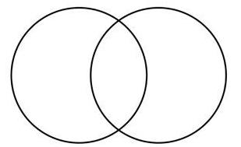
__________________________________________
_____________________
_____________________
_____________________
_____________________
_____________________
_____________________
__________________________________________
_____________________
_____________________
_____________________
_____________________
_____________________
__________________________________________
_____________________
_____________________
_____________________
_____________________
_____________________
__________________________________________
_____________________
_____________________
_____________________
_____________________
_____________________
_____________________
_____________________
_____________________
_____________________
_____________________
_____________________

__________________________________________
_____________________
_____________________
_____________________
_____________________
_____________________
_____________________
__________________________________________
_____________________
_____________________
_____________________
_____________________
_____________________
__________________________________________
_____________________
_____________________
_____________________
_____________________
_____________________
__________________________________________
_____________________
_____________________
_____________________
_____________________
_____________________
_____________________
_____________________
_____________________
_____________________
_____________________
_____________________

Similarities of Factual and Subjective Information

B. Why do we need to classify the information used by the author in giving reasons or evidence?

________________________________________________________________________________________________________________________________________________________________________________________________________________________________________________________________________________________________________________________________________

What I Can Do

Activity 7: Writing an Essay
Directions: Assess your learning by writing a paragraph using factual information and subjective information in giving reasons or evidence. You can choose the type of information you will use in discussing your topic. Below are suggested topics that you can choose from. You will be rated with the rubrics provided. You can use additional sheet of paper if needed.

Suggested topics:
- Cigarette smoking is dangerous to your health
- A person that you admire the most
- A place where you would like to live your whole life
- The job you dream.
- Smartphone users in the Philippines
- Most used social media platform in the Philippines
- Other topics you want to write

CRITERIA | 10 points | 8 points | 6 points
FOCUS/  MAIN POINT | Information clearly relates to the main topic. It includes 3 information and/or reasons. | Information clearly relates to the main topic. It includes 1-2 information and/or reasons only. | Information clearly relates to the main topic. No factual information and/or reasons are given.
ORGANIZATION | Information is very organized with well-constructed paragraphs and sentences. | Information is organized, but paragraphs are not well-constructed. | The information is not organized.
LANGUAGE CONVENTION | The learner submits the output following correct spelling, punctuation, capitalization, etc. | The learner submits the output with 3-5 errors in spelling, punctuation, capitalization, etc. | The learner submits the output with 6 or more errors in spelling, punctuation, capitalization, etc.
TOTAL |  |  | /30

________________________________
(TITLE)

Assessment

Let us check how well you have mastered the lesson in this module.

Directions: Read each item below and write the letter of the correct answer.

_____1. Ana is tasked to write about “Percentage of Enrollment in the New Normal in
your school.” What type of information does she need?
A. factual C. ideal
B. subjective D. creative

_____2. Which of the following materials uses factual information as basis for evidence
or reason in writing?
A. encyclopedias, almanacs, government resources, or statistics
B. vlogs, social media, non-scholarly books or book reviews
C. vlogs, almanacs, encyclopedias, social media
D. encyclopedias, almanacs, government resources, social media

_____3. Which among the following choices is an example of a statement based on
factual information?
A. A student must top all his subjects in class.
B. A government should have a leader.
C. A teacher alone will teach values to the students.
D. A school principal provides financial support to all students.

_____4. Which among the following choices is an example of a statement that uses
subjective information?
A. Rodrigo R. Duterte is the current president of the Philippines.
B. Her friend Eimee Werble is the most beautiful lady in the Philippines.
C. Manila is the capital of the Philippines.
D. Leonor Briones is the Secretary of the Department of Education.

For items 5-7, read the text below.
Official Statement on the Opening of Classes

“As per the memorandum, the President has given approval to the recommendation of DepEd. Thus, we will implement such a decision to defer school opening to October 5 pursuant to Republic Act No. 11480. We shall use the deferment to provide relief to the logistical limitations faced by the areas placed under MECQ and to fill in the remaining gaps of the school opening that we are currently addressing.”

Source: https://www.deped.gov.ph/2020/08/14/official-statement-on-the-opening-of-classes/

_____5. What type of information is used in the text?
A. factual C. analytical
B. subjective D. creative

_____6. In the text above, the word deferment refers to?
A. Closure C. Cancellation
B. Postponement D. Opening

_____7. Which of the following reasons discussed in the implementation of the
decision to defer school opening to October 5 is NOT included in the official
statement released by the DepEd?
A. To provide relief to the logistical limitations faced
B. To fill in the remaining gaps of the school
C. To comply pursuant to Republic Act No. 11480
D. To extend the schools BRIGADA program

Read the text below to answer items 8-9.
Facebook: A Waste of Time

Facebook is one of the most popular social media sites used daily by millions of people around the world. The advancement of technology has great impact on Facebook letting its users access the site anywhere, anytime and without limit. This situation has negative effects to its users unknowingly.
First, Facebook users spend a lot of their precious time by doing unbeneficial activities such as stalking people, and chatting unnecessary things to their friends. Next, users may be involved in various cybercrimes, such as hacking or phishing. Lastly, Facebook can cause family relationship to be restrained since quality time with family is reduced.
This popular social media site is a good platform for recreation but mostly it is a waste of time.

_____8. What type of information is used in the text?
A. Factual C. Analytical
B. Subjective D. Creative

_____9. Do you think the author’s reasoning is factual? Why or why not?
A. Yes, because the author stated reasons that are true in experience.
B. Yes, because there is an in-depth discussion to the claims.
C. No, because there are no research and statistics involved.
D. No, because there are pieces of evidence to the claims.

_____10. Why do we need to analyze the type of information used by the author in
giving reasons and evidence in the text?
A. To understand the purpose of the text
B. To lay critical judgments
C. To give arguments
D. To create a debate

Answer Key

What I Know
Activity 1: PRE-TEST
- A
- D
- C
- A
- A

What’s In
Activity 2: Determine Relevance
Statement #3: This statement talks about plants while the rest of the statements are about volcanoes and volcanic eruptions.

Activity 3: Observing the Text
1. The reading selection A talks about then President Obama’s address. He entails his reasons about why the Democrats and Republicans can work together. He gave several reasons using facts.
2. The reading selection B presents how she celebrates her crown as a black woman. She uses her own opinion and judgments on how she can embrace and represent it with power and respect.
3. Reading selection A uses factual information while reading selection B uses subjective information.

What’s More
Activity 4: Validate Info
1. Subjective – Answers may vary.
2. Factual - Answers may vary.
3. Subjective - Answers may vary.
4. Subjective - Answers may vary.
5. Factual - Answers may vary.

Activity 5: Identifying Information in the text
Answers may vary.

What I Have Learned
Activity 6: Compare and Contrast
Answers may vary.

What I Can Do
Activity 7: Writing an Essay
Answers may vary.

Assessment
1. A 6. B
2. A 7. D
3. B 8. B
4. B 9. C
5. A 10. A

References:

BOOK
Almonte, Liza R., Lerma L. Flandez, Nedia L. Agustan, Henone de Paz-Langutan, Dream Rose O. Malayo, Liberty A. Mangaluz, Elenita R. Miranda, Lito A. Palomar, Adelia Chua-Soliaban, and Grace Annette B. Soriano, A Journey Through Anglo-American Literature Learner’s Material, Pasig City: Vibal Group, Inc., 2014, 528-529

ONLINE SOURCES
Arkansas State University. “Understanding Information and Information Sources”. Date Accessed February 4, 2021, https://libguides.astate.edu/information/types#:~:text=Factual%20information%20is%20information%20that,%2C%20Almanacs%2C%20Government%20Resources%2C%20Statistics.

Ohio State University Libraries. 2- Types of Sources “Fact or Opinion.” Date Accessed, February 4, 2021, https://ohiostate.pressbooks.pub/choosingsources/chapter/fact-or-opinion/.

Lyda Dillard, 2021 Click2Houston.com, Dillard, February 3, 2021, https://www.click2houston.com/features/2021/02/03/personal-essay-a-black-womans-crown-should-be-celebrated/.

Department of Education. “Official Statement on the Opening of Classes.”. Accessed January 28, 2021. https://www.deped.gov.ph/2020/08/14/official-statement-on-the-opening-of-classes/.

DEVELOPMENT TEAM

Writers: Laurence F. Ferrer, Basilan National High School
Omar A. Mualim, Basilan National High School
Editor:

Language Editor:
Proofreader: Sayana S. Hasan, EPS
Illustrators:
Layout Artist: Marco David N. Codera
Management Team:
Julieto H. Fernandez, Ed. D., CESO VI
SDS-Isabela City
Maria Laarni T. Villanueva, Ed. D., CESE
ASDS-Isabela City
Henry R. Tura, CID Chief
Elsa A. Usman, LR Supervisor
Helen De Leon, EPS-English, Module Coordinator

10 multiple choice questions

Region IX: Zamboanga Peninsula Hymn – Our Eden Land
Here the trees and flowers bloom  Here the breezes gently Blow,  Here the birds sing Merrily,  The liberty forever Stays,  Here the Badjaos roam the seas  Here the Samals live in peace  Here the Tausogs thrive so free  With the Yakans in unity | Gallant men And Ladies fair  Linger with love and care  Golden beams of sunrise and sunset  Are visions you’ll never forget  Oh! That’s Region IX  Hardworking people Abound,  Every valleys and Dale  Zamboangueños, Tagalogs, Bicolanos, | Cebuanos, Ilocanos, Subanons, Boholanos, Ilongos,  All of them are proud and true  Region IX our Eden Land  Region IX  Our..  Eden...  Land...

My Final Farewell
Farewell, dear Fatherland, clime of the sun caress'd  Pearl of the Orient seas, our Eden lost!,  Gladly now I go to give thee this faded life's best,  And were it brighter, fresher, or more blest  Still would I give it thee, nor count the cost.  On the field of battle, 'mid the frenzy of fight,  Others have given their lives, without doubt or heed;  The place matters not-cypress or laurel or lily white,  Scaffold or open plain, combat or martyrdom's plight,  T is ever the same, to serve our home and country's need.  I die just when I see the dawn break,  Through the gloom of night, to herald the day;  And if color is lacking my blood thou shalt take,  Pour'd out at need for thy dear sake  To dye with its crimson the waking ray.  My dreams, when life first opened to me,  My dreams, when the hopes of youth beat high,  Were to see thy lov'd face, O gem of the Orient sea  From gloom and grief, from care and sorrow free;  No blush on thy brow, no tear in thine eye.  Dream of my life, my living and burning desire,  All hail ! cries the soul that is now to take flight;  All hail ! And sweet it is for thee to expire ;  To die for thy sake, that thou mayst aspire;  And sleep in thy bosom eternity's long night.  If over my grave some day thou seest grow,  In the grassy sod, a humble flower,  Draw it to thy lips and kiss my soul so,  While I may feel on my brow in the cold tomb below  The touch of thy tenderness, thy breath's warm power.  Let the moon beam over me soft and serene,  Let the dawn shed over me its radiant flashes,  Let the wind with sad lament over me keen ;  And if on my cross a bird should be seen,  Let it trill there its hymn of peace to my ashes. | Let the sun draw the vapors up to the sky,  And heavenward in purity bear my tardy protest  Let some kind soul o 'er my untimely fate sigh,  And in the still evening a prayer be lifted on high  From thee, 0 my country, that in God I may rest.  Pray for all those that hapless have died,  For all who have suffered the unmeasur'd pain;  For our mothers that bitterly their woes have cried,  For widows and orphans, for captives by torture tried  And then for thyself that redemption thou mayst gain  And when the dark night wraps the graveyard around  With only the dead in their vigil to see  Break not my repose or the mystery profound  And perchance thou mayst hear a sad hymn resound  'T is I, O my country, raising a song unto thee.  And even my grave is remembered no more  Unmark'd by never a cross nor a stone  Let the plow sweep through it, the spade turn it o'er  That my ashes may carpet earthly floor,  Before into nothingness at last they are blown.  Then will oblivion bring to me no care  As over thy vales and plains I sweep;  Throbbing and cleansed in thy space and air  With color and light, with song and lament I fare,  Ever repeating the faith that I keep.  My Fatherland ador'd, that sadness to my sorrow lends  Beloved Filipinas, hear now my last good-by!  I give thee all: parents and kindred and friends  For I go where no slave before the oppressor bends,  Where faith can never kill, and God reigns e'er on high!  Farewell to you all, from my soul torn away,  Friends of my childhood in the home dispossessed!  Give thanks that I rest from the wearisome day!  Farewell to thee, too, sweet friend that lightened my way; Beloved creatures all, farewell! In death there is rest!

I Am a Filipino, by Carlos P. Romulo
I am a Filipino–inheritor of a glorious past, hostage to the uncertain future. As such I must prove equal to a two-fold task–the task of meeting my responsibility to the past, and the task of performing my obligation to the future.  I sprung from a hardy race, child many generations removed of ancient Malayan pioneers. Across the centuries the memory comes rushing back to me: of brown-skinned men putting out to sea in ships that were as frail as their hearts were stout. Over the sea I see them come, borne upon the billowing wave and the whistling wind, carried upon the mighty swell of hope–hope in the free abundance of new land that was to be their home and their children’s forever.  I am a Filipino. In my blood runs the immortal seed of heroes–seed that flowered down the centuries in deeds of courage and defiance. In my veins yet pulses the same hot blood that sent Lapulapu to battle against the first invader of this land, that nerved Lakandula in the combat against the alien foe, that drove Diego Silang and Dagohoy into rebellion against the foreign oppressor.  The seed I bear within me is an immortal seed. It is the mark of my manhood, the symbol of dignity as a human being. Like the seeds that were once buried in the tomb of Tutankhamen many thousand years ago, it shall grow and flower and bear fruit again. It is the insignia of my race, and my generation is but a stage in the unending search of my people for freedom and happiness. | I am a Filipino, child of the marriage of the East and the West. The East, with its languor and mysticism, its passivity and endurance, was my mother, and my sire was the West that came thundering across the seas with the Cross and Sword and the Machine. I am of the East, an eager participant in its spirit, and in its struggles for liberation from the imperialist yoke. But I also know that the East must awake from its centuried sleep, shake off the lethargy that has bound his limbs, and start moving where destiny awaits.  I am a Filipino, and this is my inheritance. What pledge shall I give that I may prove worthy of my inheritance? I shall give the pledge that has come ringing down the corridors of the centuries, and it shall be compounded of the joyous cries of my Malayan forebears when first they saw the contours of this land loom before their eyes, of the battle cries that have resounded in every field of combat from Mactan to Tirad Pass, of the voices of my people when they sing:  “I am a Filipino born to freedom, and I shall not rest until freedom shall have been added unto my inheritance—for myself and my children and my children’s children—forever.”

