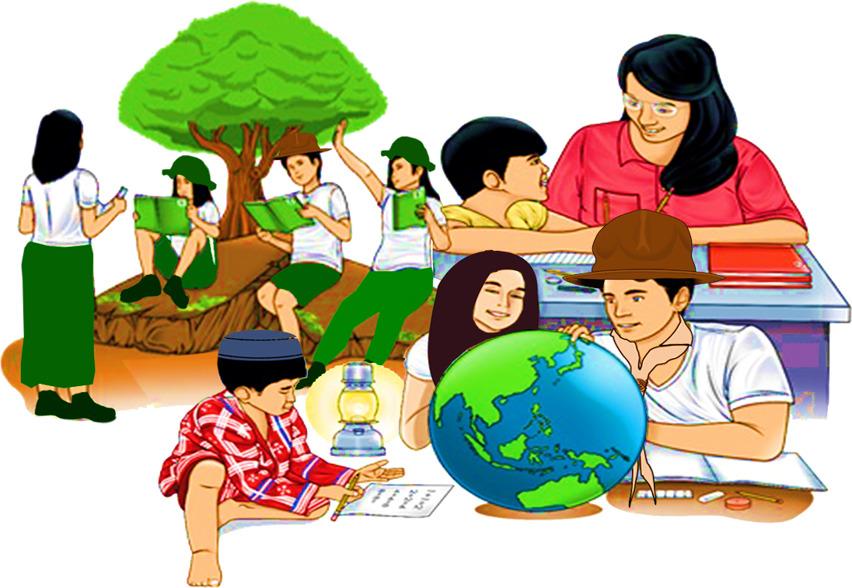
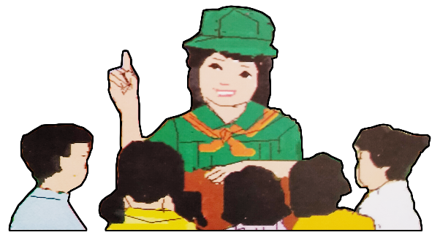
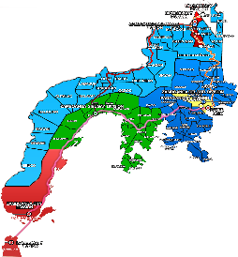

Quarter 4 – Module 4
Ways to Expand Definition of Words
ENGLISH
Name of Learner: ___________________________
Grade & Section: ___________________________
Name of School: ___________________________
10

Zest for Progress
Zeal of Partnership
Republic of the Philippines
Department of Education
Regional Office IX, Zamboanga Peninsula

What I Need to Know KKKKKKKKKKkkkkkkknKNOW

In communication, you sometimes failed to convey the accurate meaning of a word. Hence, it is essential to expand definition of words to explain complex terms, abstract concepts, controversial terms, unfamiliar and broad terms, and vague ideas that go beyond certain basics before you can attain the accuracy.

Thus, this module contains the ways to expand definition of words in different situations to enrich your comprehension and your ability to express yourself -- both in speech and in writing.

This module contains the lesson that will lead you to:

Learning Competency: Give the expanded definition of words
( EN10V- IIIa-13.9 )

After going through this module, you are expected to:

- Identify ways to expand definition of words; and
- Use the expanded definition of words in sentences and paragraphs.

What I Know

Activity 1: A Quick Check

A. Directions: Read and understand the selection carefully. Answer the questions that follow by encircling the letter of your answer.

Walk with Nature

To live in God’s wondrous creation is not only a blessing but an opportunity to be thankful for. Oftentimes, we tend to ignore the magic it brings us, but let us not forget that what it offers generate a great change. A change that surely makes a difference on our very own existence.

- The following choices relate to the word creation EXCEPT:

A. Idea C. God’s gift
B. Blessing D. Magic

- Which of the following choices DOES NOT promote and preserve God’s creation?

A. Everybody must be responsible to take care of the God’s creation.
B. Everybody must be one in sharing thoughts to save God’s creation.
C. Everybody must be dependent to the LGU to take care of God’s creation.
D. Everybody must be optimistic to take a part in saving God’s creation.

- What does the magic of nature convey to generate a great change?

A. A change to accept the tasks to fulfill the obligation
B. A change to make a difference for any existence
C. A change to live or self-satisfaction
D. A change to help others for your own benefit

- Which of the following statements expresses negativity about God’s creation?

A. God’s creation is a blessing to be thankful.
B. God’s creation is an opportunity to share.
C. God’s creation is a way to change.
D. God’s creation is a big problem for me.

- Does God’s wondrous creation consider a great magic to humanity?

A. Yes, it is.
B. No, it doesn’t offer great opportunity to discover.
C. Yes, it generates a great change.
D. No, it doesn’t generate a great change.

B. Directions: Write a sentence that describes each picture.

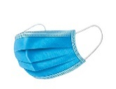

- _________________________________________________

_________________________________________________

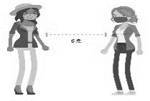

- _________________________________________________

__________________________________________________
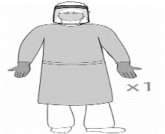

__________________________________________________

What’s In

Activity 2

Directions: Complete the statements below to state your point of view on nature’s gift to us.
- I feel that nature is ____________________________________________________________

- I believe that nature is _________________________________________________________

What’s New

Activity 3: Complete me

Directions: It is not enough to find out the meaning of a word. Expanding your definition of word is important for comprehension. In order to gain clear understanding of words, supply the missing parts in the box.

- Magical Word
PANDEMIC
It reminds me of ___________________________________________________________

It actually means ___________________________________________________________

Activity 4.: Act it Out

A. Directions: Read the article in the box. Then, answer the questions by giving your views about pandemic. Use the graphic organizer to write your answers.

Coronaviruses are a family of viruses that can cause illnesses such as the common cold, severe acute respiratory syndrome (SARS) and Middle East respiratory syndrome (MERS).
Most of the time, it spreads when a sick person coughs or sneezes. They can spray droplets as far as 6 feet away. If you breathe them in or swallow them, the virus can get into your body. You can also get the virus from touching your mouth, nose, possibly your eyes.
COVID-19 and flu are both contagious respiratory illnesses, but they are caused by different viruses. COVID-19 is caused by infection with a new coronavirus (called SARS-CoV-2), and flu is caused by infection with influenza viruses. Both COVID-19 and flu can have varying signs and symptoms, ranging from no symptoms to severe symptoms. Common symptoms that COVID-19 and flu share include: fever or feeling feverish/ chills, cough, shortness of breath, fatigue, sore throat, runny nose, muscle pain, and headache. Some people may have vomiting and diarrhea, though this is more common in children than adults. Flu viruses can cause mild to severe illnesses, including common signs and symptoms mentioned. However, COVID-19 seems to cause more serious illnesses in some people. Other signs and symptoms of COVID-19, different from flu, may include change in or loss of taste or smell.
The spread of COVID-19 and other coronaviruses can be prevented by taking these steps:
- Stay at a distance of at least one meter from other people.
- Wash hands regularly with soap and water. If that's not possible, use hand sanitizer or disinfecting wipes.
- Avoid touching your face.
- Monitor daily for symptoms such as fever, cough and shortness of breath.

.

1.In what way can a person be infected by the virus? _________________________________________________________________
_________________________________________________________________

2. How does COVID -19 differ from flu? __________________________
__________________________
3. What are the three common symptoms of corona virus?
___________________________
___________________________

COVID-19

4. How to prevent the transmission of COVID-19?
_________________________________________________________________
_________________________________________________________________

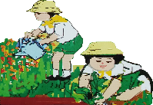
What Is It

Expanded definition may explain the word’s etymology or historical roots, describes sensory characteristics of something (how it looks, feels, sounds, taste, smells) identifies its parts, indicates how something is used, explains what is not , provides an example of it, and /or notes similarities or differences between this term and other words or things. It comes in the form of additional sentences that support a formal definition which becomes the topic sentence of a paragraph.

The Three Ways of Expanding a Definition into a Paragraph
1. Expanding by Giving an Example
It helps you illustrate and describe by providing clear, specific, extra facts or information to the word and clarify an abstract and formless concept. You can use these signals for concrete examples: for example, for instance, such as, similar to, specifically, to illustrate, much like, in the same way as.
Here are examples on how to expand definition by giving examples:
A. In a definition essay about “kindness,” for example, you could write about an act of kindness you recently witnessed. Someone who mows the lawn of an elderly neighbor is a valid example, just as someone who gave you an encouraging word when you were feeling down.
B. Speed is a concept that marks our time. Everybody is in hurry to go somewhere. Industry for instance, is constantly demanding new inventions that will speed up production so that the constant cry of bosses to the workmen is speed it up! The maker of automobiles, for example, boasts the newest type of a car which is faster than the old model. In the same way the shoppers push and shove each other all about the counters much likely when all are in a hurry to get something. And, in the same way, people who are going to school, shop, or office rush breathlessly to do important tasks.
2. Expanding by Comparing and Contrasting
It shows how the subject is like /unlike or how the topic differs or is similar from others in the same class. They are used to explain two subjects and help you decide between two options. With the signal words: also, although and, as well as, better, bigger than, but, compared with, different from, either however, on the other hand, similar to, while, and yet.
Here are examples on how to expand definition by comparing and contrasting:
A. Many people have never heard of the term “confrere,” for instance. One basic definition is “a fellow member of a profession, fraternity, etc.” As such, you could compare “confrere” with “colleague,” which is a similar yet more familiar concept.
B. Speed is a concept that marks our day. Sluggishness is out. Speed is demanded by industry which is constantly on the look – out for new inventions. Sluggishness is penalized, especially in industries where compensation depends upon output. Speed is the attractive come – on for short – term courses in cooking, computerizing, sewing, diving, learning, learning a new language, and others. The slower long term courses are not so appealing. Instant coffee is usually preferred to coffee that must be boiled yet. Yes, speed is the word for the day.

3. Expanding by Describing a Process
It gives a series of instructions to make or produce something. It joins with the use of linking verbs and common signals such as and, then, and then, before, during, finally, first, lastly, today, since, and immediately.
Here is an example on how to expand definition by describing a process:
You have to beat first the eggs then pour them into the pan. Turn the heat down and use your fork to mix slowly. And then just put a knife underneath and flip the omelet over.
What’s More

Activity 5: My Treasure

Directions: Recall the three ways to expand definition of words then supply the needed ideas to complete the prompt.

I realized that in life, successful learners…
- Definition by Example
_____________________________________________________________________________________________________
2. Definition by Comparison and Contrast
______________________________________________________________________________________________________
- Definition by Process
______________________________________________________________________________________________________

Activity 6: Challenge Me

Directions: Take the challenge by expanding the definition of words. Do this in a short paragraph. A rubric is provided as your guide in writing.
Challenge 1
Education Amid Pandemic

Expand by Giving an Example
__________________________________________________________________________________________________________________________________________________________________________________________________________________________________________________________________________________________________________________________________________________

Expand by Comparing and Contrasting
_________________________________________________________________________________________________________________________________________________________________________________________________________________________________________________________________________________________________________________________________________________________________________________________________

Challenge 2
Reading and Writing

Challenge 3
Facing too Much School-related Tasks

Expanding by Describing a Process
________________________________________________________________________________________________________________________________________________________________________________________________________________________________________________________________________________________________________________________________________________________________________________________________________

Rubrics in Writing a Paragraph
 | Excellent (15 pts) | Good (10pts) | Poor (5 pts)
Topic Sentence | Main topic is clearly stated in a complete opening sentence with correct sentence structure. | Main topic is stated in an opening sentence but sentence structure is not correct. | Main topic is not clearly stated. Sentence structure is not correct.
Organization of Ideas | Paragraph is well-organized, | Paragraph is somewhat organized. | Paragraph needs to be better organized.
Content | Information clearly relates to the main idea. | Information is somewhat related to the main idea. | Information is not related to the main idea.
Word Choice | Word choice is creative and enhances the ideas. | Word choice enhances the ideas. | Word choice is limited.
Grammar | There are no errors in grammar. | There are few errors in grammar. | There are several errors in grammar.
Total Points

What I Have Learned

Activity 7: Fill it out

A. Directions: Share your insights from this module by completing the ideas.

- I have learned that expanded definition of words can ____________________________
_________________________________________________________________________.

- The three ways of expanded definition of words:
A. Expanding by giving an example means ______________________________________ __________________________________________________________________________.
B. Expanding by comparing and contrast means __________________________________
__________________________________________________________________________.
C .Expanding by process means ___________________________________________________ __________________________________________________________________________.

B. Directions: Complete the Venn diagram by saying something about yourself and nature.

Love for Nature
______________
______________
______________
_____
Love for Self
______________
______________
______________
_____
Similarities
__________________
______________
______________
_____

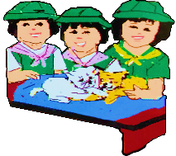

What I Can Do

Activity 8: My Paradise
- Directions: Analyze the picture. Choose any of the three ways of expanding definition of words to describe or define the picture. Be guided with the rubrics.

__________________________________________________________________________
__________________________________________________________________________
__________________________________________________________________________
__________________________________________________________________________
__________________________________________________________________________
__________________________________________________________________________
__________________________________________________________________________
__________________________________________________________________________
__________________________________________________________________________
__________________________________________________________________________
__________________________________________________________________________
__________________________________________________________________________
__________________________________________________________________________
__________________________________________________________________________
__________________________________________________________________________
__________________________________________________________________________
__________________________________________________________________________
__________________________________________________________________________
__________________________________________________________________________
__________________________________________________________________________

Category | EXEEDS EXPECTATION  15 | SATISFACTORY  10 | POOR  5
Organization of Thought | Information is presented in order | Information is presented in order but not totally in order. | Information is poorly written.
Content | Information clearly relates to the main idea. | Information is somewhat related to the main idea. | Information is not related to the main idea.
Word Choice | Word choice is creative and enhances the ideas. | Word choice enhances the ideas. | Word choice is limited.
Grammar | There are no errors in grammar. | There are few errors in grammar. | There are several errors in grammar.
Total points
Rubrics in Formulating Expanded Definition

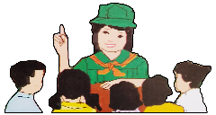
Assessment

Test I- Multiple Choice

Directions: Read each item carefully. Choose the letter of the best answer and write it on the space provided before each number.

_________1. Which of the following choices best expresses the use of expanded definition by giving examples on the theme “pandemic”?
- Routinely operating agencies and institutions such as the education, business, and industry sectors decrease workforce but receives increase loads of work.
- Know-hows of technology-based modes of communication and interaction became a primary skill that every workforce.
- Significance of performing proper basic health care steps had been highlighted and
well-spread to the public.
- Issues on gaps and flaws in government protocols during pandemic had been escalated to be solved and addressed in a limited span of time.
_________ 2. Which way of expanding definition of words is best suited for the line below?
“Industry for instance is constantly demanding new inventions that will speed up production.”

- Expanding by Example C. Expanding by Process
- Expanding by Comparison and Contrast D. Expanding by Motivation

_________ 3. Which of the following ways of expanding definition is used in the statement below?
Basic health care procedures before were not as well strictly publicized and implemented as when the COVID-19 bombarded the globe.

A. Expanding by giving an example
B. Expanding by comparing and contrasting
C. Expanding by describing a process
D. Expanding by giving example and describing
_________ 4. This is the common signal in comparing and contrasting ideas for clarification and better comprehension.
A. Different from C. For example
B. Compared with D. Expanding by

_________ 5. Which of the following statements gives the best expanded definition of the line, “Health care providers and front liners are overworked.”?
A. Health care providers and other identified front liners were stretched on both hours and extension of work to provide effective and efficient service to the public.
B. Health care providers and other identified front liners developed mental health illness due to the
heavy loads of work.
C. Health care providers and other identified front liners were seemingly given special treatment.
D. Health care providers and other identified front liners were not expected to always perform their
duties 24/7.

_________ 6. Which of the ways of expanding definition of words is applied in the lines below?
“You have first wash your hands with soap thoroughly. Then, apply the sanitizer to be clean safe from virus.”

A. Expanding by Example C. Expanding by Process
B. Expanding by Comparison and Contrast D. Expanding by Motivation

_________ 7. What is the correct way to expand ideas on a topic used in the sentence below?
Education, for instance, is an effective platform to instill awareness and values to the youth which when developed, becomes a motivation to positively act towards it.

A. Expanding by giving an example
B. Expanding by comparing and contrasting
C. Expanding by describing a process
D. Expanding by giving example and describing
_________ 8. How do you expand the definition of word to enrich comprehension and express yourself effectively?
A. Expanding by summary, analyzation, sample
B. Expanding by example, comparison and contrast, and process
C. Expanding by process, summary, Conclusion
D. Expanding by Conclusion, Contrast/comparison/ summary

_________ 9. Which of the choices DOES NOT denote the signal for expanded words by examples?

A. However
B. For instance
C. Then
D. Also

_________ 10. The following choices use expanded definition by describing the process of the socio-economic difference in communities EXCEPT:
A. On the height of the virus spread, Mrs. Cruz, a public-school teacher, shifts from developing lesson plans into modules to answer the demand of suspending face-to-face classes.
B. On the height of the virus spread, Mang Lando, a pedicab driver had to change career into being a garbage collector, with which the income was lesser yet the work is tougher. On the other hand, Mr. Ramos continued to work as bank manager working 3 days a week only instead of 5, receiving the same amount of compensation.
C. On the height of the virus spread, Jenny, daughter of a taxi driver, always submits her module on the set due date even she has to go to nearby internet shop to submit those. On the other hand, Marie, daughter of a branch manager was often reprimanded by their teacher for submitting late modules even if she has the internet connection at home.
D. On the height of the virus spread, Candice, a housewife started to develop an online business. First, she asked for the business permit to make her business legal. Then, she posted her item by Facebook page. Finally, she was able to have an extra income.

Additional Activity
(Optional)

Directions: Complete the following phrases in accordance to your status in life. Use the three (3) ways to expand definition of terms and emphasize their common signals.
- I am a student …
I have ________________________________________________________________
I can _________________________________________________________________
I will _________________________________________________________________

- I am a youth …
I have ________________________________________________________________
I can _________________________________________________________________
I will _________________________________________________________________

- I am a daughter/son …
I have ________________________________________________________________
I can _________________________________________________________________
I will _________________________________________________________________

ANSWER KEY
What I Know  Activity 1  A.  1.A  2.C  3.B  4.D  5.C  B.  Answers may vary. | What’s In  Activity 2  Answers may vary. | What’s New Activity 3  Answers may vary. | What’s New Activity 4  Answers may vary. | What’s More  Activity 5  Answers may vary.
What’s More  Activity 6  Answers may vary | What I Have Learned Activity 7  Answers may vary. | What I Can Do  Activity 8  Answers may vary. | Assessment  1.A  2.A  3.B  4.B  5.A  6.C  7.A  8.B  9.A  10.B | Additional Activity  Answers may vary.

References:

Books

Almonte, Liza R., Flandez, Lerma L., Hermosa, Angelina Lourdes, Nedia Lagustan, Liberty A. Mangaluz, Elenita R. Miranda, Paul Anthony B. Mendoza, Lito A. Palomar, Grace B. Annette Barradas-Soriano, and Karen B. Villanueva, Celebrating Diversity through World Literature. Pasig City: Rex Book Store, Inc. 2015, 274, 290, 296, 308, 312, 315-316, 333, 375-376.

Bermudez, Virginia , Ed.D, Josephine Cruz Ph.D., Eugenia Gorgon Ed.D, Remedios Nery, and Milagros San Juan Ph.D. English Expressways. Quezon City: SD Publications, Inc. 2010.

Online Sources

“Coronavirus Disease COVID-19 Pandemic.” UNDP, January 30, 2021, https://www.undp.org/content/undp/en/home/coronavirus.html.

“Signal Words: Types, Functions and Examples”, Akademia, accessed January 29, 2021, https://akademia.com.ng/signal-words-types-functions-and-examples/.

“Types of Definitions Used in Technical Writing - Writing Class (Video).” 2021a. Study.Com. Accessed February 1, 2021, https://study.com/academy/lesson/types-of-definitions-used-in-technical-writing.html.

‘WebMD, “Coronavirus and COVID-19: What You Should Know.” WebMD., accessed February 9, 2021, https://www.webmd.com/lung/coronavirus.

DEVELOPMENT TEAM

Writers: Clarisel DS. Ismael, Basilan National High School
Nhor Haima S. Hassim, Geras Integrated School
Editor:

Language Editor:
Proofreader: Violeta M. Sta. Elena, EPS
Illustrators:
Layout Artist: Joyce Ethel L. Sienes
Management Team:
Julieto H. Fernandez, Ed. D., CESO VI
SDS-Isabela City
Maria Laarni T. Villanueva, Ed. D., CESE
ASDS-Isabela City
Henry R. Tura, CID Chief
Elsa A. Usman, LR Supervisor
Helen De Leon, EPS-English, Module Coordinator

Region IX: Zamboanga Peninsula Hymn – Our Eden Land
Here the trees and flowers bloom  Here the breezes gently Blow,  Here the birds sing Merrily,  The liberty forever Stays,  Here the Badjaos roam the seas  Here the Samals live in peace  Here the Tausogs thrive so free  With the Yakans in unity | Gallant men And Ladies fair  Linger with love and care  Golden beams of sunrise and sunset  Are visions you’ll never forget  Oh! That’s Region IX  Hardworking people Abound,  Every valleys and Dale  Zamboangueños, Tagalogs, Bicolanos, | Cebuanos, Ilocanos, Subanons, Boholanos, Ilongos,  All of them are proud and true  Region IX our Eden Land  Region IX  Our..  Eden...  Land...

My Final Farewell
Farewell, dear Fatherland, clime of the sun caress'd  Pearl of the Orient seas, our Eden lost!,  Gladly now I go to give thee this faded life's best,  And were it brighter, fresher, or more blest  Still would I give it thee, nor count the cost.  On the field of battle, 'mid the frenzy of fight,  Others have given their lives, without doubt or heed;  The place matters not-cypress or laurel or lily white,  Scaffold or open plain, combat or martyrdom's plight,  T is ever the same, to serve our home and country's need.  I die just when I see the dawn break,  Through the gloom of night, to herald the day;  And if color is lacking my blood thou shalt take,  Pour'd out at need for thy dear sake  To dye with its crimson the waking ray.  My dreams, when life first opened to me,  My dreams, when the hopes of youth beat high,  Were to see thy lov'd face, O gem of the Orient sea  From gloom and grief, from care and sorrow free;  No blush on thy brow, no tear in thine eye.  Dream of my life, my living and burning desire,  All hail ! cries the soul that is now to take flight;  All hail ! And sweet it is for thee to expire ;  To die for thy sake, that thou mayst aspire;  And sleep in thy bosom eternity's long night.  If over my grave some day thou seest grow,  In the grassy sod, a humble flower,  Draw it to thy lips and kiss my soul so,  While I may feel on my brow in the cold tomb below  The touch of thy tenderness, thy breath's warm power.  Let the moon beam over me soft and serene,  Let the dawn shed over me its radiant flashes,  Let the wind with sad lament over me keen ;  And if on my cross a bird should be seen,  Let it trill there its hymn of peace to my ashes. | Let the sun draw the vapors up to the sky,  And heavenward in purity bear my tardy protest  Let some kind soul o 'er my untimely fate sigh,  And in the still evening a prayer be lifted on high  From thee, 0 my country, that in God I may rest.  Pray for all those that hapless have died,  For all who have suffered the unmeasur'd pain;  For our mothers that bitterly their woes have cried,  For widows and orphans, for captives by torture tried  And then for thyself that redemption thou mayst gain  And when the dark night wraps the graveyard around  With only the dead in their vigil to see  Break not my repose or the mystery profound  And perchance thou mayst hear a sad hymn resound  'T is I, O my country, raising a song unto thee.  And even my grave is remembered no more  Unmark'd by never a cross nor a stone  Let the plow sweep through it, the spade turn it o'er  That my ashes may carpet earthly floor,  Before into nothingness at last they are blown.  Then will oblivion bring to me no care  As over thy vales and plains I sweep;  Throbbing and cleansed in thy space and air  With color and light, with song and lament I fare,  Ever repeating the faith that I keep.  My Fatherland ador'd, that sadness to my sorrow lends  Beloved Filipinas, hear now my last good-by!  I give thee all: parents and kindred and friends  For I go where no slave before the oppressor bends,  Where faith can never kill, and God reigns e'er on high!  Farewell to you all, from my soul torn away,  Friends of my childhood in the home dispossessed!  Give thanks that I rest from the wearisome day!  Farewell to thee, too, sweet friend that lightened my way; Beloved creatures all, farewell! In death there is rest!

I Am a Filipino, by Carlos P. Romulo
I am a Filipino–inheritor of a glorious past, hostage to the uncertain future. As such I must prove equal to a two-fold task–the task of meeting my responsibility to the past, and the task of performing my obligation to the future.  I sprung from a hardy race, child many generations removed of ancient Malayan pioneers. Across the centuries the memory comes rushing back to me: of brown-skinned men putting out to sea in ships that were as frail as their hearts were stout. Over the sea I see them come, borne upon the billowing wave and the whistling wind, carried upon the mighty swell of hope–hope in the free abundance of new land that was to be their home and their children’s forever.  I am a Filipino. In my blood runs the immortal seed of heroes–seed that flowered down the centuries in deeds of courage and defiance. In my veins yet pulses the same hot blood that sent Lapulapu to battle against the first invader of this land, that nerved Lakandula in the combat against the alien foe, that drove Diego Silang and Dagohoy into rebellion against the foreign oppressor.  The seed I bear within me is an immortal seed. It is the mark of my manhood, the symbol of dignity as a human being. Like the seeds that were once buried in the tomb of Tutankhamen many thousand years ago, it shall grow and flower and bear fruit again. It is the insignia of my race, and my generation is but a stage in the unending search of my people for freedom and happiness. | I am a Filipino, child of the marriage of the East and the West. The East, with its languor and mysticism, its passivity and endurance, was my mother, and my sire was the West that came thundering across the seas with the Cross and Sword and the Machine. I am of the East, an eager participant in its spirit, and in its struggles for liberation from the imperialist yoke. But I also know that the East must awake from its centuried sleep, shake off the lethargy that has bound his limbs, and start moving where destiny awaits.  I am a Filipino, and this is my inheritance. What pledge shall I give that I may prove worthy of my inheritance? I shall give the pledge that has come ringing down the corridors of the centuries, and it shall be compounded of the joyous cries of my Malayan forebears when first they saw the contours of this land loom before their eyes, of the battle cries that have resounded in every field of combat from Mactan to Tirad Pass, of the voices of my people when they sing:  “I am a Filipino born to freedom, and I shall not rest until freedom shall have been added unto my inheritance—for myself and my children and my children’s children—forever.”

