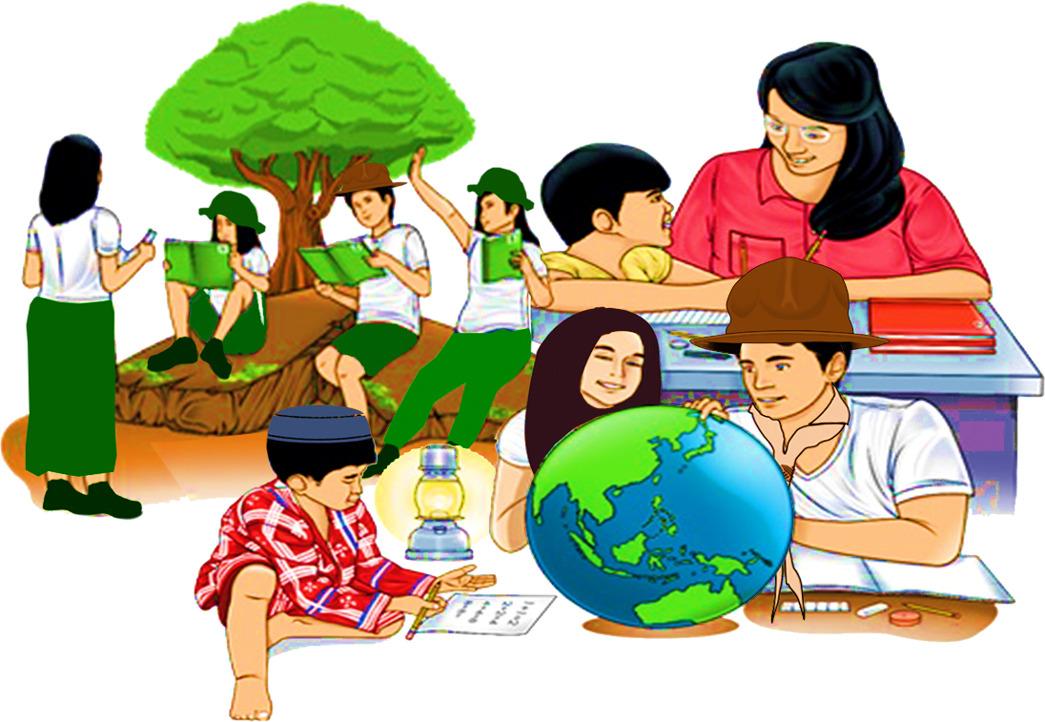
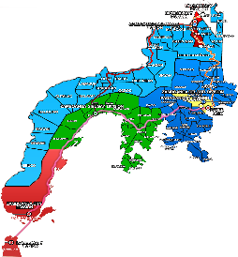

Quarter 4 – Module 8
Research Report

ENGLISH
Name of Learner: ___________________________
Grade & Section: ___________________________
Name of School: ___________________________
10

Zest for Progress
Zeal of Partnership
Republic of the Philippines
Department of Education
Regional Office IX, Zamboanga Peninsula

What I Need To Know KKKKKKKKKKkkkkkkknKNOW

Thinking and feeling alone will not do much in addressing societal concerns and in making a difference in our global society. UNESCO (www.unesco.org) forwards that being a global citizen means acquiring the “knowledge, tolerant, inclusive, secure and sustainable world.”

Through the help of tasks and activities in this module, as well as the knowledge you have learned in the previous lessons, you will surely hone your communication skills and improve your understanding of the target concept to compose a research report on a relevant social issue.

This module contains lesson that will lead you to:

Learning Competency: Compose a research report on a relevant social issue.
(EN10SS-IVe-2.3)

At the end of this module, you are expected to:

1. Write a research report on a relevant social issue; and
2. Apply the steps and tips in composing a research report.

What I Know
Activity 1
Directions: Read and answer the questions carefully. Choose the letter with the correct answer. Write your answer on the space provided.

_____1. What does the statement below imply?
The language of the report would be so clear and understandable.

- The report should use words that take into account the reader’s interest in reading the report.
- The report should use standard language for high intellectual readers.
- The report should have catchy introduction and well-explained title.
- The report should use universal language.

______2. Which among the following steps in writing a research report should be prepared first?
- Conduct research and take note.
- Make a plan.
- Choose a topic.
- Reread the report.

______3. Why is preparing outline important in writing a research report?
- This will provide the writer the information he or she needs.
- This will help the writer organize his or her notes and thoughts.
- This will guide the writer to come up with a successful result in writing project.
- This will help the organizer and reader to understand the explained title.

______4. Why do you need to include illustrations and visual representations in
your data?
- To make attractive and presentable
- To lend additional credibility to your systematic investigation
- To impress the reader of your creativity
- To make the information real and justifiable

_______5. Who will be the prospect readers of your report if it is written in simple
and relatable manner?
- Specialized audience
- General audience
- Common audience
- Foreign audience

What’s In

Activity 2
Directions: In this activity, use your prior knowledge and skills learned from the previous module to define the parts of research report in a concept map.

Introduction
________________________________________________________________________________________________________

Research Report

Conclusion
____________________________________________________________________________________________________
Body
________________________________________________________________________________________________________

What’s New

Activity 3: Be A Global Citizen
Directions: Read and understand the text below and answer the process questions that follow.

What Does It Mean to Be a Global Citizen?

At the Global Citizens’ Initiative, we say that a “global citizen” is someone who identifies with being part of an emerging world community and whose actions contribute to building this community’s values and practices.

To test the validity of this definition we examine its basic assumptions: (a) that there is such a thing as an emerging world community with which people can identify; and (b) that such a community that has a nascent set of values and practices.

Historically, human beings have always formed communities based on shared identity. Such identity gets forged in response to a variety human needs—economic, political, religion, and social. As group identities grow together, those who help them organize into communities, articulate their shared values, and build governance structures to support high beliefs.

Today, the forces of global engagement are helping some people identify as global citizens who have a sense of belongingness to a world community. This growing global identity in large part is made possible by the forces of modern information, communications, and transportations technologies. In increasing ways—these technologies are strengthening our ability to connect to the rest of the world—through the internet; through participation in the global economy; through the ways in which worldwide environmental factors play havoc with our lives; through the empathy we feel when we see pictures of humanitarian disasters in other countries; or through the ease with which we can travel and visit other parts of the world.

Those of us who ourselves as global citizens are not abandoning other identities, such as allegiances to our countries, ethnicities, and political beliefs. These traditional identities give meaning to our lives and will continue to help shape who we are. However, as a result of living in a globalized world, we understand that we have an added layer of responsibility; we also are responsible for being members of a worldwide community of people who share the same global identity that we have.

We may not yet be fully awakened to this new layer of responsibility, but it is there waiting to be grasped. The major challenge that we face in the new millennium is to embrace our global way of being and build a sustainable values-based community.

What might our community’s values be? They are the values that world leaders have been advocating for past 70 years and include human rights, environmental protection, religious pluralism, gender equity, sustainable worldwide economic growth, poverty alleviation, prevention of conflicts between countries, elimination of weapons of mass destruction, humanitarian assistance, and preservation of cultural diversity.

Since world War II, efforts have been undertaken to develop global policies and institutional structures that can support these enduring values. These efforts have been made by international organizations, sovereign states, transnational corporations, international professional associations, and others. They have resulted in a growing body of international agreements, treaties, statutes, and technical standards.

Yet, despite these efforts we have a long way to go before there is a global policy and institutional infrastructure that can support our emerging world community and the values it stands for. There are significant gaps of policy in many domains, large questions about how to get countries and organizations to comply with existing policy frameworks, issues of accountability and transparency and, most important of all from a global citizenship perspective, an absence of mechanisms that enable greater citizen participation in the institutions of global governance.

The Global Citizens’ Initiative sees the need for a cadre of citizen leaders who can play activist roles in efforts to build our emerging world community. Such global citizenship activism can take many forms, including advocating, at the local and global level for policy and programmatic solutions that address the global problems; participating in the decision-making processes of global governance organizations; adopting and promoting changes in behavior that help protect the earth’s environment; contributing to the world-wide humanitarian relief efforts; and organizing events that celebrate the diversity in world music and art, culture and spiritual traditions.

Most of us on the path of global citizenship are still somewhere at the beginning of our journey. Our eyes have been opened and our consciousness raised. Instinctively, we feel a connection with others around the world yet we lack the adequate tolls, resources, and support to act on our vision. Our ways of thinking and being are still colored by trapping of old allegiances and ways of seeing things that no longer are as valid they used to be. There is a longing to pull back the veil that keeps us from more clearly seeing the world as a whole and finding more sustainable ways of connecting with those who share our common humanity.

Questions:

- What does global citizenship mean?
_____________________________________________________________________________________________________________________________________________________________________________________________________________________________________________________________________________________________________________________________________________________________________________________________________________________________________________________________________________________________________________________________________________________________________________________

- How are you going to face the foremost challenge in the new millennium?
_______________________________________________________________________________________________________________________________________________________________________________________________________________________________________________________________________________________________________________________________________________________________________________________________________________________________________________________________________________________________________________________________________________________________________________________

- What have the world leaders been advocating for the past 70 years?
_______________________________________________________________________________________________________________________________________________________________________________________________________________________________________________________________________________________________________________________________________________________________________________________________________________________________________________________________________________________________________________________________________________________________________________________

- What does global citizenship entail?
_______________________________________________________________________________________________________________________________________________________________________________________________________________________________________________________________________________________________________________________________________________________________________________________________________________________________________________________________________________________________________________________________________________________________________________________

- How can you play your role as a global citizen?
_______________________________________________________________________________________________________________________________________________________________________________________________________________________________________________________________________________________________________________________________________________________________________________________________________________________________________________________________________________________________________________________________________________________________________________________

What Is It

How research report writing would be?
The purpose of the research report writing is to deliver the results of the research to the interested person as far as possible and publish it in a coherent way so that the reader understands the information. The reader can determine the rationale of the research study itself. So, while you write down your own research report, keep in mind the following factors well.

- The report will agree realistically. Its report would be real based on the data obtained in the study.
- It will be complete. The researcher should be aware that all the things are included as per purpose of the research study.
- It will be short as possible. This does not mean that it is necessary to summarize without discussing the necessary issues. It is big enough to discuss essential issues in details but short for unnecessary subject matters.
- The language of the report would be so clear and understandable. The report should use words that take into account the reader’s interest in reading the report.
- The researcher would be intellectually honest.
- The report would be readable so that the reader feels interested in reading it.

7 Steps to a Successful Research Report

- Choose a topic. It should be a subject that you can understand and one that interests you.
- Make a plan. Create a calendar together to map out the process.
- Check with teacher. You should double-check the topic with the teacher.
- Conduct research and take notes. You can use a range of resources—from books, periodicals, and the internet—to do this. Practice taking notes without copying word-for-word to reduce the risk of plagiarism.
- Outline the project. This will help you organize the notes and thoughts.
- Write the report. Use the outline as a road map.
- Edit and reread the report. Checking and correcting mistakes are the hallmarks of a good student.

Tips for Writing a Research Report

- Define the context for the report.
As is obtainable when writing an essay, defining your context for a research report would help you create a detailed yet concise document. This is why you need to create an outline before writing so that you do not miss out on anything.

- Define your audience.
Writing with your audience in mind is essential as it determines the tone of the report. If you are writing for a general audience, you would want to present the information in a simple and relatable manner. For a specialized audience, you would need to make use of technical and field-specific terms.

- Include significant findings.
The idea of a research report is to present some sort of abridged version of your systematic investigation. In your report, you should include irrelevant information while highlighting only the important data and findings.

- Include illustrations.
Your research report should include illustration and other visual representations of your data. Graphs, pie charts, and relevant images lend additional credibility to your systematic investigation.

- Choose the right title.
A good research report title is brief, precise, and contains keywords from the research. It should provide a clear idea of your investigation so that readers can grasp the entire focus of your research from the title.

- Proofread the report.
Before publishing the document, ensure that you give it a second look to authenticate the information. If you can, get someone else to go through the report, too, and you can also run it through proofreading and editing software.

What’s More

Activity 4: Think Globally, Act Locally
Directions: What does it mean to be a global citizen? Assess your global citizenship competencies by using the checklist below. Place a on the middle column to signify that you possess the indicated competency.

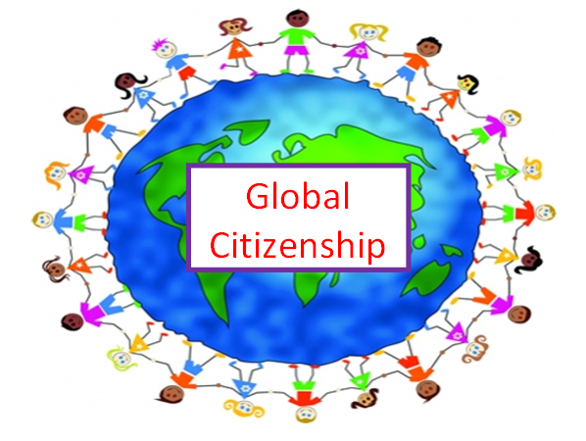 |  | As a global citizen I…
 |  | am aware of current global issues and trends
 |  | embody universal values, peace and human rights, diversity, justice, democracy, tolerance, and nondiscrimination
 |  | have cognitive skills for critical, creative and innovative thinking, problem solving, and decision making
 |  | have noncognitive skills such as empathy, openness to experiences and other perspectives, interpersonal/communicative skills and aptitude for networking and interacting with people of different backgrounds and origins
 |  | have behavioral capacities to launch and engage in proactive actions.

Activity 5: Write to Inspire
Directions: We have witnessed our community is facing different kinds of issues. An example is early marriage, either by choice or by parental marriage, we have seen the negative result of their preference.

As a young citizen of your community, how will you inspire your young fellowmen to pursue their education and keep believing in their dreams instead of marrying early?
Write your essay in the box provided. Use the rubrics as your guide in writing.

__________________________________________________________________________________________
___________________________________________________________________________________________________________________________________________________________________________________________________________________________________________________________________________________________________________________________________________________________________________
_________________________________________________________________________________________________________________________________________________________________________________________________________________________________________________________________________________
__________________________________________________________________________________________
_________________________________________________________________________________________________________________________________________________________________________________________________________________________________________________________________________________
__________________________________________________________________________________________
_________________________________________________________________________________________________________________________________________________________________________________________________________________________________________________________________________________
__________________________________________________________________________________________
_________________________________________________________________________________________________________________________________________________________________________________________________________________________________________________________________________________
__________________________________________________________________________________________
_________________________________________________________________________________________________________________________________________________________________________________________________________________________________________________________________________________
__________________________________________________________________________________________
_________________________________________________________________________________________________________________________________________________________________________________________________________________________________________________________________________________
__________________________________________________________________________________________
_________________________________________________________________________________________________________________________________________________________________________________________________________________________________________________________________________________
__________________________________________________________________________________________
_________________________________________________________________________________________________________________________________________________________________________________________________________________________________________________________________________________

Rubrics in writing the essay
Category | Points |  |  |  | Points
 | 10 | 8 | 6 | 4
Organization | Ideas are very organized with well-constructed paragraphs | Ideas are organized with well-constructed  paragraph | Ideas are organized but paragraphs are not well-constructed | The ideas appear disorganized
Quality of Ideas | Ideas clearly relates to the main topic. It includes several supporting details | Ideas clearly relates to the main topic. It provides 1-2 supporting details | Ideas clearly relates to the main topic. No details given | Ideas has little to do with main topic
Mechanics | No grammatical, spelling, or punctuations errors | Almost no grammatical, spelling, or punctuation errors | A few grammatical, spelling, or punctuation errors | Many grammatical, spelling, or punctuation errors
Total

Activity 6: Wordle It
Directions: Make a quick write-up of what you understand about being a global citizen. Create your own word cloud using the key words in your short write-up in the box provided. Look at the example below.
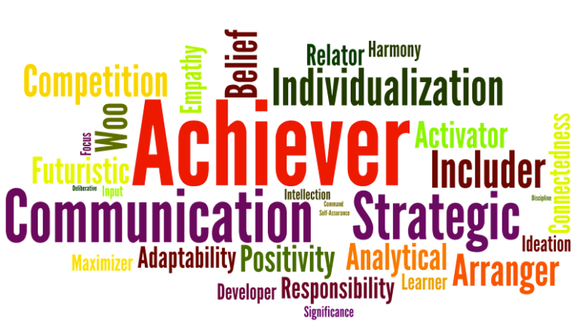

What I Have Learned

Activity 7: Complete All
Directions: Let’s assess your learning by completing the concept map below.

____________________________________________________________________________________________________________________________________________________________________________________________________________________________________________________________________

(What is the purpose?)

____________________________________________________________________________________________________________________________________________________________________________________________________________________________________________________________________

(How to have an effective report?)

Research Report

_________________________________________________________________________________________________________________________________________________________________________________________________________________________________

(Why should it be realistic?)
____________________________________________________________________________________________________________________________________________________________________________________________________________________________________________________________________

(How to choose a topic?)

What I Can Do

Activity 8 Compose Research Report
Directions: This time, the knowledge and skills you acquired in this module and in the previous lessons under Fourth quarter will be assessed. You may now compose your own research report on a relevant social issue. Choose only one (1) from the given topics. Use separate sheet for your answer. Be guided with the given rubrics.
Topics:
- Early Pregnancy/Early Marriage
- COVID-19
- Climate Change
- Illegal Drugs
- Smoking
Research Report
Adapted from Rubistar.com
Criteria | 4  Excellent | 3  Proficient | 2  Developing | 1  Beginning | Points
Catchy  Introduc-  tion | *Exceptional introduction that grabs interest of reader and states topic | *Proficient introduction that is interesting and states topic | *Basic introduction that states topic but lacks interest | *Weak or no introduction of topic
Credible | *exceptionally researched  *detailed and accurate information  *Information clearly relates to the thesis or the research questions/objectives | *information relates to the main topic/thesis/objective  *well-researched in detail and from a variety of sources | *information relates to the main topic, few details and/or examples are given  *uses limited sources | *information has little or nothing to do with the thesis  *information has weak or no connection to the thesis
Well-Explained | *Exceptionally critical, relevant, and consistent connections made between evidence and thesis  *excellent analysis | *consistent connections made between evidence and thesis  *good analysis | *some connection made between evidence and thesis  *some analysis | *limited or no connections made between evidence and thesis  *lacks analysis
Well-Organized | *exceptionally clear, logical, mature, and thorough development of the topic with excellent transitions between and within paragraphs | *clear and logical order that supports the topic with good transitions between and within paragraphs | *somewhat clear and logical development with basic transitions between and within paragraphs | *lacks development of ideas with weak or no transitions between and within paragraphs
Compelling Conclusion | *excellent summary of topic with concluding ideas that impact reader  *introduces no new information | *good summary of topic with clear concluding ideas  *introduces no new information | *basic summary of topic with some final concluding ideas  *introduces no new information | *lacks summary of topic
Well-  Written | *control of grammar, usage, and mechanics  *almost entirely free of spelling, punctuation, and grammatical errors | *Contains few spellings, punctuation, and grammatically errors | *contains several spelling, punctuation, and grammatical errors that which detract from the paper’s readability | *so many spelling, punctuation, and grammatical errors that the paper cannot be understood
Total
Assessment

Directions: Read each item carefully. Choose the letter of the best answer. Write your answer on the space before each number.

____1. Why do you need to define the context of your research report?
- To create a detailed yet concise document.
- To create an informative detailed yet lengthy document.
- To make a short and presentable document.
- To make a straight forward information and ideas.

____2. What would be the last step that a writer must do before publishing the report?
- Choose a topic. B. Make a plan. C. Proofread the report. D. Create an outline.

____3. Why should a research report title be brief, precise, and contain keywords from the research?
- To provide a clear idea of your investigation so that readers can grasp the entire focus of your research from the title.
- To provide details on the history of your document so that readers will understand the concept of your report.
- To provide the readers conclusion on the title of your research report.
- To provide clear details and information so that readers will be interested in reading the report.

____4. Which of the following statements describes global citizenship?
- Global citizenship is the idea that everyone is a part of the world-wide community.
- Global citizenship is that each country exists by itself and does not have anything to do with other countries.
- Global citizenship is something that someone earns by taking a test.
- Global citizenship is only available to people who speak another language.

____5. Which of the following statements is an example of a civic responsibility?
- Supporting a group that want to harass other people in your community
- Participating and voting in election
- Refusing to run for an elected office in government
- Throwing trash on the ground at the park

____6. What step of research report that you use range of resources from books, periodicals, and in the
internet?
- Outline the project.
- Conduct research and take notes.
- Edit and reread the report.
- Check with the teachers.

____7. What are the main parts of global citizenship?
- Civic responsibilities, languages, food, and global economy
- Cultural awareness, environment, pollution, and global economy
- Civic responsibilities, cultural awareness, global economy, and environment
- Environment, cultural awareness, religion and games

____8. People in your neighborhood want to organize an event to support a charitable organization. What
are you most likely to do?
- Listen carefully, take notes of what everyone is saying, and write a report with suggestions
- Ask people for their views, point your own ideas, and come up with plan.
- Take photos of their meeting and start a new Facebook page for the group.
- Volunteer to help, make the event happen once the plan has been set.

____9. A school in your area has a very successful global development club. What would you rather do?
- Help the club organize and recruit new members.
- Meet with the principal in the area to talk about starting club at their school.
- Make a documentary film or create a children’s book about the club.
- Redesign the clubs meeting space to make it easier for the group to interact.

____10. Which of the following is the purpose of writing a research report?
- To deliver the documented report to the public through book and magazine.
- To deliver the results of the research to the interested person and publish it in a coherent way so the reader can understand the information.
- To provide unlimited information based from a research to the interested person and publish it through a pamphlet.
- To provide the reader an interesting and timely information to inspire him or her based from a research.

ANSWER KEY
What I Know Activity 1  - A  - C  - B  - B  - B | What’s In  Activity 2  Answers may vary. | What’s New Activity 3  Answers may vary. | What’s More Activity 4  Answers may vary. | What’s More Activity 5  Answers may vary.
What’s More Activity 6  Answers may vary. | What I Have Learned Activity 7  Answers may vary. | What I Can Do Activity 8  Answers may vary. | Assessment  1. A 6. B  2. C 7. C  3. A 8. D  4. A 9. D  5. B 10. B

References:

Book
Almonte, Liza R., Flandez, Lerma L., Hermosa, Angelina Lourdes, Nedia Lagustan, Liberty A. Mangaluz, Elenita R. Miranda, Paul Anthony B. Mendoza, Lito A. Palomar, Grace B. Annette Barradas-Soriano, and Karen B. Villanueva, Celebrating Diversity through World Literature, Pasig City: Rex Book Store, Inc. 2015, 485-488.

Online Sources

Campus Career Club. April 7, 2019. “Research Report Writing Steps with Format”
https://www.campuscareerclub.com/research-report-writing-steps/

Formplus Blog on October 07. “Research Report: Definition, types + [Writing Guide]”
https://www-formpl-us.cdn.ampproject.org/v/s/www.formpl.us/blog/amp/research-report?amp_js_v=a6&amp_gsa=1&usqp=mq331AQHKAFQCrABIA%3D%3D#aoh=16115605149852&referrer=https%3A%2F%2Fwww.google.com&amp_tf=from%20%251%24s&ampshare=https%3A%2F%2Fwww.formpl.us%2Fblog%2Fresearch-report

Miss Weir. November 27, 2015. Global-Citizenship
https://blogs.glowscotland.org.uk/nl/greenhillprimaryschool/global-citizenship-2/

Nathan Freeburg. August 21, 2014. Sample Strengths Wordle
https://www.leadershipvisionconsulting.com/the-10-most-frequently-asked-questions-about-how-we-are-using-strengths/preview-day-wordle-1311/

Scholastic Parents Staff. “7 Steps to a Successful Research Report”
https://www.scholastic.com/parents/school-success/homework-help/homework-project-tips/7-steps-to-successful-research-report.html

DEVELOPMENT TEAM

Writers: Pilar F. Ramos, Begang National High School
Layla M. Musa, Tandung Ahas National High School
Editor:

Language Editor:
Proofreader: Violeta M. Sta. Elena, EPS
Illustrators:
Layout Artist: Joyce Ethel L. Sienes
Management Team:
Julieto H. Fernandez, Ed. D., CESO VI
SDS-Isabela City
Maria Laarni T. Villanueva, Ed. D., CESE
ASDS-Isabela City
Henry R. Tura, CID Chief
Elsa A. Usman, LR Supervisor
Helen De Leon, EPS-English, Module Coordinator

Region IX: Zamboanga Peninsula Hymn – Our Eden Land
Here the trees and flowers bloom  Here the breezes gently Blow,  Here the birds sing Merrily,  The liberty forever Stays,  Here the Badjaos roam the seas  Here the Samals live in peace  Here the Tausogs thrive so free  With the Yakans in unity | Gallant men And Ladies fair  Linger with love and care  Golden beams of sunrise and sunset  Are visions you’ll never forget  Oh! That’s Region IX  Hardworking people Abound,  Every valleys and Dale  Zamboangueños, Tagalogs, Bicolanos, | Cebuanos, Ilocanos, Subanons, Boholanos, Ilongos,  All of them are proud and true  Region IX our Eden Land  Region IX  Our..  Eden...  Land...

My Final Farewell
Farewell, dear Fatherland, clime of the sun caress'd  Pearl of the Orient seas, our Eden lost!,  Gladly now I go to give thee this faded life's best,  And were it brighter, fresher, or more blest  Still would I give it thee, nor count the cost.  On the field of battle, 'mid the frenzy of fight,  Others have given their lives, without doubt or heed;  The place matters not-cypress or laurel or lily white,  Scaffold or open plain, combat or martyrdom's plight,  T is ever the same, to serve our home and country's need.  I die just when I see the dawn break,  Through the gloom of night, to herald the day;  And if color is lacking my blood thou shalt take,  Pour'd out at need for thy dear sake  To dye with its crimson the waking ray.  My dreams, when life first opened to me,  My dreams, when the hopes of youth beat high,  Were to see thy lov'd face, O gem of the Orient sea  From gloom and grief, from care and sorrow free;  No blush on thy brow, no tear in thine eye.  Dream of my life, my living and burning desire,  All hail ! cries the soul that is now to take flight;  All hail ! And sweet it is for thee to expire ;  To die for thy sake, that thou mayst aspire;  And sleep in thy bosom eternity's long night.  If over my grave some day thou seest grow,  In the grassy sod, a humble flower,  Draw it to thy lips and kiss my soul so,  While I may feel on my brow in the cold tomb below  The touch of thy tenderness, thy breath's warm power.  Let the moon beam over me soft and serene,  Let the dawn shed over me its radiant flashes,  Let the wind with sad lament over me keen ;  And if on my cross a bird should be seen,  Let it trill there its hymn of peace to my ashes. | Let the sun draw the vapors up to the sky,  And heavenward in purity bear my tardy protest  Let some kind soul o 'er my untimely fate sigh,  And in the still evening a prayer be lifted on high  From thee, 0 my country, that in God I may rest.  Pray for all those that hapless have died,  For all who have suffered the unmeasur'd pain;  For our mothers that bitterly their woes have cried,  For widows and orphans, for captives by torture tried  And then for thyself that redemption thou mayst gain  And when the dark night wraps the graveyard around  With only the dead in their vigil to see  Break not my repose or the mystery profound  And perchance thou mayst hear a sad hymn resound  'T is I, O my country, raising a song unto thee.  And even my grave is remembered no more  Unmark'd by never a cross nor a stone  Let the plow sweep through it, the spade turn it o'er  That my ashes may carpet earthly floor,  Before into nothingness at last they are blown.  Then will oblivion bring to me no care  As over thy vales and plains I sweep;  Throbbing and cleansed in thy space and air  With color and light, with song and lament I fare,  Ever repeating the faith that I keep.  My Fatherland ador'd, that sadness to my sorrow lends  Beloved Filipinas, hear now my last good-by!  I give thee all: parents and kindred and friends  For I go where no slave before the oppressor bends,  Where faith can never kill, and God reigns e'er on high!  Farewell to you all, from my soul torn away,  Friends of my childhood in the home dispossessed!  Give thanks that I rest from the wearisome day!  Farewell to thee, too, sweet friend that lightened my way; Beloved creatures all, farewell! In death there is rest!

I Am a Filipino, by Carlos P. Romulo
I am a Filipino–inheritor of a glorious past, hostage to the uncertain future. As such I must prove equal to a two-fold task–the task of meeting my responsibility to the past, and the task of performing my obligation to the future.  I sprung from a hardy race, child many generations removed of ancient Malayan pioneers. Across the centuries the memory comes rushing back to me: of brown-skinned men putting out to sea in ships that were as frail as their hearts were stout. Over the sea I see them come, borne upon the billowing wave and the whistling wind, carried upon the mighty swell of hope–hope in the free abundance of new land that was to be their home and their children’s forever.  I am a Filipino. In my blood runs the immortal seed of heroes–seed that flowered down the centuries in deeds of courage and defiance. In my veins yet pulses the same hot blood that sent Lapulapu to battle against the first invader of this land, that nerved Lakandula in the combat against the alien foe, that drove Diego Silang and Dagohoy into rebellion against the foreign oppressor.  The seed I bear within me is an immortal seed. It is the mark of my manhood, the symbol of dignity as a human being. Like the seeds that were once buried in the tomb of Tutankhamen many thousand years ago, it shall grow and flower and bear fruit again. It is the insignia of my race, and my generation is but a stage in the unending search of my people for freedom and happiness. | I am a Filipino, child of the marriage of the East and the West. The East, with its languor and mysticism, its passivity and endurance, was my mother, and my sire was the West that came thundering across the seas with the Cross and Sword and the Machine. I am of the East, an eager participant in its spirit, and in its struggles for liberation from the imperialist yoke. But I also know that the East must awake from its centuried sleep, shake off the lethargy that has bound his limbs, and start moving where destiny awaits.  I am a Filipino, and this is my inheritance. What pledge shall I give that I may prove worthy of my inheritance? I shall give the pledge that has come ringing down the corridors of the centuries, and it shall be compounded of the joyous cries of my Malayan forebears when first they saw the contours of this land loom before their eyes, of the battle cries that have resounded in every field of combat from Mactan to Tirad Pass, of the voices of my people when they sing:  “I am a Filipino born to freedom, and I shall not rest until freedom shall have been added unto my inheritance—for myself and my children and my children’s children—forever.”

