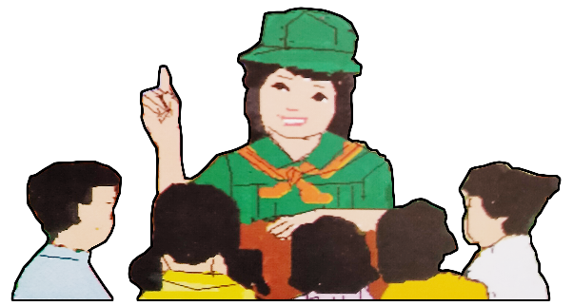
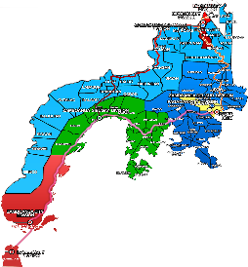
Name of Learner: ___________________________
Grade & Section: ___________________________
Name of School: ___________________________
Republic of the Philippines
Department of Education
Regional Office IX, Zamboanga Peninsula

Quarter 4 – Module 3
Adapting to Peers
ENGLISH
7

Zest for Progress
Zeal of Partnership

What I Need To Know
KKKKKKKKKKkkkkkkknKNOW

Scientifically, adaptation is a way by which species change to suit or to survive in its environment. Indeed, this idea is also applied to you as Grade 7 learners. Whether you are at home or in school or with your acquaintances and friends, the same rule is applied: How will you adjust or adapt to people’s way of thinking, attitudes, beliefs, and prejudices? Does the idea of adapting to peers mean a more harmonious and lasting relationship?

This lesson is anchored on MELCS (EN7LC – IV –g – 8.2) Determine the worth of ideas mentioned in the text listened to , which focuses on how to adapt to peers and will help you improve your analytical, linguistic and critical skills as you enthusiastically participate in various learning activities.

At the end of this module, you are expected to:
- Infer the ideas of the poem listened to.

What I Know
Activity 1. Cheer for peers
Think of people you consider as your peers. Choose an object that you can associate with them based on the illustrations below.

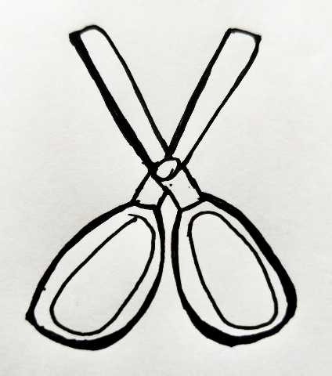

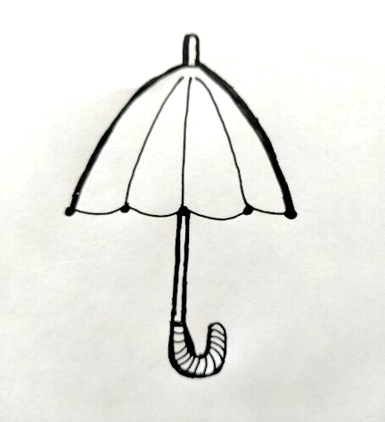

Write a simple paragraph comparing the characteristics of your friend to an object that you have chosen.
_______________________________________________________________________
_______________________________________________________________________
_______________________________________________________________________
_______________________________________________________________________
_______________________________________________________________________
_______________________________________________________________________
_______________________________________________________________________

What’s In

Activity 2. Pros and Cons
Having your peers around you gives you a sense of belongingness. Consider your present status with your peers. Is being with your peers advantageous or disadvantageous on your part? Write your answer in the pros and cons chart.

PEERS | PROS (Advantages) | CONS (Disadvantages)

What’s New

Activity 3. Break that Wall
Despite the advantages and disadvantages of being with peers, you remain in your decision of developing friendly relationship with others.
- Study the questions on the “break that wall” diagram.
- Think of your answers to the questions.
- Answer the questions based on your personal view.

1. What holds you back 2. What can you say about 3. What do you find
in gaining friends? your closest friend? interesting in others?
____________________ ____________________ __________________
____________________ ____________________ __________________
____________________ ____________________ __________________
____________________ ____________________ __________________
____________________ ____________________ __________________
____________________ ____________________ __________________

BREAK THAT WALL

4. Why do you befriend others? 5. What qualities would you 6. Do your peers help you
want from your friends ? develop your personality?
_______________________ ______________________ ______________________
______________________ ____________________ ______________________
______________________ ____________________ ______________________
______________________ _____________________ ______________________
______________________ ____________________ ______________________
______________________ _____________________ ______________________

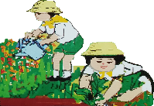

What Is It

What is it

Activity 4. Poetically Yours
Let somebody read to you the lines from the poem titled “My Neighbor”. Take note of the key ideas of the poem.

My Neighbor
By Ricaredo Demetillo

1
My neighbour, being well – to – do
Bought years ago a lot and a house
And built high walls as if to say:
“All interlopers here, keep out!”

2
Its true thieves, jimmy doors and snitch
What usable lie strewn about
So it is right my neighbour blocks
Suspect intrusion to his house

3
Now all the urchins shy, the cold tall gate
That guard the ripe fruits from their slings
Still I can’t keep my curiosity
To trespass slyly with a peek;

4
So know how each lush flower – bed
Is sprayed by hoses in the sun
And guess when roses scent the air
Or drop their petals on the grass

5
I know too that my neighbor’s girl
Who strains beneath her yaya’s hand
Looks longingly beyond the gate
Where my boy tumble in the sun

Answer the following questions briefly.

1. Why did the neighbour build high walls around his residence?
_______________________________________________________________________________
_______________________________________________________________________________
_______________________________________________________________________________

2. Describe the neighbour’s attitude towards others. Write the lines that give clues to your description.
_______________________________________________________________________________
_______________________________________________________________________________
_______________________________________________________________________________

3. Is it right for the neighbour to build high walls around his house? What forced him to do so?
_______________________________________________________________________________
_______________________________________________________________________________
_______________________________________________________________________________

4. How did the people react on the action of the neighbour?
_______________________________________________________________________________
_______________________________________________________________________________
_______________________________________________________________________________

5. In spite of high walls and tall gate, what did the narrator discover?
_______________________________________________________________________________
_______________________________________________________________________________
_______________________________________________________________________________

Sensing out the T and M (Tone and Mood). Study the review notes on tone and mood.

Making Inference. Making an inference involves using what you know to make a guess about what you don’t know or reading between the lines. Inference is just a big words that means a conclusion or judgement.

How to Make Inference? Readers who make inference use the clues in the text along with their own experiences to help them figure out what is not directly said, making the text personal and memorable.
www. Teachervision.com.inferences

Example:

A character has a diaper in her hand, spit – up on her shirt, and a bottle warming on the counter.
(You can infer that this character is a mother.)
A man is carrying his suitcase and running towards the elevator.
(You can infer that this character is late for work.)
A lady and a young man are walking and whispering.
(You can infer that they are lovers.)

Tone is the attitude the writer takes toward an audience, a subject, or a character. Tone is conveyed through the writer’s choice of words and details, joyous or angry, and proud or sympathetic. It is suggested by the choice of words, the arrangement of the words the author used.

Mood is the feeling of atmosphere the readers perceive or feel while reading. Thus, it is the overall emotion created by a work of literature.

Reference: Hovland L. et al..(1997). Elements of Literature Introductory.

- Determine the tone and mood of the poem “My Neighbor” by answering the following:

- Pick out certain terms /words that may suggest the feeling of the author. (Tone column)
- What have you felt while reading and understanding the poem? (mood column)
- What do you think is the poet’s purpose of writing the poem?

Mood | Tone
Author’s purpose:

Aside from learning about the mood and tone of the material listened to, it is also important to know the sensory images used in a poem. All these are important in making inference.

This is Good to Know!

Imagery is an element of the poem that uses words that appeal to senses. Generally, imagery in literary works (prose and poetry) uses sensory experiences such to the sense of sight, (visual), tactile (touch), sound (auditory), taste and smell to describe the impressions of the writers and to create vivid pictures that can suggest the readers the meaning of the poem/prose.

Examples:
-golden petals of the daffodils (sight)
- Scorching heat of the sun (touch)
- patter of the feet (sound)
- aromatic scent of co(smell)
- sweet strawberry (taste)

What’s More

Activity 5. Sense – O – Image. Reread the poem “ My Neighbor” Analyze the elements of the poem based on Sensory language used in the poem. Accomplish the sense – O – Image organizer.

- Choose the image that represents the sensory language used in the poem and place it on the column provided.

Process Questions:

- What sense do the lines generally appeal to?( answer table below)

- Aside from those stated, are there other sensory images used in the poem? Enumerate them.

- What is the importance of sensory images employed by the poet in this poem?
___________________________________________________________________________________
___________________________________________________________________________________
___________________________________________________________________________________

Sense – o – Image
Cold tall gate
Lush flower – bed is sprayed by hoses in the sun
Roses drop their petals on the grass
The boys tumble in the sun
Ripe fruits from their slings
Roses scent the air

Activity 6.
The Symbolical Masterpiece
- Present your understanding of the poem through an illustration or drawing.
- Draw an illustration which you think highlights the message of the poem.
Draw here

Rubrics for THE SYMBOLICAL MASTERPIECE
Criteria | 10 | 8 | 6 | 4
Focus/ Theme | All the elements of the illustration directly highlight the theme | Some of the elements of the illustration highlight the theme | Only few elements of the illustration highlight the theme | The illustration and its elements fail to highlight the theme.
Relevance/ Appropriateness | Visual contents reflect exemplary relevance and importance of the concept. | Visual contents somehow reflect the relevance and importance of the concept. | Visual contents are somehow reflective of the concept yet partially significant. | Visual contents are not necessarily related to the concept.
Creativity and Originality | The overall illustration is visually appealing and creatively done. | The illustration is visually appealing yet ideas are limited | The illustration is presentable but not creatively done. | The illustration is not visually appealing and dull.

What I Have Learned

Activity 7. My Treasure
Great! You have accomplished all the tasks assigned to you. Now it is time for you to reflect on the significant learning you have added to your knowledge bank. Express your learning by completing the thought prompts as shown below:

1. The most meaningful lesson I learned is __________________________________________
____________________________________________________________________________
____________________________________________________________________________
____________________________________________________________________________
____________________________________________________________________________
____________________________________________________________________________

2. For me, the best lesson that is worth keeping is ____________________________________
____________________________________________________________________________
____________________________________________________________________________
____________________________________________________________________________
____________________________________________________________________________
____________________________________________________________________________

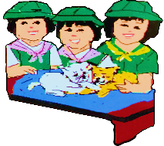
What I Can Do

Activity 8. What’s the word?

- Consider the information from the material that you used.
- Take note that synonyms or meanings of the unknown words that you will try to identify in the crossword puzzle are the literal meanings of the word based on the context of the poem.

ACROSS
2 – Urchin
3 – Sling
4- Trespass
5 – Spray
6 – Peek

 |  |  | ⁸I
 |  |  | N
 |  |  |  |  |  |  |  |  | ¹⁰C
 |  |  |  |  |  |  |  | ⁵W | E
 |  | ² | R |  | T |  |  |  |  |  |  |  | ¹¹T
 | ⁷R |  | U |  |  |  |  | E | E
³L |  | O |  |  | ⁹L |  |  |  |  |  |  |  | B
 | B |  | T |  |  |  |  | ⁶G |  | A |  | C
A |  |  |  |  | V |  |  |  | Y
Y |  | ⁴I |  | T | R |  |  | E
D
DOWN
3 – Lush 9 – jimmy 10- slyly
7 – Snitch 8 - intrusion 11- hose

Activity 9. Fresh from the Oven.

Locate information from the poem listened to. Determine whether each statement is true (T) or False (F). Indicate the paragraph number where you found the information.
__________1. The boy is curious about things behind the high walls.
__________2. The man is unafraid of his neighbour so he built high walls around his house.
__________3. The boy is jealous about what the neighbour is hiding.
__________4. Yaya is taking care of the little girl.
__________5. The poem is all about friendship.

Assessment

Directions: Supply each sentence with a correct answer. Encircle the letter of your choice.
1. Which of these lines taken from the poem indicates the reaction of the people to the action made by the rich neighbor?
A. “All interlopers here, keep out!”
B. Still I can’t keep my curiosity, to trespass slyly with a peek.
C. So it is right, my neighbour blocks intrusion to the house.
D. Where my boys stumble to the ground.

2. Is the daughter of the well – to – do neighbour happy? Why?
A. Yes, because she has all the riches in the world
B. Yes, because she feels safe inside the house.
C. No, because she feels sick all the time.
D. No, because it is happier to be with neighbours.

3. What does the poem teach us?
A. Friends make our life colourful and blissful. C. Friends make our life miserable.
B. Friends make our life complicated. D. Friends make the world go round.

4. The following are synonyms of the word “Interloper” except;
A. Intruder B. Stranger C. Trespasser D. Scavenge

5. How do you differentiate the lifestyle of the neighbor’s daughter from that of the boys?
A. The neighbor’s daughter is sad while the boys are happy.
B. The neighbor’s daughter is happy while the boys are sad.
C. The neighbor’s daughter loves to be with the boys.
D. Both the neighbor’s daughter and the boys are happy

6. What is the mood of the poem?
A. Happy B. Sad C. Gloomy D. Angry

7. Describe the attitude of the well – to – do man towards his neighbours.
A. The rich man is very accommodating.
B. The rich man loves his neighbours.
C. The rich man doesn’t want his neighbours around.
D. The rich man doesn’t mind his neighbours.

8. In spite of high walls and tall gate, what did the narrator discover? What lines in the poem show the narrator’s discovery?
A. So know how each lush flower –bed is sprayed by hoses in the sun.
B. So it is right, my neighbour blocks suspect intrusion to his house.
C. Still I can’t keep my curiosity to trespass slyly with a peek.
D. My neighbours bought years ago a house and a lot.

9. Which stanza of the poem shows the result of having parents who are overprotective?
A. 1st and 2nd stanzas B. 3rd stanza C. 4th stanza D. 5th stanza

10. The term “urchin” in the 3rd stanza refers to ____________.
A. Sea animals B. Neighbors C. The daughter D. The well – to - do

Additional Activity (Optional)
Wonderful! You are now at the final part of your module. This time, accomplish the additional task below.
Activity 10. Heart Art
Fill in the left part of the heart with names of people you love and the right part with the reasons for loving them.

REASON
NAMES

ANSWER KEY
What’s New
Activity 3
Answers may vary
What is It
Activity 4
Answers may vary
What’s In
Activity 2
Answers may vary
What I Know
Activity 1
Answers may vary

What’s More
Activity 6
Answers may vary
What’s More
Activity 5
Answers may vary
What I Can Do
Activity 8
Across Down
2- crit 3- leafy
3- loop 7- rob
4- intrude 8- Interruption
5- wet 9- lever
6- glance 10- cleverly
11- tube

What I Have Learned
Activity 7
Answers may vary

Assessment
1. B 6. B
2. D 7. C
3. A 8. A
4. D 9. D
5. A 10. B
What I Can Do
Activity 9
1. F-3
2. F-1
3. F-2
4. T-5
5. F-1

Additional Activity
Activity 10
Answers may vary

References:

English- Grade 7, Learner’s Material, First Edition, Department of Education, FEB Printing Corp., Philippines, 2017

DEVELOPMENT TEAM

Writer: Ma. Leila R. Duplin
Somia M. Baraluddin
Basilan National High School
Editor:
Language Editor:
Proof Reader: Sayana S. Hassan, EPS
Illustrators: Julienne Izabel A. Buante, Ma. Leila R. Duplin,
Somia M. Baraluddin
Layout Artist: Julienne Izabel A. Buante
Management Team:
Julieto H. Fernandez, Ed. D., CESO VI
SDS-Isabela City
Maria Laarni T. Villanueva, Ed. D., CESE
ASDS-Isabela City
Henry R. Tura, CID Chief
Elsa A. Usman, LR Supervisor
Helen De Leon, EPS-English, Module Coordinator

Region IX: Zamboanga Peninsula Hymn – Our Eden Land
Here the trees and flowers bloom  Here the breezes gently Blow,  Here the birds sing Merrily,  The liberty forever Stays,  Here the Badjaos roam the seas  Here the Samals live in peace  Here the Tausogs thrive so free  With the Yakans in unity | Gallant men And Ladies fair  Linger with love and care  Golden beams of sunrise and sunset  Are visions you’ll never forget  Oh! That’s Region IX  Hardworking people Abound,  Every valleys and Dale  Zamboangueños, Tagalogs, Bicolanos, | Cebuanos, Ilocanos, Subanons, Boholanos, Ilongos,  All of them are proud and true  Region IX our Eden Land  Region IX  Our..  Eden...  Land...

My Final Farewell
Farewell, dear Fatherland, clime of the sun caress'd  Pearl of the Orient seas, our Eden lost!,  Gladly now I go to give thee this faded life's best,  And were it brighter, fresher, or more blest  Still would I give it thee, nor count the cost.  On the field of battle, 'mid the frenzy of fight,  Others have given their lives, without doubt or heed;  The place matters not-cypress or laurel or lily white,  Scaffold or open plain, combat or martyrdom's plight,  T is ever the same, to serve our home and country's need.  I die just when I see the dawn break,  Through the gloom of night, to herald the day;  And if color is lacking my blood thou shalt take,  Pour'd out at need for thy dear sake  To dye with its crimson the waking ray.  My dreams, when life first opened to me,  My dreams, when the hopes of youth beat high,  Were to see thy lov'd face, O gem of the Orient sea  From gloom and grief, from care and sorrow free;  No blush on thy brow, no tear in thine eye.  Dream of my life, my living and burning desire,  All hail ! cries the soul that is now to take flight;  All hail ! And sweet it is for thee to expire ;  To die for thy sake, that thou mayst aspire;  And sleep in thy bosom eternity's long night.  If over my grave some day thou seest grow,  In the grassy sod, a humble flower,  Draw it to thy lips and kiss my soul so,  While I may feel on my brow in the cold tomb below  The touch of thy tenderness, thy breath's warm power.  Let the moon beam over me soft and serene,  Let the dawn shed over me its radiant flashes,  Let the wind with sad lament over me keen ;  And if on my cross a bird should be seen,  Let it trill there its hymn of peace to my ashes. | Let the sun draw the vapors up to the sky,  And heavenward in purity bear my tardy protest  Let some kind soul o 'er my untimely fate sigh,  And in the still evening a prayer be lifted on high  From thee, 0 my country, that in God I may rest.  Pray for all those that hapless have died,  For all who have suffered the unmeasur'd pain;  For our mothers that bitterly their woes have cried,  For widows and orphans, for captives by torture tried  And then for thyself that redemption thou mayst gain  And when the dark night wraps the graveyard around  With only the dead in their vigil to see  Break not my repose or the mystery profound  And perchance thou mayst hear a sad hymn resound  'T is I, O my country, raising a song unto thee.  And even my grave is remembered no more  Unmark'd by never a cross nor a stone  Let the plow sweep through it, the spade turn it o'er  That my ashes may carpet earthly floor,  Before into nothingness at last they are blown.  Then will oblivion bring to me no care  As over thy vales and plains I sweep;  Throbbing and cleansed in thy space and air  With color and light, with song and lament I fare,  Ever repeating the faith that I keep.  My Fatherland ador'd, that sadness to my sorrow lends  Beloved Filipinas, hear now my last good-by!  I give thee all: parents and kindred and friends  For I go where no slave before the oppressor bends,  Where faith can never kill, and God reigns e'er on high!  Farewell to you all, from my soul torn away,  Friends of my childhood in the home dispossessed!  Give thanks that I rest from the wearisome day!  Farewell to thee, too, sweet friend that lightened my way; Beloved creatures all, farewell! In death there is rest!

I Am a Filipino, by Carlos P. Romulo
I am a Filipino–inheritor of a glorious past, hostage to the uncertain future. As such I must prove equal to a two-fold task–the task of meeting my responsibility to the past, and the task of performing my obligation to the future.  I sprung from a hardy race, child many generations removed of ancient Malayan pioneers. Across the centuries the memory comes rushing back to me: of brown-skinned men putting out to sea in ships that were as frail as their hearts were stout. Over the sea I see them come, borne upon the billowing wave and the whistling wind, carried upon the mighty swell of hope–hope in the free abundance of new land that was to be their home and their children’s forever.  I am a Filipino. In my blood runs the immortal seed of heroes–seed that flowered down the centuries in deeds of courage and defiance. In my veins yet pulses the same hot blood that sent Lapulapu to battle against the first invader of this land, that nerved Lakandula in the combat against the alien foe, that drove Diego Silang and Dagohoy into rebellion against the foreign oppressor.  The seed I bear within me is an immortal seed. It is the mark of my manhood, the symbol of dignity as a human being. Like the seeds that were once buried in the tomb of Tutankhamen many thousand years ago, it shall grow and flower and bear fruit again. It is the insignia of my race, and my generation is but a stage in the unending search of my people for freedom and happiness. | I am a Filipino, child of the marriage of the East and the West. The East, with its languor and mysticism, its passivity and endurance, was my mother, and my sire was the West that came thundering across the seas with the Cross and Sword and the Machine. I am of the East, an eager participant in its spirit, and in its struggles for liberation from the imperialist yoke. But I also know that the East must awake from its centuried sleep, shake off the lethargy that has bound his limbs, and start moving where destiny awaits.  I am a Filipino, and this is my inheritance. What pledge shall I give that I may prove worthy of my inheritance? I shall give the pledge that has come ringing down the corridors of the centuries, and it shall be compounded of the joyous cries of my Malayan forebears when first they saw the contours of this land loom before their eyes, of the battle cries that have resounded in every field of combat from Mactan to Tirad Pass, of the voices of my people when they sing:  “I am a Filipino born to freedom, and I shall not rest until freedom shall have been added unto my inheritance—for myself and my children and my children’s children—forever.”

