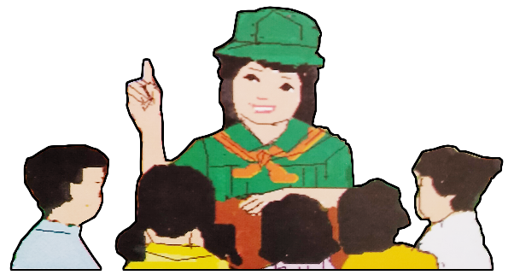
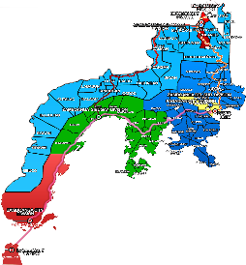
Quarter 4 – Module 4
Fact Vs Opinion
ENGLISH
Name of Learner: ___________________________
Grade & Section: ___________________________
Name of School: ___________________________
7

Zest for Progress
Zeal of Partnership
Republic of the Philippines
Department of Education
Regional Office IX, Zamboanga Peninsula

What I Need To Know KKKKKKKKKKkkkkkkknKNOW

In today’s society, learning is everywhere. If you want to know how to cook your favorite dish or acquire a new skill you can just watch it on YouTube. If you want to learn something new, you can just search and click it on your smart phones with the help of the different platforms from the internet.

But how can you make sure that you followed the correct procedure in cooking your favorite dish? How will you know that the ideas viewed from the different platforms of the internet are the right information?

With the emerging innovations using technology nowadays, you can now have an access to all the things you want to learn. Be wise and you must have the ability to determine whether it is a fact or an opinion to avoid being manipulated easily and for you to really acquire the right information.

In this module, you are expected to:
- Determine the truthfulness and accuracy of the material viewed. (EN7VC-1-h-10)

What I Know
Directions: Read each item carefully and write the letter of your answer on the space provided.

__________1. Which of the following information below is a fact?
A. The Philippines celebrate Independence Day every 12th of June.
B. Rodrigo Duterte could be re-elected as the President in the next election.
C. I think Dr. Rizal is proud with the youths of today.
D. The Spaniard will enjoy their stay up to this generation.

__________2. Which of the following statements defines an opinion?
A. Opinion is a statement that is true
B. It is an expression of telling the truth
C. A person’s belief, or judgment about something
D. is tested and proven

__________3. Which of the following expresses an opinion?
A. Facebook is a mobile application.
B. I believe that the weather report on Facebook is accurate than in the newspaper.
C. Newspaper is a printed material that produces news on current events.
D. Weather updates are posted by PAGASA.

__________4. Which of the following defines a fact?
- Statements that expresses the truth C. Statements that expresses one’s belief
- Statements that expresses one’s opinion. D. Statement that expresses one’s judgment

__________5. Which of the following is NOT true about opinion?
- This expresses one’s judgement C. This expresses one’s belief
- Opinion expresses one’s personal idea. D. This expresses the truth

What’s In

Activity 1. Fact or Opinion

Directions: Write the word F if the statement is FACT and O if the statement is OPINION on the space provided.

- I think Anahaw will be the next national flower.
- There are three stars in the Philippine flag that represents Luzon, Visayas and Mindanao.
- If mobile games were not developed, the children nowadays will be more focused on their studies.
- Dr. Jose Rizal is our National Hero.
- If Isko Moreno can maintain his good standing as the City Mayor of Manila, he could be the next President of the Philippines.

Activity 2.
Directions: Below are the screenshots of the logos of different platforms from the internet. Which of the following platforms give you right or opinionated information? Write your answer in the corresponding columns.

Facebook | Instagram
Google | Youtube
Wikipedia | 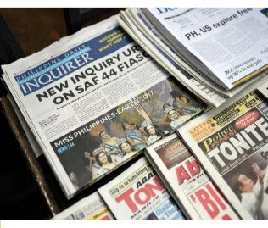  Newspapers
Rappler | CNN
DepEd Commons | Merriam Webster Dictionary

RIGHT | OPINIONATED
1. | 1.
2. | 2.
3. | 3.
4. | 4.
5. | 5.

What’s New

Activity 3
Directions: Write at least five (5) ideas and information you know about Fact and Opinion inside the box.
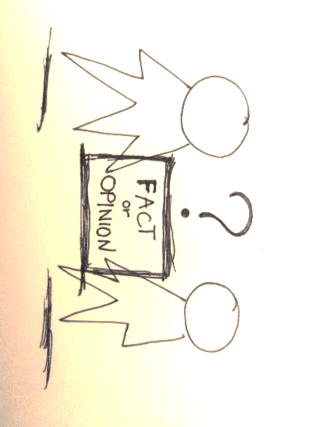
FACTS
1.

2.
3.
4.
5.

OPINION
1.
2.
3.
4.
5.

What Is It

Students must develop skills in determining truthfulness in any statements. To do this, one must understand the definitions and concepts of fact and opinion.

What is FACT?
A fact is a statement that is consistent with reality or can be proven with evidence. It is a statement that is real or true, or a thing that can be shown to be real or true. A fact is something that has really happened or is actually the case. The usual test for a statement of fact is whether it can be seen to be true.

Examples:
- The sun rises in the east.
- The Philippine President is Rodrigo R. Duterte.
- The troposphere is the bottom layer of the atmosphere, where clouds, rain, snow, and other weather phenomena occur.
- Manila is the Capital city of the Philippines.
- Dr. Jose P. Rizal is our National Hero

What is OPINION?
An opinion is a personal judgment. It is an expression of someone’s view or belief that is not demonstrable as fact. Opinions can provide useful information, but they should be supported by evidence.

Examples:
- The salad is sweeter than the jelly.
- Her fashion style is on trend.
- Many lower-income families of the barrio manage to maintain a comfortable standard of living through the communal action of family members who contribute their wages to the head of the family.
- I think dancing Zumba is better than jogging.
- In my perspective, buying a brand-new car using a credit card is not practical these days.

Fact and opinion are often interrelated to one another especially in texts and speeches. Therefore, students must unlock skills in distinguishing the differences of the two.

Here are examples of signal words used in determining facts and opinions:

FACT
● The new study confirms…
● Medical experts have recently discovered…
● According to the results of the clinical trials…
● The doctors demonstrated…

OPINION
● They claimed that…
● It is the teacher’s view that…
● The debater argues that…
● Many people suspect that…

From the examples above, the signal words used are helpful in determining whether the statement is a fact or an opinion.

What’s More

Activity 4: Support Your Answer
Directions: Read the text carefully. Try to note down at least one statement of fact and opinion. State your reason for identifying the statement as fact or opinion.
Many pesticides that are banned in wealthy nations are shipped to Central America, often with disastrous results. Pesticide containers have safety instructions written in a language farmer can’t read. Some pesticides are so toxic that anyone applying them should wear a tightly sealed rubber suit and a respirator. Unfortunately, most farmers are too poor to afford any protection; those who can afford the gear don’t buy it, because rubber suits are impractical in the tropics.

Statement | Reason
- Fact: _______________________________  ____________________________________  ____________________________________  - Opinion: ___________________________  ____________________________________  ____________________________________ | __________________________________________  __________________________________________  __________________________________________  __________________________________________  __________________________________________  __________________________________________
Activity 5. Fact vs. Opinion

Directions: View the given pictures below and determine whether the picture is giving you a fact or opinionated information. Write the letter of your answer on the space provided.

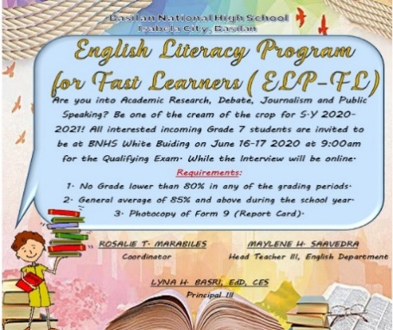

- B. C.
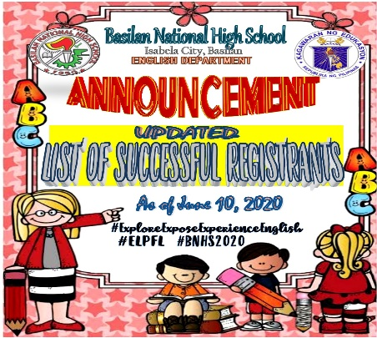
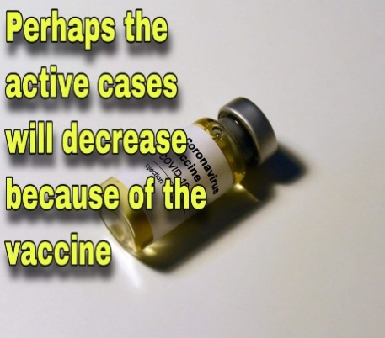

D. E. F.

FACT | OPINION
- __________  - __________  - __________ | - __________  - __________  - __________

What I Have Learned

Activity 6: Fill-up the Pail
Directions: Read each statement inside the boxes. Identify whether it is a fact or opinion and write it down on its respective pail.
It is an expression of someone’s belief
It is a personal judgment
It is supported by evidences

It is something that has really happened
It is a statement that is consistent with reality
It is an expression of someone’s view

FACT
OPINION
1. _________________
___________________
2. _________________
___________________
3. _________________
___________________
1. _________________
___________________
2. _________________
___________________
3. _________________
___________________

What I Can Do

Activity 7. Make A Stand
Option A
Directions: Watch the video titled “What does education mean to you?” and determine whether it is a FACT or OPINION and why. Just use the link below.
https://youtu.be/Un5msddQI6U
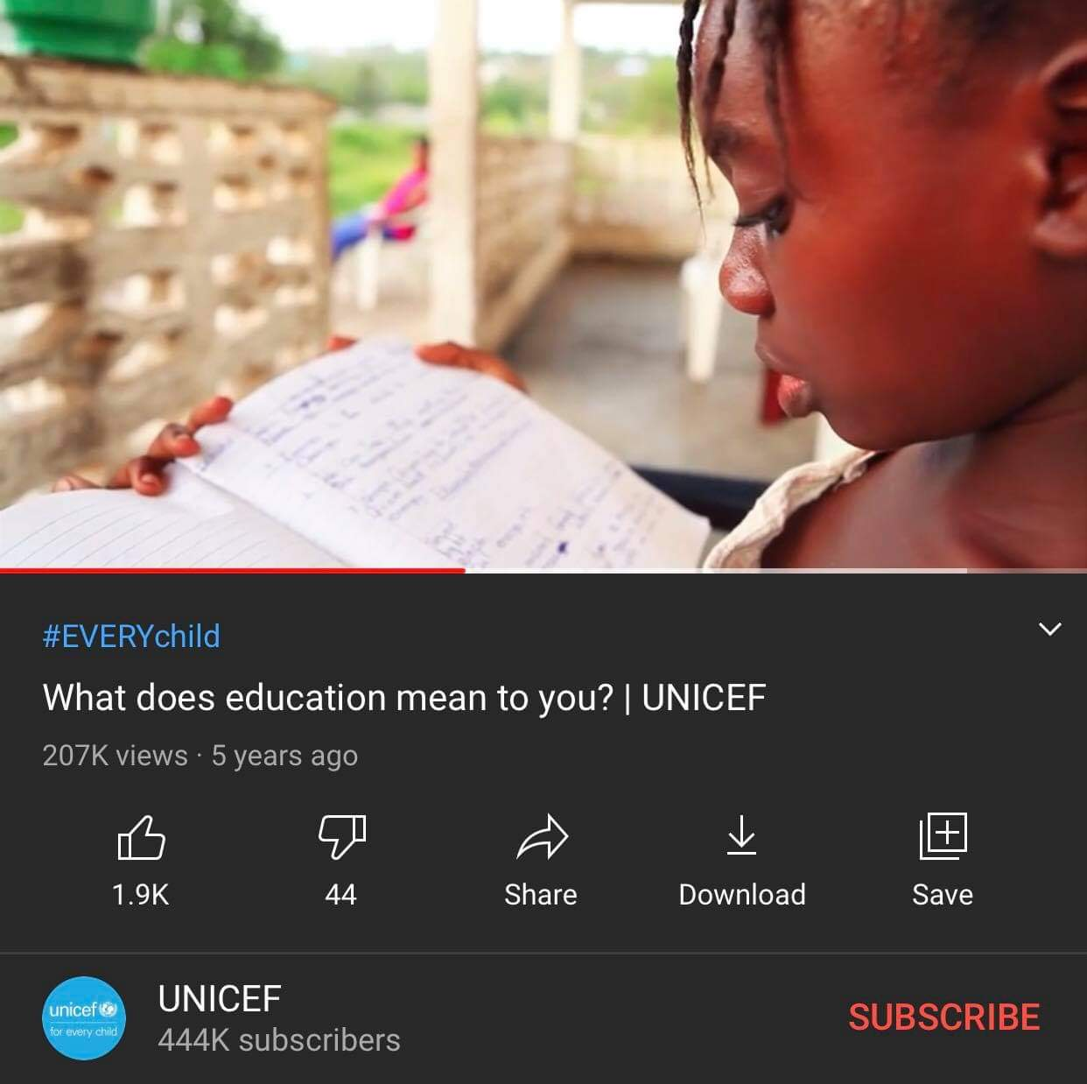

Note: If the student has no internet connection, please use option B of the activity.
Option B
Directions: Analyze the given infographic below and determine whether the picture states a FACT or an OPINION. Defend your answer by writing your explanation on the space provided.
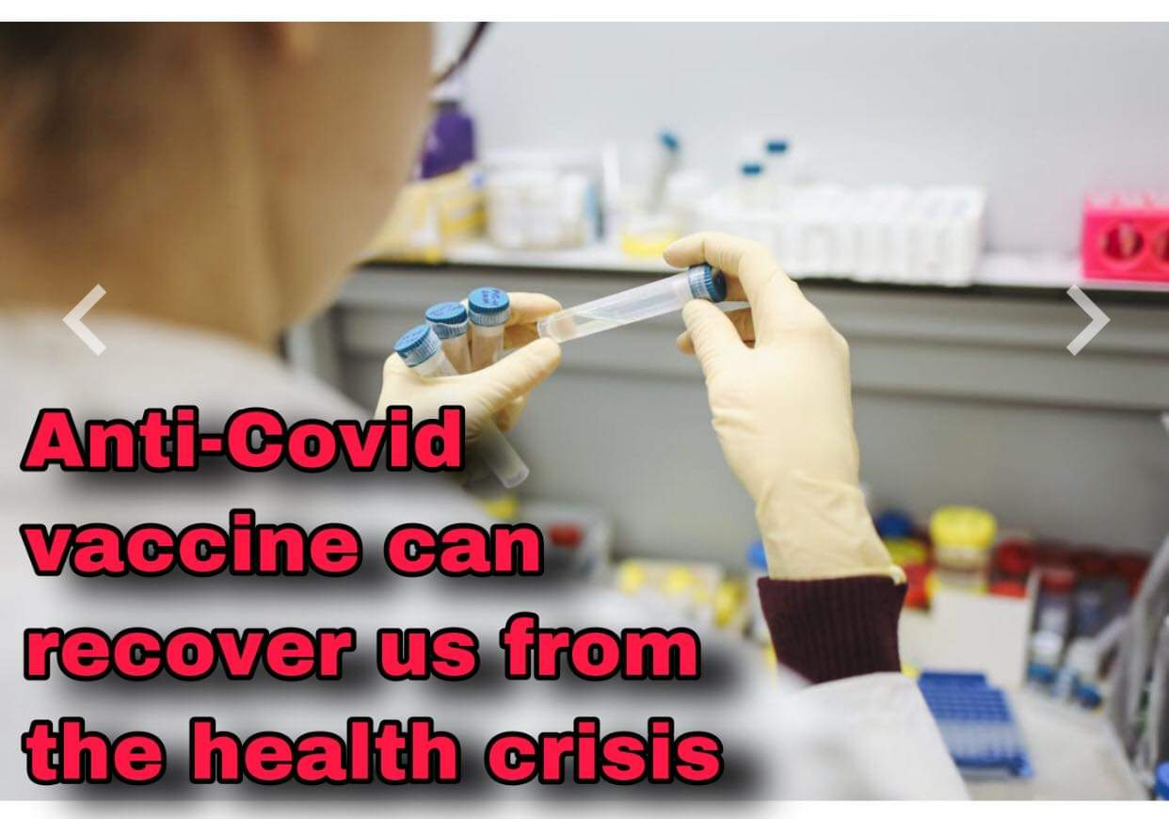

FACT OR OPINION?
_____________________________________________________________________________________
_____________________________________________________________________________________
_____________________________________________________________________________________
_____________________________________________________________________________________
RUBRICS FOR THE ACTIVITIES IN WHAT I CAN DO
CRITERIA | Outstanding  (5) | Very good  (4) | Average  (3) | Developing  (2)
FOCUS/ CONTENT | The paragraph contains meaningful focus and 4-5 supporting details. | The paragraph contains little but meaningful focus and there are 2-3 supporting details. | The paragraph contains little focus and there is only 1 supporting detail. | The paragraph contains no focus and there are no supporting details.
ORGANIZATION OF THOUGHTS | The introduction is inviting, states the main topic and provides an overview. Information is relevant and presented in a logical order. The conclusion is strong. | The introduction states the main topic and provides an overview. A conclusion is included. | The introduction states the main topic. A conclusion is included. | There is no clear introduction, structure, and conclusion.
LANGUAGE MECHANIC | All sentences are well constructed and have varied structure and length. There are no errors in grammar, mechanics, and/or spelling. | Most sentences are well constructed and have varied structure and length. The writer makes a few errors in grammar, mechanics, and/or spelling. | Most sentences are well constructed, but they have a similar structure and/or length. The writer makes several errors in grammar, mechanics, and/or spelling. | Sentences sound awkward, are distractively repetitive, or are difficult to understand. The writer makes numerous errors in grammar, mechanics, and/or spelling.
Assessment

Directions: Read the items carefully and encircle the letter of the correct answer.
- Which of the given statements below is TRUE about fact?
- A statement that is consistent with fake news.
- A statement with reality or can be proven with evidence.
- A statement that consists of personal judgment.
- A statement that expresses one’s belief.

- Which of the following words below expresses a personal judgment?
- Fact B. Fantasy C. Opinion D. Reality

- Which of the following sentences explains an opinion?
- It is an expression of someone’s view or belief C. A statement of facts
- It is an expression of truth D. Something that is real
- Which of the following statements explains the reason why an opinion cannot be a fact?
- An opinion cannot be a fact because it is just a personal idea and not proven.
- An opinion cannot be a fact because it is tested and proven.
- An opinion cannot be a fact because it states the truthfulness of something.
- An opinion cannot be a fact because it states the reality of something.

- Which of the following statements is NOT true about facts?
- It is a statement that is consistent with reality
- It can be proven with evidence
- It is a statement that is real or true
- It expresses a personal belief on something

- Which of the given statements below shows the BEST comparison between Fact and Opinion?
- Fact is a statement that is consistent with reality while Opinion is not true.
- Fact is a statement that is consistent with truthfulness while Opinion is more on fake news.
- Fact is a statement that is proven while Opinion is an expression of someone’s view or belief
- Fact is a statement that is proven while Opinion states a false information.

- Below are the screenshots of the different logos of different platforms from the internet. Which of the following sites gives a purely factual information?
- B. C. . D.

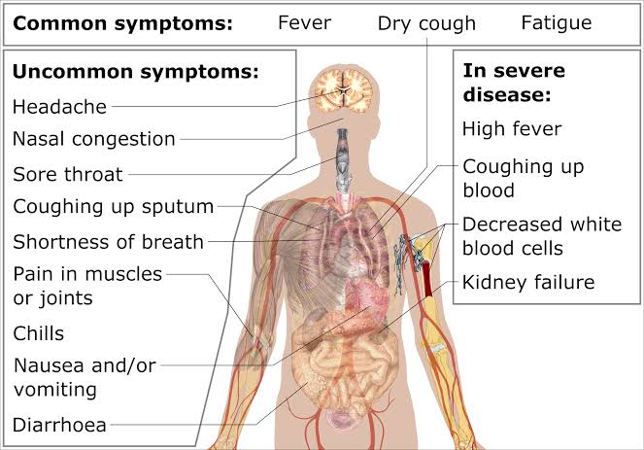
For question number 8, refer to the infographic below:

- Does the given infographic above give a fact or an opinion?
- It is a fact because it gives an information that are already proven
- It is fact because it gives an information that are not proven
- It is an opinion because it gives factual information
- It is an opinion because it gives an unproven information

- Which of the following statement is NOT true about an opinion?
- An opinion is a personal judgment.
- An opinion is an expression of someone’s view or belief.
- An opinion provides information that are not supported by evidences.
- An opinion can provide factual information.

For number 10, refer to the text in the box:
1. A fact is a statement that is consistent with reality or can be proven with evidence. 2. It is a statement that is unreal or false, or a thing that can be shown to be real or true. 3. A fact is something that has really happened or is actually the case. 4. The usual test for a statement of fact is whether it can be seen to be true.

- All the sentences are correct about fact EXCEPT:
- Sentence 1 C. Sentence 3
- Sentence 2 D. Sentence 4
Additional Activity (Optional)

Activity 8: Determine Me
Directions: Watch the video titled “Vaccination during COVID-19 (Explainer Video) | WHO Philippines, UNICEF, DOH” and determine whether it is a FACT or OPINION and why. Just use the link below. https://www.youtube.com/watch?v=QGv73EPcgm0
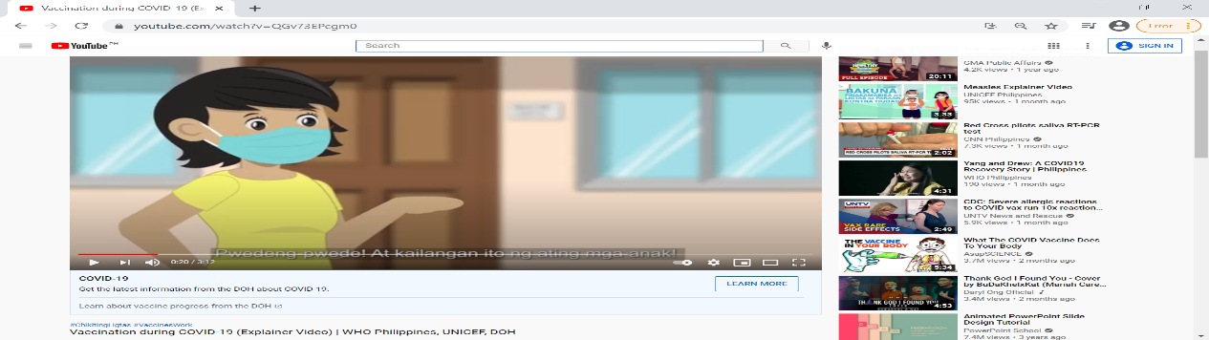

ANSWER:
______________________________________________________________________________________
______________________________________________________________________________________
______________________________________________________________________________________
______________________________________________________________________________________
______________________________________________________________________________________
______________________________________________________________________________________
______________________________________________________________________________________
______________________________________________________________________________________
______________________________________________________________________________________

Answer Key:

What’s New
Activity 3
Answers may vary
What’s In
Activity 2
Right Opinionated
1. Deped Commons 1. Facebook
2. Rappler 2. Instagram
3. CNN 3. YouTube
4. Merriam Webster 4. Wikipedia
5. Newspapers 5. Google
What’s In
Activity 1
1. O
2. F
3. O
4. F
5. O
What I know
1. A
2. C
3. B
4. A
5. D
What’s More Activity 4
Fact Opinion
1. B 1. A
2. C 2. D
3. E 3. F

What’s More
Activity 5
Answers may vary
What I Have Learned Activity 6
Fact Opinion
1. It is supported 1. It is a personal
By evidences. judgement.
2. It is a statement 2. It is an expression
that is consistent of someone’s belief.
with reality.
3. It is something 3. It is an expression
that really happened. of someone’s view.

Assessment
1. B 6. C
2. A 7. C
3. A 8. A
4. A 9. D
5. D 10. B
What I Can Do
Activity 7
Answers may vary

Additional Activity
Activity 8
Answers may vary

References:

File: Facebook f logo (2019).svg
Retrieved from: https://commons.m.wikimedia.org/wiki/File:Facebook_f_logo_(2019).svg#mw-jump-to-license
File: Instagram logo 2016.svg-wikipidea
Retrieved from: https://en.m.wikipedia.org/wiki/File:Instagram_logo_2016.svg
Freepik, Google logo.jpg
Retrived from: https://www.flaticon.com/free-icon/search_281764?term=google&page=1&position=2&page=1&position=2&related_id=281764&origin=search
Freepik, YouTube logo.jpg
Retrieved from: https://www.flaticon.com/free-icon/youtube_1384060?term=youtube%20logo&page=1&position=2&page=1&position=2&related_id=1384060&origin=style
Freepik, Wikipedia logo.jpg
Retrieved from: https://www.flaticon.com/free-icon/wikipedia-logo_48927?term=wikipedia&page=1&position=3&page=1&position=3&related_id=48927&origin=search
Retrieved from: https://commons.deped.gov.ph/assets/deped-core-va...eed63c82e6de78825ee64dc30c87d066513c046256104.png
File: Webster_logo.svg
Retrieved from: https://upload.wikimedia.org/wiki/Merriam-Webster#/media/File%3AMerriam-Webster_logo.svg
File: Rappler_logo.svg
Retrieved from: https://en.m.wikipedia.org/wiki/Rappler#/media/File%ARappler_logo.svg
File: CNN.png
Retrieved from: https://en.m.wikipedia.org/wiki/CNN#/media/File%3ACNN.svg
File: Manila Bulletin New Layout Newspaper (December 9, 2019).jpg
Retrieved from: https://en.m.wikipedia.org/wiki/File:Manila_Bulletin_New_Layout_Newspaper_(December_9,_2019).jpg
File:unknown
Retrieved from: https://www.pexels.com/photo/person-holding-test-tubes-3735747/
File: Unknown
Retrieved from:https://images.unsplash.com/photo-1608243499644-c55bd9f2b837?ixlib=rb-1.2.1&q=80&fm=jpg&crop=entropy&cs=tinysrgb&dl=hakan-nural-Z2n-r7pg6kM-unsplash.jpg
File: Unknown
Retrieved from: https://images.unsplash.com/flagged/photo-1553802922-5f7e9934e328?ixlib=rb-1.2.1&q=80&fm=jpg&crop=entropy&cs=kristina-petrick-OJHNzGwqTSA-unsplash.jpg
Fact, Wikipedia, https://en.m.wikipedia.org/wiki/Fact
English Expressways, Textbooks for fourth Year, SD Publication Inc, 2007, p. 197
English-Grade 7 Learner’s Material, First Edition, Department of Education, FEB Printing Corp.,,Philippines, 2017
https://www.literacyideas.com/teaching-fact-and-opinion

DEVELOPMENT TEAM

Writer: Christianvil T. Garcia Chandra-Lou G. Francisco
Basilan National High School Malamawi National High School
Editor:

Language Editor:
Proof Reader: Sayana S. Hassan, EPS
Illustrators: Julienne Izabel A. Buante, Julienne Izabel A. Buante
Chandra-Lou G. Francisco
Layout Artist: Julienne Izabel A. Buante
Management Team:
Julieto H. Fernandez, Ed. D., CESO VI
SDS-Isabela City
Maria Laarni T. Villanueva, Ed. D., CESE
ASDS-Isabela City
Henry R. Tura, CID Chief
Elsa A. Usman, LR Supervisor
Helen De Leon, EPS-English, Module Coordinator

Region IX: Zamboanga Peninsula Hymn – Our Eden Land
Here the trees and flowers bloom  Here the breezes gently Blow,  Here the birds sing Merrily,  The liberty forever Stays,  Here the Badjaos roam the seas  Here the Samals live in peace  Here the Tausogs thrive so free  With the Yakans in unity | Gallant men And Ladies fair  Linger with love and care  Golden beams of sunrise and sunset  Are visions you’ll never forget  Oh! That’s Region IX  Hardworking people Abound,  Every valleys and Dale  Zamboangueños, Tagalogs, Bicolanos, | Cebuanos, Ilocanos, Subanons, Boholanos, Ilongos,  All of them are proud and true  Region IX our Eden Land  Region IX  Our..  Eden...  Land...

My Final Farewell
Farewell, dear Fatherland, clime of the sun caress'd  Pearl of the Orient seas, our Eden lost!,  Gladly now I go to give thee this faded life's best,  And were it brighter, fresher, or more blest  Still would I give it thee, nor count the cost.  On the field of battle, 'mid the frenzy of fight,  Others have given their lives, without doubt or heed;  The place matters not-cypress or laurel or lily white,  Scaffold or open plain, combat or martyrdom's plight,  T is ever the same, to serve our home and country's need.  I die just when I see the dawn break,  Through the gloom of night, to herald the day;  And if color is lacking my blood thou shalt take,  Pour'd out at need for thy dear sake  To dye with its crimson the waking ray.  My dreams, when life first opened to me,  My dreams, when the hopes of youth beat high,  Were to see thy lov'd face, O gem of the Orient sea  From gloom and grief, from care and sorrow free;  No blush on thy brow, no tear in thine eye.  Dream of my life, my living and burning desire,  All hail ! cries the soul that is now to take flight;  All hail ! And sweet it is for thee to expire ;  To die for thy sake, that thou mayst aspire;  And sleep in thy bosom eternity's long night.  If over my grave some day thou seest grow,  In the grassy sod, a humble flower,  Draw it to thy lips and kiss my soul so,  While I may feel on my brow in the cold tomb below  The touch of thy tenderness, thy breath's warm power.  Let the moon beam over me soft and serene,  Let the dawn shed over me its radiant flashes,  Let the wind with sad lament over me keen ;  And if on my cross a bird should be seen,  Let it trill there its hymn of peace to my ashes. | Let the sun draw the vapors up to the sky,  And heavenward in purity bear my tardy protest  Let some kind soul o 'er my untimely fate sigh,  And in the still evening a prayer be lifted on high  From thee, 0 my country, that in God I may rest.  Pray for all those that hapless have died,  For all who have suffered the unmeasur'd pain;  For our mothers that bitterly their woes have cried,  For widows and orphans, for captives by torture tried  And then for thyself that redemption thou mayst gain  And when the dark night wraps the graveyard around  With only the dead in their vigil to see  Break not my repose or the mystery profound  And perchance thou mayst hear a sad hymn resound  'T is I, O my country, raising a song unto thee.  And even my grave is remembered no more  Unmark'd by never a cross nor a stone  Let the plow sweep through it, the spade turn it o'er  That my ashes may carpet earthly floor,  Before into nothingness at last they are blown.  Then will oblivion bring to me no care  As over thy vales and plains I sweep;  Throbbing and cleansed in thy space and air  With color and light, with song and lament I fare,  Ever repeating the faith that I keep.  My Fatherland ador'd, that sadness to my sorrow lends  Beloved Filipinas, hear now my last good-by!  I give thee all: parents and kindred and friends  For I go where no slave before the oppressor bends,  Where faith can never kill, and God reigns e'er on high!  Farewell to you all, from my soul torn away,  Friends of my childhood in the home dispossessed!  Give thanks that I rest from the wearisome day!  Farewell to thee, too, sweet friend that lightened my way; Beloved creatures all, farewell! In death there is rest!

I Am a Filipino, by Carlos P. Romulo
I am a Filipino–inheritor of a glorious past, hostage to the uncertain future. As such I must prove equal to a two-fold task–the task of meeting my responsibility to the past, and the task of performing my obligation to the future.  I sprung from a hardy race, child many generations removed of ancient Malayan pioneers. Across the centuries the memory comes rushing back to me: of brown-skinned men putting out to sea in ships that were as frail as their hearts were stout. Over the sea I see them come, borne upon the billowing wave and the whistling wind, carried upon the mighty swell of hope–hope in the free abundance of new land that was to be their home and their children’s forever.  I am a Filipino. In my blood runs the immortal seed of heroes–seed that flowered down the centuries in deeds of courage and defiance. In my veins yet pulses the same hot blood that sent Lapulapu to battle against the first invader of this land, that nerved Lakandula in the combat against the alien foe, that drove Diego Silang and Dagohoy into rebellion against the foreign oppressor.  The seed I bear within me is an immortal seed. It is the mark of my manhood, the symbol of dignity as a human being. Like the seeds that were once buried in the tomb of Tutankhamen many thousand years ago, it shall grow and flower and bear fruit again. It is the insignia of my race, and my generation is but a stage in the unending search of my people for freedom and happiness. | I am a Filipino, child of the marriage of the East and the West. The East, with its languor and mysticism, its passivity and endurance, was my mother, and my sire was the West that came thundering across the seas with the Cross and Sword and the Machine. I am of the East, an eager participant in its spirit, and in its struggles for liberation from the imperialist yoke. But I also know that the East must awake from its centuried sleep, shake off the lethargy that has bound his limbs, and start moving where destiny awaits.  I am a Filipino, and this is my inheritance. What pledge shall I give that I may prove worthy of my inheritance? I shall give the pledge that has come ringing down the corridors of the centuries, and it shall be compounded of the joyous cries of my Malayan forebears when first they saw the contours of this land loom before their eyes, of the battle cries that have resounded in every field of combat from Mactan to Tirad Pass, of the voices of my people when they sing:  “I am a Filipino born to freedom, and I shall not rest until freedom shall have been added unto my inheritance—for myself and my children and my children’s children—forever.”

