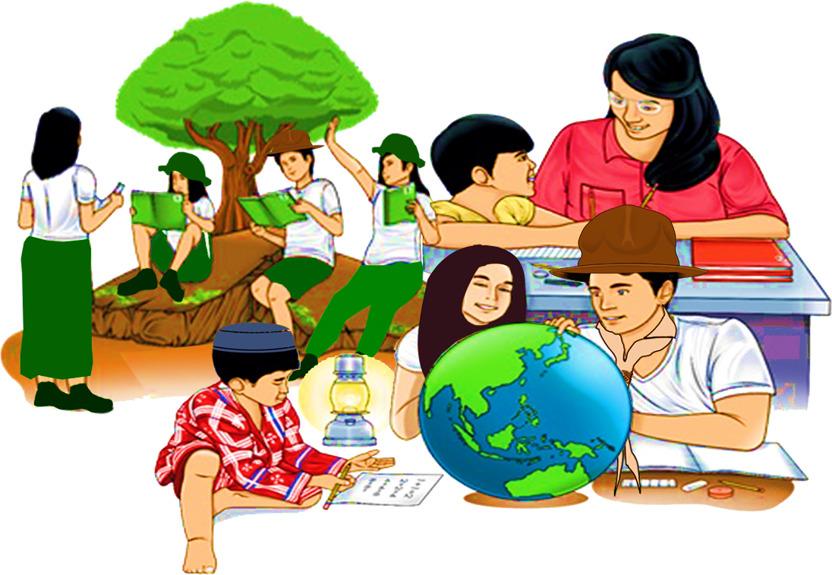
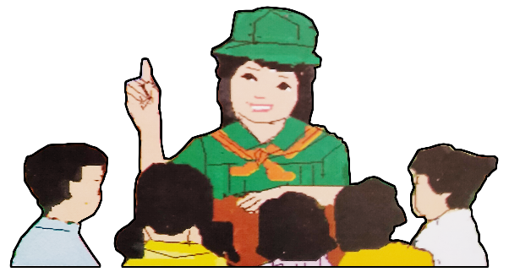
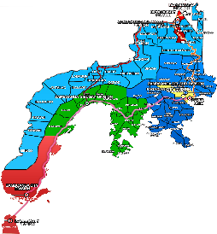

Quarter 4 – Module 6
Setting Aside Differences
)
ENGLISH
Name of Learner: ___________________________
Grade & Section: ___________________________
Name of School: ___________________________
7

Zest for Progress
Zeal of Partnership
Republic of the Philippines
Department of Education
Regional Office IX, Zamboanga Peninsula

What I Need To Know
KKKKKKKKKKkkkkkkknKNOW

Literature is a very important tool for us to know people around the world. You may not be able to visit different places but through reading, you will reach the farthest place that you want and you will learn the culture of people of that particular place you are reading. Since the very beginning of civilization, literature can already be observed, then some of the literary pieces were written by unknown authors and until later these were already published and became known.
Through literary pieces, writers will be able to assert their unique identity and culture and as readers you will discover the identity of other people in different places and understand them better. This module, which was anchored on the Most Essential Learning Competency (MELCs), “Discover literature as a tool to assert one’s unique identity and to better understand people”(EN7LT-III-G-5), aims to provide the learners the idea on how to appreciate and understand people’s identity.
In this module, you are expected to:
- Discover one’s unique identity through the material read.

What I Know

Activity 1: Fact or Bluff
Directions: Write Fact if the statement describes the literary pieces read in class and Bluff if it does not describe.
______________ 1. Stories have characters that make it interesting.
______________ 2. All main characters of stories have beautiful experiences.
______________ 3. Articles are informative pieces.
______________ 4. Authors get ideas in writing informative literary pieces from imagination.
______________ 5. All literary pieces whether stories or articles mirror life.
______________ 6. In stories, conflict is one element that describes the unique identity of the main character in his struggles.
______________ 7. Any literary piece is insignificant.
______________ 8. Poems are just expressions of the author’s emotions and are not reflections of life.
______________ 9. Stories, articles or poems are not to be disregarded because they explain how people live.
_____________ 10. We understand people when we read any literary piece.

What’s In

Activity 2. Deliciously Different.
Directions: Filipinos have their specialty in terms of foods according to the place they belong. Group the list of Filipino foods below according to their place of origin. Use the three major islands of the Philippines.
1. buko pie 7. cassava cake 12. yema cake
2. dried mangoes 8. lechon 13. strawberries
3. durian 9. chicken inasal 14. bagnet
4. cassava 10. marang 15. mangosteen
5. kinilaw 11. La paz bachoy 16. tuna
6. durian tart

Luzon | Visayas | Mindanao

Activity 3. You’re Not Eating Your Words.
Directions: Study the sentences related to the selection that you are about to read. Complete the following sentences by choosing the most appropriate word.
1. Filipinos decide to ______ abroad to experience different foods.
A. arise B. come C. go D. step

2. It is difficult to ______ a choice about the food that they will eat.
A. create B. do C. make D. place

3. Sometimes, they like to eat _______ steaks from restaurants.
A. fine B. sound C. well-done D. hastily

4. In the end, they will _____ a decision to eat in a Filipino-themed restaurant.
A. do B. make C. vary D. create

5. They keep on ______ for a restaurant to satisfy their hunger.
A. appreciating B. praising C. looking D. seeing

6. Finally, they arrived at a restaurant __________ with a lot of patis, daing, and all their favorite Filipino food.
A. fit B. healthy C. keep D. well-stocked

What’s New
Activity 4. Different But Delicious.
Directions: Read the narrative text titled, “Where’s the Patis?” by Carmen Guerrero-Nakpil.

Where’s the Patis?
Carmen Guerrero-Nakpil

Travel has become the great Filipino dream. In the same way that an American dreams of becoming a millionaire or an English boy dreams of going to one of the great universities, the Filipino dreams of going abroad. His most constant vision is that of himself as a tourist.

To visit Hong Kong, Tokyo, and other cities of Asia, per chance, to catch a glimpse of Rome, Paris, or London and to go to America (even if only for a week in a fly-specked motel in California) in the sum of all delights.

Yet having left the Manila International Airport in a pink cloud of despedidas and sampaguita garlands and pabilin, the dream turns into nightmare very quickly. But why? Because the first bastion of the Filipino spirit was the palate. And in all the palaces and fleshpots and skyscrapers of that magic world called “abroad” there is no patis to have.

Consider the Pinoy abroad, he has discarded barong tagalog or “polo” for a sleek, dark western suit. He takes to the habiliments from Hong Kong Brooks Brothers or Savile Row with the greatest of ease. He has also shed the casual informality of manner that is characteristically Filipino. He gives himself the airs of cosmopolite to the credit-card born. He is extravagantly courteous (especially in a borrowed language) and has taken to hand- kissing and too plenty of American “D’you mind?”

He hardly misses the heat, the native accent of Tagalog or Ilonggo or the company of his brown-skinned, cheerful compatriots. He takes, like a duck to water, to the skyscrapers, the temperate climate, the strange landscape and the fabled refinement of another world. How nice, after all, to be away from old RP for a change!

But as he sits down to meal, no matter how sumptuous, his heart sinks. His stomach juices, he discovers, are much less cosmopolitan than the rest of him. They are much less adaptable that his sartorial or social habits. They have remained in that dear barrio in Bulacan or in that little town in Ilocos and nothing that is set on the table before him can summon them to London or Paris.

There he is in the most expensive restaurant in Europe, surrounded by beautiful women and impeccably dressed men bending over their rich meal. Waiters in black ties and tails stand at his elbow ready to cater to his smallest wish. An array of glass, silver, china, and artistic blooms is set before him. An elegant wagon of hors d’oeuvres approaches: pink salmon from Scotland, golden English herring, sensuous anchovies from France, green salad from Belgian farm, mounds of Italian pasta, Russian caviar on ice, melon halves, stuffed eggs, shrimp smothered in piquant red sauce.

At that precise moment the Pinoy is overcome with a yearning for a mound of white rice, a bowl of sinigang and a little saucer of patis. What would happen, he asked himself, if I shouted for sinigang na bangus? The thought that perishes as he catches sight of the world-weary hauteur of the face of the waiter. With a sigh, he applies himself to the foreign delicacies. The herring, after a few mouthfuls tastes almost like tinapa. The shrimp would be excellent if he had some white sukang Iloko to soak it in but the melon is never half as good as the ones his wife buys from her suki in San Andres.

Now he must make another choice. The waiter, with an air of prime minister approaching a concordant murmurs, something about choosing a soup. The menu is in French and to be safe, our hero asks the waiter to recommend the specialty of the house. A clear consommé! When it comes, the Pinoy discovers that it is merely the kind of soup Filipinos sip when they are convalescing from “tifus” or “trancazo”. Tomato soup is almost an emetic. Onion soup with bits of bread and cheese is too odd for words but palatable. If he is lucky, the waiter brings bouillabaisse with a flourish. A French classic? Nonsense. We Filipinos invented it. It is sinigang, he tells the astonished waiter, only not quite good as we do it at home. And where, for heaven’s sake is the patis?

The entrée of the main course is quite another problem. Poulet is chicken. Fillet de sole is fish, though recognizable neither as apahap nor lapu-lapu. Tournedos is meat done in a barbarian way, thick and barely cooked with red juices still oozing out. The safest choice is steak. If the Pinoy can get it, well done enough and sliced thinly enough, it might remind him of tapa.

If the waiter only knew enough about Philippine cuisine, he might suggest venison which is really something like tapang usa, or escargots which the unstylish poor on Philippine beaches know as snails. Or even frogs’ legs which are a Pampango delight.

But this is the crux of the problem- where is the rice? A silver tray offers varieties of bread: slices of crusty French bread, soft yellow rolls, rye bread, crescents studded with sesame seeds. There are also potatoes in every conceivable manner, fried, mashed, boiled, buttered. But no rice.

The Pinoys learn that rice is considered a vegetable in Europe and America. The staff of life a vegetable!

And when it comes- a special order which takes at least half an hour-the grains are large, oval, and foreign-looking and what’s more, yellow with butter. And oh horrors! - One must shove it with pork or piled it with one’s knife on the back of another fork.

After a few days of these debacles, the Pinoy, sick with longing, decides to comb the strange city for a Chinese Restaurant, the closest thing to the beloved, gastronomic country. There in the company of other Asian exiles, he will put his nose finally in a bowl of rice and find it more fragrant than an English rose garden, more exciting than a castle on the Rhine and more delicious than pink champagne.

To go with rice, there is siopao (not so rich as at Salazar) pansit guisado reeking with garlic (but never so good as any that can be bought in the sidewalks of Quiapo) fried lumpia with the incorrect sauce, and even mami (but nothing like the downtown wanton)

Better than a Chinese restaurant is the kitchen of a kababayan. When in a foreign city, a Pinoy searches every busy sidewalks, theater, and restaurant for the well-remembered golden features of a fellow- Pinoy. But make no mistake. It is only because he is in desperate need of Filipino meal and, like a homing pigeon, he follows his nose to a Filipino kitchen that is well stocked with bagoong, patis, garlic, balat ng lumpia, gabi leaves and misua.

When the Pinoy finally finds such a treasure-house, he will have every meal with his kababayan. Forgotten are the bistros and the smart restaurant. The back of his hand to the Four Seasons and the Tour d’ Argent. Ah, the regular orgies of cooking and eating that ensue. He may never have known his host before. In Manila, if he saw him again, they would hardly exchange two words. But here in this odd, barbarian land where people eat inedible things and have never heard of patis, they are brothers forever.

The Filipino may denationalize himself but not his stomach. He may travel over the seven seas and the five continents and the two hemispheres and lose the savor of home and forget his identity and believe himself a citizen of the world. But he remains- the gastronomically, at least-always a Filipino. For, if in no other way, the Filipino loves his country with his stomach.

Source: Carmen Guerrero-Nakpil, “Where’s the Patis?”, English 7 Learner’s Material 2017, 322-325

Activity 5. Let’s Connect!
Instructions: Fill in the table with facts read in the selection.
Filipino food | Foreign food

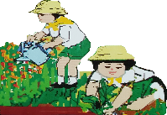
What Is It

The selection, “Where’s the Patis?” by Carmen Guerrero- Nakpil is a narrative that describes the unique Filipino identity being a food lover. Among the different tasty food, he still longs for rice and patis even in foreign countries. He is sick with longing for them.
A narrative is a form of literature which explains the experiences of the narrator. Through it, readers will be able to understand other people who are in contact with the narrator in the text. In this text, readers get to know more about Europeans, English, French and Chinese when the narrator went to expensive restaurants abroad.
Aside from narratives, other literary pieces such as poems, short stories, novels and many more are also the lens of one’s identity. By just reading the literary pieces, the reader will be immersed in the situation and could develop tolerance in the different identities.
Through the literary pieces written, the reader can be acquainted with some experiences of an individual and could have a glimpse of their unique identity. One’s identity is influenced by the beliefs, race and even the place where he came from. And through literature, the readers can understand and appreciate the uniqueness of every individual’s identity without judgment and bias.
What’s More

A. Directions. Read the questions carefully and choose the best answer by writing only the letter.
1. Which countries did the person in the selection visit?
A. Hongkong, Tokyo and London
B. Tokyo, Malaysia and America
C. America, Britain and Europe
D. Rome, Paris and Spain
2. Where does pink salmon originate?
A. Scotland
B. France
C. Russia
D. Italy

3. Why do you think the person in the selection misses things from the Philippines?
A. He is very hungry.
B. He sees them abroad.
C. He is given same things abroad.
D. He cannot have them in places he goes.
4. Why do you think “the Pinoy” in the selection will choose to eat with his kababayan rather than in an expensive restaurant?
A. He misses Filipinos too.
B. He can talk with his kababayan in the same language.
C. He enjoys eating with him with the same food as if at home.
D. He can talk about their families back home.
5. Why do Filipinos love to eat rice?
A. It is delicious.
B. It is a source of carbohydrates.
C. It gives more energy.
D. It is Filipinos’ staple food.

Activity 6. Fill in the Blanks
Directions: Fill in the blanks using the words given in the box. Base your answer from the narrative text you have read.
crave foreign specialty
narrative identity

1. The selection “Where’s the Patis?” is a ________.
2-3. Its main idea is to tell the readers that Filipinos _______ for Filipino food rather than the deliciously-prepared ________ food.
4. This form of literature also describes that in other countries people also have their own ________.
5. A Filipino may travel around the world and denationalize himself but his_____ remains through his stomach.

Activity 7. Graphic Organizer
Directions: Fill out the graphic organizer below with the details that describe the identity of a “Pinoy” in foreign countries.

Which countries did he visit?

Do you think the person misses things in the Philippines?
What are the international foods mentioned?
PINOY

What are the things mentioned that contribute to his identity?

What I Have Learned

Activity 8. Complete the statement.
Literature describes the unique identity of people. It is a _____________________________________
__________________________________________________________________________________
__________________________________________________________________________________
__________________________________________________________________________________
__________________________________________________________________________________

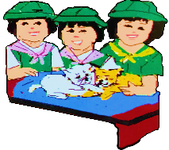
What I Can Do
Activity 9-A. My Identity
Directions: Write a composition of not more than 200 words about your own unique identity as a young Filipino. Use the rubrics as your guide in this activity. You can use the worksheet in the next page.
RUBRICS FOR WRITING A COMPOSITION

 | OUTSTANDING  (10 points) | VERY GOOD  (8 points) | GOOD  (6 points) | DEVELOPING  (4 points)
STRUCTURE | The composition has precise and clear structure. | The composition has a clear structure but a few misplaced ideas. | The composition has an unclear structure with a lot of misplaced ideas. | No structure was observed in the composition.
COHESION | The ideas in the composition are clearly linked to one another. | Most of the ideas in the composition are linked properly. | Only a few ideas are linked properly in the composition. | Links to the ideas are not clearly established.
CHOICE OF WORDS | The words used are all appropriate to the task. | Most of the words used are appropriate to the task. | Only a few words used are appropriate to the task. | Most of the words used are not appropriate to the task.
IDEAS | The readers can easily understand the ideas from the text. | The readers have to reread some of the sentences to understand the ideas in the composition. | The readers have to reread the whole composition to understand the ideas. | Most of the ideas are confusing leading to misinterpretation.

Worksheet no. 1

Activity 9-B. Reading Selection
The following is an excerpt of a short story, which is also a form of literature, showing the unique identity of an individual in a specific place in the Philippines. Read the selection and find out the Filipino identity by answering the questions that follow.

The Happiest Boy in the World
N.V.M. Gonzalez
(An excerpt)

One warm July night, Julio was writing a letter to- of all people – his landlord, Ka Ponso. It was about his son Jose who wanted to go to school in Mansalay, the town where Ka Ponso lived.

They had moved here to the island of Mindoro about a year ago because Julio had been unable to find any land of his own to farm. As it was, he thought himself lucky when Ka Ponso agreed to take him on as a tenant.

“Dear Compadre,” he started writing. A while before, his wife had given birth to a baby, Ka Ponso had happened to be in the neighborhood and offered to be the baby’s godfather. After that they had begun to call each other compadre. Julio was writing in Tagalog, bending earnestly over a piece of paper torn out of his son’s school notebook.

It was many months since he had had a writing implement in his hand. That was when he had gone to the municipal office in Mansalay to file a homestead application. Then he had used a pen and, to this surprise, had been able to fill in the blank form neatly. Nothing had come of the application, although Ka Ponso had assured him he had looked into the matter and talked with the officials concerned. Now, using a pencil instead of a pen, Julio was sure he could make his letter legible enough for Ka Ponso

“It’s about my boy Jose,” he wrote. “He’s in the sixth grade now.” He didn’t add that Jose had had to miss a year of school since coming here to Mindoro. “Since he’s quite a poor hand at looking after your carabaos, I thought it would be best that he go to school in the town.”

He leaned back against the wall. He was sitting in the floor writing one end of the long wooden bench that was the sole piece of furniture in their one-room house. The bench was in one corner, across from it stood the stove. To his right, his wife and the baby girl lay under a hemp of mosquito net. Jose too was here, sprawled beside a sack of un-husked rice by the doorway. He had been out all afternoon looking for one of Ka Ponso’s carabao that had strayed away to the newly planted rice clearings along the other side of the river. Now Jose was snoring lightly, like the tired youth he was. He was twelve years old.

The yellow flame of the kerosene lamp flickered ceaselessly. The dank smell of food, mainly, fish broth, that has been spilled from many a bowl and dried on the bench now seemed to rise from the very texture of the wood itself. The stark fact, if Julio’s nature had been sensitive to it, might have struck him a hard and sudden blow, but as it was, he just looked about the room, even as the small assailed his nostrils, and stared a moment at the mosquito net and then at Jose as he lay there by the door then he went on with his letter.

“This boy Jose, compadre,” he wrote, “is quite an industrious lad. If only you can make him do anything you wish any work. He can cook rice, and I’m sure he’d do well washing the dishes.”

Julio recalled his last visit to Ka Ponso’s place about three months ago, during the fiesta. It was a big house with many servants. The floors were so polished you could almost see your own image under your feet as you walked, and there was always a servant who followed you about with a rag to wipe away the smudges of dirt that your feet left on the floor.
“I hope you will not think of this as a great bother,” Julio continued, trying his best to phrase his thoughts. He had a vague fear that Ka Ponso might not regard his letter favorably. But he wrote on, slowly and steadily, stopping only from time to time to regard what he had written. “We shall repay you for whatever you can do for us, compadre. It’s true that we already owe you for many things, but my wife and I will do all we can indeed to repay you.”

Suddenly he began wondering how Jose would act in Ka Ponso’s house, unaccustomed as he was to many things there. The boy might even stumble over a chair and break some dishes. On and on went his thoughts, worrying about the boy.

‘And I wish you would treat Jose as you would your own son, compadre. You may beat him if he does something wrong. Indeed, I want him to look up to yu as a second father.”.

Well, he had completed the letter. He had feared he would never be able to write it. But now he was done, and, it seemed, the letter read well. The next day he must send Jose off with it.

About six o’clock the following morning, a boy of twelve was riding a carabao along the riverbed road to town. He made a very puny load on the carabao’s broad back. Walking close behind the carabao, the father accompanied him as far as the bend of the riverbed. When the beast hesitated to cross the small rivulet that cut the road as it passed a clump of bamboo, the man picked up a stick and prodded the animal. Then he handed the stick to the boy, as one might give a precious gift.

Now the boy was out of his father’s sight, concealed by a stand of tall hemp plants, their green leaves glimmering in the morning sun. Thinking of his father, Jose grew suddenly curious about the letter in his short pocket. He stopped his carabao under a shady tree by the roadside. A bird sang in a bush close by, and Jose could hear it as he read the letter.

Jumping from word to word, he found it difficult to understand his father’s dialect now that he saw it in writing. But as the meaning of each sentence became clear to him, he experienced a curious exultation. It was as though he was the happiest boy in the world and that bird was singing expressly for him. He also heard the tinkling of the stream far away. There he and his father had parted. The world seemed full of bird song and music from the stream.

Source: N.V.M. Gonzales, “The Happiest Boy in the World”, English 7 Learner’s Materials, 2017:339-342

Activity 10. What About the Story?
Directions: Answer the questions in complete sentences.
1. Who are the characters in the story?__________________________________________
_________________________________________________________________________
2. How does the author describe Julio?__________________________________________
_________________________________________________________________________
3. How does Julio describe the unique identity of his son Jose? ______________________
_________________________________________________________________________
4. What makes Julio different from Ka Ponso? ____________________________________
__________________________________________________________________________
5. If you were Jose, how would you feel if somebody sponsored you to go to school? ____
__________________________________________________________________________

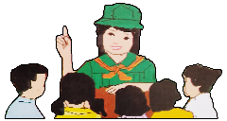
Assessment

A. Directions. Read the questions carefully and encircle the letter of the best answer.

1. Which countries did the person in the selection visit?
A. Hongkong, Tokyo and London C. America, Britain and Europe
B. Tokyo, Malaysia and America D. Rome, Paris and Spain

2. Where does pink salmon originate?
A. Scotland B. France C. Russia D. Italy

3. Why do you think the person in the selection misses things from the Philippines?
A. He is very hungry. C. He is given same things abroad.
B. He sees them abroad. D. He cannot have them in places he goes.

4. Why do you think “the Pinoy” in the selection will choose to eat with his kababayan rather than in an expensive restaurant?
A. He misses Filipinos too.
B. He can talk with his kababayan in the same language.
C. He enjoys eating with him with the same food as if at home.
D. He can talk about their families back home.

5. Why do Filipinos love to eat rice?
A. It is delicious. C. It gives more energy.
B. It is a source of carbohydrates. D. It is Filipinos’ staple food.

6. All are forms of literature EXCEPT:
A. artworks B. short stories C. narratives D. poems

7. How does literature explain the identity of people in different countries or situations?
A. the author explains it briefly C. through what the characters say and do
B. when you read the history of the setting D. when you know who the author is

8. Why does literature describe the identity of people anywhere in the world?
A. because literature is passed on from generation to generation
B. because literature is a gift to authors
C. because literature is a mirror of life
D. because literature is published

9. Do you come to realize the differences of people’s identity? How?
A. Yes, when I read different books.
B. Yes, when I encounter characters from different places
C. No, when the form of literature is only fantasy
D. No, when there is no author of the literary piece

10. What makes the narrator a “Pinoy”?
A. His physical attributes C. His experiences abroad.
B. His connections to foreigners. D. His choice of food.

Additional Activity (Optional)

Activity 11. Pick –up Lines
Directions: Identify the identity of a person or group from the given lines taken from other literary pieces. Write a word or phrase of your answer on the space provided.

1. For the Filipino would welcome any kind of life that the gods would offer him. (Pliant Like the Bamboo by I.V.Mallari)
_______________________________________________________________________________________
_______________________________________________________________________________________
_______________________________________________________________________________________

2. Then the Japanese came like a storm, like a plague of locusts, like a pestilence – (Pliant Like the Bamboo by I.V.Mallari)
_______________________________________________________________________________________
_______________________________________________________________________________________
_______________________________________________________________________________________

3. Later he had been told that at harvest time he would have to pay back twice that amount…Julio was not the sort to complain. (The Happiest Boy in the World by N.V. M. Gonzales)
______________________________________________________________________________________________________________________________________________________________________________
_______________________________________________________________________________________

Activity 12. Flower Power.
Directions: Fill out the graphic organizer to describe briefly your own identity.

Who Am I?

Answer Keys:

What’s In
Activity 3
1. C
2. C
3. C
4. B
5. C
6. D
What’s In Activity 2
Luzon Visayas Mindanao
buko pie dried mangoes durian
La Paz batchoy chicken inasal cassava
yema Cake kinilaw durian tart
strawberries lechon cassava cake
bagnet marang
mangosteen
tuna
What I Know
Activity 1
1. F 6. F
2. B 7. B
3. F 8. B
4. B 9. F
5. F 10. F

What’s New
Activity 4
Answers may vary
Additional Activity
Activity 11 & 12
Answers may vary
What I Can Do
Activity 9
Answers may vary
What’s New
Activity 5
Answers may vary

What’s More
Activity 6
1. narrative
2. crave
3. foreign
4. specialty
5. identity
What I Can Do
Activity 10
1. Julio, Ka Ponso, the boy
2. a loyal and humble person
3. an industrious boy
4. Julio is a tenant while Ka Ponso is a land owner
5. answes may vary
Assessment
1. A 6. A
2. A 7. C
3. D 8. C
4. C 9. B
5. D 10. D
What’s More
Activity 7
Answers may vary

What I Have Learned
Activity 8
Answers may vary

References:
Carmen G. Nakpil, “Where’s the Patis?”, English 7 Learner’s Material 2017: 322-325
English-Grade 7, Learner’s Material, First Edition, Department of Education, FEB Printing Corp., Philippines, 2017

DEVELOPMENT TEAM

Writer: Lylani M. Suela
Begang National High School
Editor:

Language Editor:
Proof Reader: Sayana S. Hassan, EPS
Illustrators: Julienne Izabel A. Buante, Lylani M. Suela
Layout Artist: Julienne Izabel A. Buante,
Management Team:
Julieto H. Fernandez, Ed. D., CESO VI
SDS-Isabela City
Maria Laarni T. Villanueva, Ed. D., CESE
ASDS-Isabela City
Henry R. Tura, CID Chief
Elsa A. Usman, LR Supervisor
Helen De Leon, EPS-English, Module Coordinator

Region IX: Zamboanga Peninsula Hymn – Our Eden Land
Here the trees and flowers bloom  Here the breezes gently Blow,  Here the birds sing Merrily,  The liberty forever Stays,  Here the Badjaos roam the seas  Here the Samals live in peace  Here the Tausogs thrive so free  With the Yakans in unity | Gallant men And Ladies fair  Linger with love and care  Golden beams of sunrise and sunset  Are visions you’ll never forget  Oh! That’s Region IX  Hardworking people Abound,  Every valleys and Dale  Zamboangueños, Tagalogs, Bicolanos, | Cebuanos, Ilocanos, Subanons, Boholanos, Ilongos,  All of them are proud and true  Region IX our Eden Land  Region IX  Our..  Eden...  Land...

My Final Farewell
Farewell, dear Fatherland, clime of the sun caress'd  Pearl of the Orient seas, our Eden lost!,  Gladly now I go to give thee this faded life's best,  And were it brighter, fresher, or more blest  Still would I give it thee, nor count the cost.  On the field of battle, 'mid the frenzy of fight,  Others have given their lives, without doubt or heed;  The place matters not-cypress or laurel or lily white,  Scaffold or open plain, combat or martyrdom's plight,  T is ever the same, to serve our home and country's need.  I die just when I see the dawn break,  Through the gloom of night, to herald the day;  And if color is lacking my blood thou shalt take,  Pour'd out at need for thy dear sake  To dye with its crimson the waking ray.  My dreams, when life first opened to me,  My dreams, when the hopes of youth beat high,  Were to see thy lov'd face, O gem of the Orient sea  From gloom and grief, from care and sorrow free;  No blush on thy brow, no tear in thine eye.  Dream of my life, my living and burning desire,  All hail ! cries the soul that is now to take flight;  All hail ! And sweet it is for thee to expire ;  To die for thy sake, that thou mayst aspire;  And sleep in thy bosom eternity's long night.  If over my grave some day thou seest grow,  In the grassy sod, a humble flower,  Draw it to thy lips and kiss my soul so,  While I may feel on my brow in the cold tomb below  The touch of thy tenderness, thy breath's warm power.  Let the moon beam over me soft and serene,  Let the dawn shed over me its radiant flashes,  Let the wind with sad lament over me keen ;  And if on my cross a bird should be seen,  Let it trill there its hymn of peace to my ashes. | Let the sun draw the vapors up to the sky,  And heavenward in purity bear my tardy protest  Let some kind soul o 'er my untimely fate sigh,  And in the still evening a prayer be lifted on high  From thee, 0 my country, that in God I may rest.  Pray for all those that hapless have died,  For all who have suffered the unmeasur'd pain;  For our mothers that bitterly their woes have cried,  For widows and orphans, for captives by torture tried  And then for thyself that redemption thou mayst gain  And when the dark night wraps the graveyard around  With only the dead in their vigil to see  Break not my repose or the mystery profound  And perchance thou mayst hear a sad hymn resound  'T is I, O my country, raising a song unto thee.  And even my grave is remembered no more  Unmark'd by never a cross nor a stone  Let the plow sweep through it, the spade turn it o'er  That my ashes may carpet earthly floor,  Before into nothingness at last they are blown.  Then will oblivion bring to me no care  As over thy vales and plains I sweep;  Throbbing and cleansed in thy space and air  With color and light, with song and lament I fare,  Ever repeating the faith that I keep.  My Fatherland ador'd, that sadness to my sorrow lends  Beloved Filipinas, hear now my last good-by!  I give thee all: parents and kindred and friends  For I go where no slave before the oppressor bends,  Where faith can never kill, and God reigns e'er on high!  Farewell to you all, from my soul torn away,  Friends of my childhood in the home dispossessed!  Give thanks that I rest from the wearisome day!  Farewell to thee, too, sweet friend that lightened my way; Beloved creatures all, farewell! In death there is rest!

I Am a Filipino, by Carlos P. Romulo
I am a Filipino–inheritor of a glorious past, hostage to the uncertain future. As such I must prove equal to a two-fold task–the task of meeting my responsibility to the past, and the task of performing my obligation to the future.  I sprung from a hardy race, child many generations removed of ancient Malayan pioneers. Across the centuries the memory comes rushing back to me: of brown-skinned men putting out to sea in ships that were as frail as their hearts were stout. Over the sea I see them come, borne upon the billowing wave and the whistling wind, carried upon the mighty swell of hope–hope in the free abundance of new land that was to be their home and their children’s forever.  I am a Filipino. In my blood runs the immortal seed of heroes–seed that flowered down the centuries in deeds of courage and defiance. In my veins yet pulses the same hot blood that sent Lapulapu to battle against the first invader of this land, that nerved Lakandula in the combat against the alien foe, that drove Diego Silang and Dagohoy into rebellion against the foreign oppressor.  The seed I bear within me is an immortal seed. It is the mark of my manhood, the symbol of dignity as a human being. Like the seeds that were once buried in the tomb of Tutankhamen many thousand years ago, it shall grow and flower and bear fruit again. It is the insignia of my race, and my generation is but a stage in the unending search of my people for freedom and happiness. | I am a Filipino, child of the marriage of the East and the West. The East, with its languor and mysticism, its passivity and endurance, was my mother, and my sire was the West that came thundering across the seas with the Cross and Sword and the Machine. I am of the East, an eager participant in its spirit, and in its struggles for liberation from the imperialist yoke. But I also know that the East must awake from its centuried sleep, shake off the lethargy that has bound his limbs, and start moving where destiny awaits.  I am a Filipino, and this is my inheritance. What pledge shall I give that I may prove worthy of my inheritance? I shall give the pledge that has come ringing down the corridors of the centuries, and it shall be compounded of the joyous cries of my Malayan forebears when first they saw the contours of this land loom before their eyes, of the battle cries that have resounded in every field of combat from Mactan to Tirad Pass, of the voices of my people when they sing:  “I am a Filipino born to freedom, and I shall not rest until freedom shall have been added unto my inheritance—for myself and my children and my children’s children—forever.”

