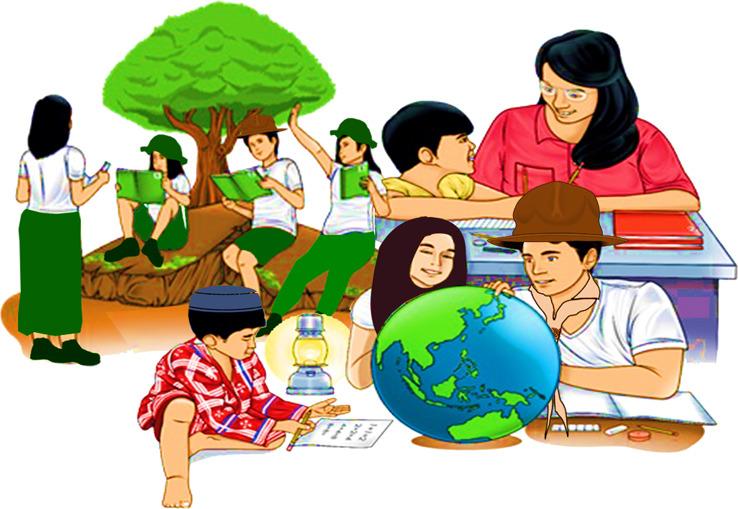
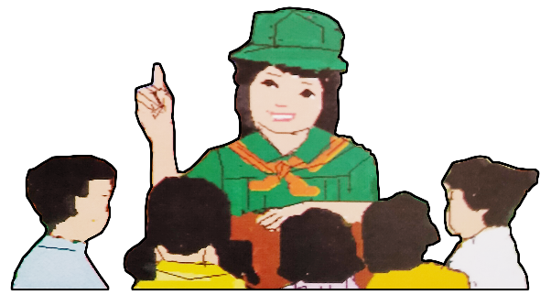
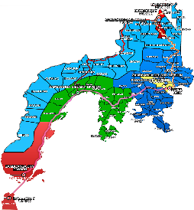

Quarter 4 – Module 3
Expanding Content of an Outline

ENGLISH
Name of Learner: ___________________________
Grade & Section: ___________________________
Name of School: ___________________________
8

Zest for Progress
Zeal of Partnership
Republic of the Philippines
Department of Education
Regional Office IX, Zamboanga Peninsula

What I Need to Know

This module was designed and written with you in mind. It is here to help you increase your knowledge about the content of an outline using notes from primary and secondary sources. The scope of this module focuses on the uses of different learning sources in outlining context.

Learning Objectives:
At the end of this module, the learners are expected to:
- Expand content of an outline using notes from primary and secondary sources (EN8WC-IIIc-1.1.6).
- explain the content of an outline using notes from primary and secondary sources.

In the light of exploring the module, you have to extend your patience in understanding and
analyzing what you are reading. Follow the directions in the activities.

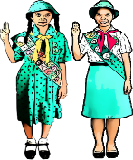
What I Know

Directions: Read the following statements and choose the letter of the correct answer.

1. All of the following are examples of documents under primary source EXCEPT:
- Original research
- Analysis of events
- First-hand accounts of someone’s experience
- An original document that does not analyze other documents

2. All of the following are examples of secondary source documents EXCEPT:
- Original materials
- Interpretations of original documents
- An analysis of primary sources or events
- Sources created later by someone who did not participate in the event

- An outline is a tool used to __________ written ideas about topic or thesis into a logical order.

- confuse
- disorganize
- jumble
- organize

- Which of the following is NOT an example of a primary source?
- Film footage of a historical event
- Diaries written at the time of an event
- Original uniforms worn at a time in history
- A poem about World War II from your classmates

- Which of the following is NOT a tip in writing an outline?
- Identify your topic.
- Put your points in no order.
- Write possible transitions between paragraphs.
- Decide what points you would like to discuss on your paper.

What’s In

Activity 1: Let’s Think

Directions: The following are documents that can be used as sources. Categorize these sources as primary or secondary sources using the organizer below.
Archives and Manuscripts Magazine Commentaries
Books Maps News
Encyclopedias Textbooks Book Reviews
Almanacs Data Personal Accounts
Periodicals Pamphlet Film

Primary Sources | Secondary Sources

Activity 2: Comment On
Directions: Look at the picture below. Using the guide questions, supply contents to the template provided to come up with an outline.
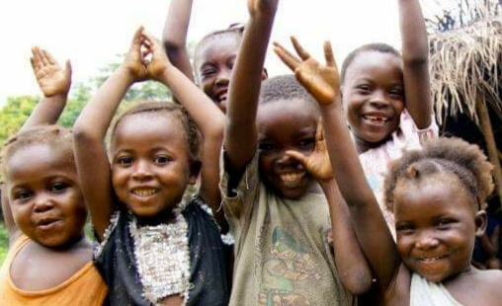
Figure 1
[Grab your reader’s attention with a great quote from the document or use this space to emphasize a key point. To place this text box anywhere on the page, just drag it.]

Guide Questions:
- What does the picture show?
- What are the possible issues underlying in the picture?

Main topic: I. ____________________________

Subtopics:

- _________________________________
- _________________________________
- _________________________________

- _________________________________
- _________________________________
- _________________________________

What’s New

Activity 3: Organize Your Point
Directions: Write the major point and subpoint for each written piece. Use the graphic organizer below in gathering entries for your outline.

Here is a text used as a primary source:

Natural Vegetation
The natural vegetation of the Philippines is rich and varied. Most of the land was originally covered by forest, containing more than 600 types of trees, of which at least 100 were of commercial importance. Tropical rainforest ordinarily prevails on the unclear lowlands and wetter mountain slopes, although pines are common at intermediate and higher altitudes in the north. Mangroves and nipa palm swamps occupy some of the coastal fringes. Much of the original forest cleared by logging, farming, and grazing is badly eroded and is covered by the tropical grass known locally as cogon. Forest products of commercial importance include both hardwood and softwood lumber and a variety of miscellaneous products, of which only bamboo and rattan are of significance.

Source: Collier’s Encyclopedia, Vol. 18, 1994, p. 686.

Major Point | Subpoint 1
 | Subpoint 2
 | Subpoint 3

Here is a literary text used as a secondary source:

These Lovely Things
Jose La. Villa Tierra

These things are lovely, and God made them so;
These little white sampaguitas wet with dew;
The graceful sway of grass, folk dancing on the lea;
The green of narra leaves; the blue of sky and sea;
The lacy waterfalls and rainbows in the sun;
The Master’s canvas in the west when day is done;
The humble nipa hut beneath the swaying palms
Listening to the breezes lilting pagan psalms;
The moonbeams on the bay; each little bird that sings;
Dalagas on the lane; the color summer brings …
These things are lovely, and God made them so,
And placed them in my country – row on row.
I’m glad I’m too poor to leave my shore
And miss this loveliness outside my cottage door.

Source: Philippine Prose and Poetry, Vol.Two (Revised Edition).
Department of Education, Bureau of Public Schools, Manila, 1964. p. 14.

Major Point | Subpoint 1
 | Subpoint 2
 | Subpoint 3

What you have just done is an example of outlining the content from primary and secondary sources. You will learn more on how to expand the content in the succeeding parts of this module.
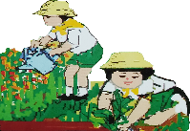
What Is It

In this lesson, you will learn a method of organizing your ideas in a logical order. It is using an outline, an organized list of what you plan to write about. It is a sketch of what your paragraph will look like. It is also your guide to keep you on the right track when you are writing your first draft.
What is an outline?

Creating an outline is a good step to take while writing your paper. It allows you to brainstorm new ideas and make sure your paper will be organized, focused and supported. Many writers find it easier to write from an outline instead of starting from a blank page.

Tips in writing an outline

- Identify your topic.
- Decide what points you would like to discuss on your paper.
- Put your points in numerical order.
- Write possible transitions between paragraphs.
Here is a sample of outlining a topic extracted from secondary source:
Topic : Chinese Boys and Girls
- Sports
- Likes
- Dislikes
- Usual Celebration
- Leisure
- Description

So let’s extend the outline into a paragraph!
Although Chinese boys and girls have almost no sports like ours, they have many games and pastimes to while away the hours. It seems, the greatest of all games to them is kite flying. And I believe that if we had such fascinating and wonderful kites as they have, we would enjoy this sport, too. On any pleasant day, but especially on Kite Day, the whole sky is full of kites. They look like flocks of swaying, many colored birds. Some of them are seven feet from tip to tip, and some are so small, you wouldn’t believe they could fly at all.

In expanding your outline into a paragraph, one may use sources, such as primary and secondary source to help you in processing the effectivity and reliability of your topic. This will also help you in adding more ideas. So let’s make it happen, students!

They are best when used together.

Figure 2 Venn diagram
What’s More

Activity 4: Let’s expand it more

Directions: Read the following report. Organize the information into a topic outline.

Clouds can be used to predict weather because different types of clouds signal different kinds of weather.
Cirrus clouds are generally wispy and elongated in form. They are made of ice crystal and they usually appear before a storm. Stratus clouds (i.e., stratified clouds) are heavily layered and often appear in sheet like formation. They are low, dark clouds which may indicate snow or rain. Cumulus clouds are billowy. They are white and may appear during good weather. Nimbus clouds are dense, dark, rain-producing clouds.
The identification of cloud types is an important skill for aviators and aviation meteorologists because clouds present variable icing hazards. Ice formation can drastically reduce the effectiveness of air foils (wings, flags, rudder, ailerons, and elevators) and may destroy the control of an aircraft.

Source: Life Accents, Singapore: Times Printer PTE Ltd.,2003.

Topic: ___________________________________

- ___________________________________
- _____________________________
- _____________________________
- _____________________________

- ________________________________
- _____________________________
- _____________________________
- _____________________________

Activity 5: Let’s do the reverse

Directions: Below is an outline about learning modalities. All you need to do is to expand more ideas in the template below.

Topic: Learning Modalities in the New Normal
- Learning Modalities

- Modular
- What is it?
- How is it done?

- Online
- What is it?
- How is it done?

- Blended
- What is it?
- How is it done?

Answer here:

____________________________________________________________________________________________________________________________________________________________________________________________________________________________________________________________________________________________________________________________________________________________________________________________________________________________________________________________________________________________________________________________________________________________________________________________________________________________________________________________________________________________________________________________________________________________________________________________________________________________________________________________________________________________________________________________________________________________________________________________________________________________________________________________________________________________________________________________________________________________________________________________________________________________________________________________________________________________________________________________________________________________________________________________________________________________________________________________________________________________________________________________________________________________
________________________________________________________________________________________________________________________________________________________________________________________________________________________________________________________________________________________________________________________________________________________________________________________________________________________________________________________________________________________________________________________
What I Have Learned

Activity 6: Expand it well
Directions: Share your thoughts about the lessons you learned in this module. Use the questions below to guide you in writing your composition.

Guide Questions:
- What is outlining?
- What are the tips in writing an outline?

________________________________________________________________________________________________________________________________________________________________________________________________________________________________________________________________________________________________________________________________________________________________________________________________________________________________________________________________________________________________________________________________________________________________________________________________________________________________________________________________________________________________________________________________________________________________________________________________________________________________________________________________________________________________________________________________________________________________________________________________________________________________________________________________________________________________________________________________________________________________________________________________________________________________________________________________________________________________________________________________________________________________________________________________________________________________________________________________________________________________________________________________________________________________________________________________________________________________________________________________________________________________________________________________________________________________________________________________________________________________________________________________________________________________________________________________________________________________________________________________________________________________________________________________________________________________________________________________________________________________________________________________________________________________________________________________________________________________________________________________________________________________________________________________________________________________________________________________________________________________________________________________________________________________________________________________________________________________________________________________________________________________________________________________________________________________________________________________________________________________________________________________________________________________
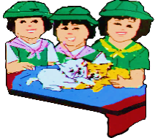
What I Can Do

In this interview Ben Bagley asks Theresa Han about the difference between Korean and American culture. Theresa is a teenager who recently moved to the United States so she has an excellent perspective for understanding the differences and similarities between these countries.
[BAGLEY] This is Ben Bagley, and I'm going to interview Theresa Han about Korea. Could you introduce yourself?
[HAN] My name is Theresa Han, I'm from South Korea, I'm 18 years old, and I'm a freshman in college.
[BAGLEY] How long have you lived in America?
[HAN] I think a little bit less than 3 years.
[BAGLEY] Where did you live in Korea?
[HAN] I lived in Pyoung Tek, it’s right below Oksana, where the American Air force is located.
[BAGLEY] What were the people like where you lived?
[HAN] They're really busy. Fathers go to their work; mothers if they have a job go to their work, and students go to school, so they don't have enough time to communicate with each other, like time to spend together, because mostly students come home like 10:00 pm-11:00 pm.
[BAGLEY] What did you do with your friends?
[HAN] We mostly go to each other's house, rent a movie or something, watch it, and do homework usually, because we have a whole bunch of homework. On the weekends we would go downtown; it's kind of like a shopping mall. It's a street. There are small restaurants, small cloths shops and all that stuff. It was...... middle of paper ... ... came home 7:00 pm. But some students stay longer, like even 10:00 pm if you are a senior and about to go to college because there is kind of, like parents and teacher think their kids or students should go to college. Like have to go to college. They’re gonna pressure them to study a lot, so when you’re a senior you start to study a lot and you don’t sleep that much. Usually I think some people sleep 3 or 4 hours per day and just study. No free time.
[BAGLEY] And they stay at school and study?
[HAN] Till like 10:00 pm but after school ends, they come home and study like until 2:00am or 3:00 am
[BAGLEY] Would it be ok if I publish this interview on the internet?

Activity 7: Let’s have it outlined
Directions: In the table below, outline the conversation of Ben Bagley and Theresa Han.

Topic: ___________________________________________________________________________

- ______________________________________________________________________

- ______________________________________________
- ___________________________________________
- ___________________________________________
- ______________________________________________
- ___________________________________________
- ___________________________________________
- _______________________________________________________________________

- ______________________________________________
- ___________________________________________
- ___________________________________________
- ______________________________________________
- ___________________________________________
- ___________________________________________

Activity 8: Write it up

Directions: From your answer above, write a paragraph to explain your ideas about “The conversation of Ben Bagley and Teresa Han”. Use the rubrics as your guide in writing.

 | Holistic | Content | Organization | Convention
Excellent | Strong evidence of writer’s voice  (5pts). | Topic is clearly defined  (5 pts). | Deliberately used outline format  (5 pts). | Proper use of two sources  (5 pts).
Better | Addresses main idea or prompt  (3 pts). | Topic is well developed  (3 pts). | Show some sense in using outline  (3 pts). | Two sources used (3pts).
Good | Partial understanding of the writing process (2 pts). | Topic and supporting sentences are weak  (2 pts). | Few sense of using of outline  (2 pts). | One source used  (2 pts).
Minimal | Minimal grasp of writing process  (1 pt). | No details or facts listed  (1 pt ). | No sense of organization  (1 pt). | Proper source used (1 pt).

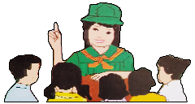
Assessment

Directions: Read the following statements and circle the letter of the correct answer.

- How does outlining help best in expanding the content?
- It allows you to explore new sources.
- It enables you to discover new ideas.
- It makes your work easier to accomplish.
- It expands the ideas from one concept to another.

- What benefit do the readers get in reading an expanded content from an outlined topic?
A. The content will have more presented information.
B. The content will lead to confusing information.
C. The content will give a bigger picture of the concept.
D. The content will provide specific details about the ideas.

- What is the benefit of using an outline to draft a paragraph?
- Outline only presents subtopics.
- Outline allows disarranging information.
- Outline is a tool used to disorganize written ideas.
- Outline allows you to compile information and set directions.

- In writing an outline, what should be considered?
- No answers are correct
- Quality of ideas
- Sentence structure
- Logical order

- A Grade 8 student is advised to write a paragraph. He/she would like to have a lengthy one. In expanding one’s paragraph, which of the following should be his/her consideration in constructing a paragraph?
- Write supporting sentence then conclude it.
- Focus on inconsistent ideas.
- Focus on primary sources.
- Draft an outline of the topic, extend possible sources and write an effective and credible paragraph.

- Which of the following statements BEST defines secondary sources?
- A source that provides more credible as evidence.
- A source that provides raw information and first-hand evidence.
- A source that gives you direct access to the subject of your research.
- A source that provides second-hand information and commentary from other researchers.

- Which of the following sentences is NOT a tip in writing an outline?
- Identify your topic.
- Put your points in no order.
- Write possible transitions between paragraphs.
- Decide what points you would like to discuss on your paper.

8. Which of the following ideas signifies a writer’s purpose in writing an outline?
- It helps the writer disorganize his ideas.
- It is a tool for the writer to disarrange ideas.
- An outline helps the writer to see no picture.
- A writer finds it easier to write from an outline instead of starting from a blank page.

9. Encyclopedias, almanacs, book reviews, magazines and commentaries are used in publication. If you are writer Ken, do you consider these sources as primary source in your publication?
- Yes, encyclopedias, Almanacs, et al are samples of secondary source.
- No, encyclopedias, Almanacs, et al are samples of secondary source.
- Yes, encyclopedias, Almanacs, et al are samples of primary source.
- No, encyclopedias, Almanacs, et al are samples of secondary source.

10. Creating an outline is a good step to take while writing your paper. From the tips learned in writing an outline, what would consider first?
- Identify your topic.
- Write possible transitions between paragraphs.
- Decide what points you would like to discuss on your paper.
- Put your points in numerical order.

Additional Activity
Directions: Read the commentary news by Dr. Takeshi Kasai. Create an outline using the tips you have learned in this module.
Source: Regional Director for the Western Pacific World Health Organization, From COVID-19 containment to suppression in the Western Pacific Region: 2020 Lessons for 2021 “World Health Organization” https://who.int/westernpacific/news/commentaries/detail-hq/from-covid-19-containment-to-suppression-in-the-western-pacific-region-2020-lessons-for-2021

References:

Textbooks
Anama, Gina A; Anna Lea A. Davide; Ricardo Ador Dionisio; Lerma L. Flandez; Armi Victoria A. Fiangaan; Marcelino E. Ibanez; Gizelle V. Laud; Jovelyn A. Lita; Roselyn D. Mujal; Christine H. Pepito; Prudencia M. Sanoy; Grace Annette B. Soriano; Peter S. Tentoco III; Riza R. Zuniga. Voyages in Communication Learning Material English - Grade 8. Pasig City: Department of Education, 2013, 198, 319, 320.

Bermudez, Virginia F., Ed.D.; Josephine M. Cruz, Ph. D.; and Remedios F. Nery, Milagros A. San Juan, Ph. D. English Expressways II. Quezon City: SD Publications, INC., 2010, 24, 32, 238, 239.

Answer Key
What I have learned
Activity 6: Expand it well!
Answers may vary
What I can do
Activity 7: Let’s have it outlined!
Answers may vary
Activity 8: Write it up!
Answers may vary

Assessment
- C
- D
- D
- D
- D
- D
- B
- D
- B
- A

What I know
- D
- A
- D
- D
- B
What’s in
Activity 1: Let’s Think! Answers may vary.
Activity 2: Comment on!
Answers may vary.
What’s New
Activity 3: Organize your point!
Answers may vary.
What’s more
Activity 4: Let’s expand it more!
Answers may vary.
Activity 5: Let’s do the reverse!
Answers may vary.

DEVELOPMENT TEAM

Writers: Farhana L. Emam, Basilan National High School
Cheamay M. Ansali, Geras Integrated School
Editor:

Language Editor:
Proofreader: Sayana S. Hasan, EPS
Illustrators: Farhana L. Emam, Cheamay M. Ansali
and Christianvil T. Garcia
Layout Artist: Christianvil T. Garcia, Basilan National High School
Management Team:
Julieto H. Fernandez, Ed. D., CESO VI
SDS-Isabela City
Maria Laarni T. Villanueva, Ed. D., CESE
ASDS-Isabela City
Henry R. Tura, CID Chief
Elsa A. Usman, LR Supervisor
Helen De Leon, EPS-English, Module Coordinator

Region IX: Zamboanga Peninsula Hymn – Our Eden Land
Here the trees and flowers bloom  Here the breezes gently Blow,  Here the birds sing Merrily,  The liberty forever Stays,  Here the Badjaos roam the seas  Here the Samals live in peace  Here the Tausogs thrive so free  With the Yakans in unity | Gallant men And Ladies fair  Linger with love and care  Golden beams of sunrise and sunset  Are visions you’ll never forget  Oh! That’s Region IX  Hardworking people Abound,  Every valleys and Dale  Zamboangueños, Tagalogs, Bicolanos, | Cebuanos, Ilocanos, Subanons, Boholanos, Ilongos,  All of them are proud and true  Region IX our Eden Land  Region IX  Our..  Eden...  Land...

p

My Final Farewell
Farewell, dear Fatherland, clime of the sun caress'd  Pearl of the Orient seas, our Eden lost!,  Gladly now I go to give thee this faded life's best,  And were it brighter, fresher, or more blest  Still would I give it thee, nor count the cost.  On the field of battle, 'mid the frenzy of fight,  Others have given their lives, without doubt or heed;  The place matters not-cypress or laurel or lily white,  Scaffold or open plain, combat or martyrdom's plight,  T is ever the same, to serve our home and country's need.  I die just when I see the dawn break,  Through the gloom of night, to herald the day;  And if color is lacking my blood thou shalt take,  Pour'd out at need for thy dear sake  To dye with its crimson the waking ray.  My dreams, when life first opened to me,  My dreams, when the hopes of youth beat high,  Were to see thy lov'd face, O gem of the Orient sea  From gloom and grief, from care and sorrow free;  No blush on thy brow, no tear in thine eye.  Dream of my life, my living and burning desire,  All hail ! cries the soul that is now to take flight;  All hail ! And sweet it is for thee to expire ;  To die for thy sake, that thou mayst aspire;  And sleep in thy bosom eternity's long night.  If over my grave some day thou seest grow,  In the grassy sod, a humble flower,  Draw it to thy lips and kiss my soul so,  While I may feel on my brow in the cold tomb below  The touch of thy tenderness, thy breath's warm power.  Let the moon beam over me soft and serene,  Let the dawn shed over me its radiant flashes,  Let the wind with sad lament over me keen ;  And if on my cross a bird should be seen,  Let it trill there its hymn of peace to my ashes. | Let the sun draw the vapors up to the sky,  And heavenward in purity bear my tardy protest  Let some kind soul o 'er my untimely fate sigh,  And in the still evening a prayer be lifted on high  From thee, 0 my country, that in God I may rest.  Pray for all those that hapless have died,  For all who have suffered the unmeasur'd pain;  For our mothers that bitterly their woes have cried,  For widows and orphans, for captives by torture tried  And then for thyself that redemption thou mayst gain  And when the dark night wraps the graveyard around  With only the dead in their vigil to see  Break not my repose or the mystery profound  And perchance thou mayst hear a sad hymn resound  'T is I, O my country, raising a song unto thee.  And even my grave is remembered no more  Unmark'd by never a cross nor a stone  Let the plow sweep through it, the spade turn it o'er  That my ashes may carpet earthly floor,  Before into nothingness at last they are blown.  Then will oblivion bring to me no care  As over thy vales and plains I sweep;  Throbbing and cleansed in thy space and air  With color and light, with song and lament I fare,  Ever repeating the faith that I keep.  My Fatherland ador'd, that sadness to my sorrow lends  Beloved Filipinas, hear now my last good-by!  I give thee all: parents and kindred and friends  For I go where no slave before the oppressor bends,  Where faith can never kill, and God reigns e'er on high!  Farewell to you all, from my soul torn away,  Friends of my childhood in the home dispossessed!  Give thanks that I rest from the wearisome day!  Farewell to thee, too, sweet friend that lightened my way; Beloved creatures all, farewell! In death there is rest!

I Am a Filipino, by Carlos P. Romulo
I am a Filipino–inheritor of a glorious past, hostage to the uncertain future. As such I must prove equal to a two-fold task–the task of meeting my responsibility to the past, and the task of performing my obligation to the future.  I sprung from a hardy race, child many generations removed of ancient Malayan pioneers. Across the centuries the memory comes rushing back to me: of brown-skinned men putting out to sea in ships that were as frail as their hearts were stout. Over the sea I see them come, borne upon the billowing wave and the whistling wind, carried upon the mighty swell of hope–hope in the free abundance of new land that was to be their home and their children’s forever.  I am a Filipino. In my blood runs the immortal seed of heroes–seed that flowered down the centuries in deeds of courage and defiance. In my veins yet pulses the same hot blood that sent Lapulapu to battle against the first invader of this land, that nerved Lakandula in the combat against the alien foe, that drove Diego Silang and Dagohoy into rebellion against the foreign oppressor.  The seed I bear within me is an immortal seed. It is the mark of my manhood, the symbol of dignity as a human being. Like the seeds that were once buried in the tomb of Tutankhamen many thousand years ago, it shall grow and flower and bear fruit again. It is the insignia of my race, and my generation is but a stage in the unending search of my people for freedom and happiness. | I am a Filipino, child of the marriage of the East and the West. The East, with its languor and mysticism, its passivity and endurance, was my mother, and my sire was the West that came thundering across the seas with the Cross and Sword and the Machine. I am of the East, an eager participant in its spirit, and in its struggles for liberation from the imperialist yoke. But I also know that the East must awake from its centuried sleep, shake off the lethargy that has bound his limbs, and start moving where destiny awaits.  I am a Filipino, and this is my inheritance. What pledge shall I give that I may prove worthy of my inheritance? I shall give the pledge that has come ringing down the corridors of the centuries, and it shall be compounded of the joyous cries of my Malayan forebears when first they saw the contours of this land loom before their eyes, of the battle cries that have resounded in every field of combat from Mactan to Tirad Pass, of the voices of my people when they sing:  “I am a Filipino born to freedom, and I shall not rest until freedom shall have been added unto my inheritance—for myself and my children and my children’s children—forever.”

