Republic of the Philippines
Department of Education
Regional Office IX, Zamboanga Peninsula

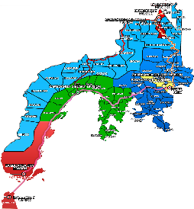
8

Zest for Progress
Zeal of Partnership

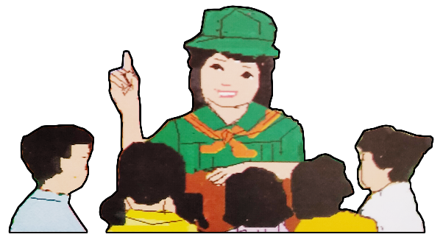
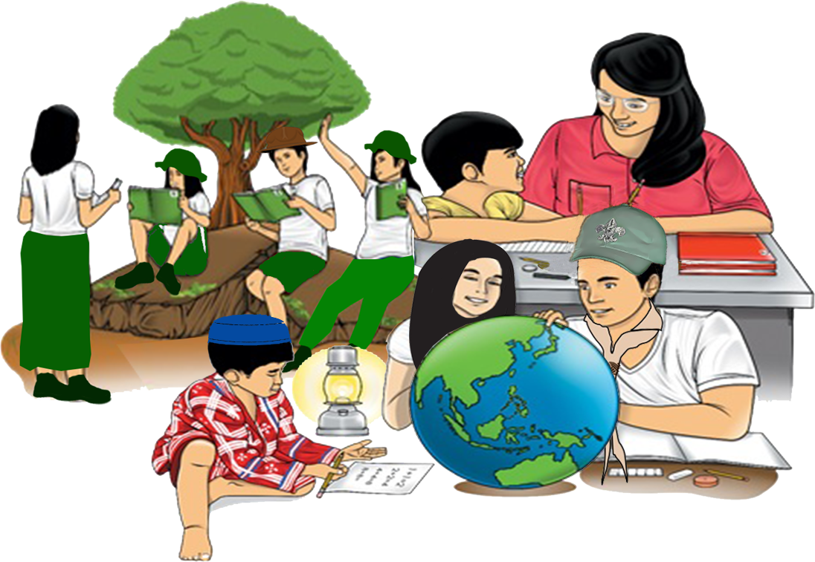
Quarter 4 - Module 5
Paragraph Composition

ENGLISH
Name of Learner: ___________________________
Grade & Section: ___________________________
Name of School: ___________________________
What I Need to Know

Part of the challenges as a writer is to compose an effective paragraph. This involves activities that lead the students into writing with a certain amount of control in the choice of topic, the necessary and relevant details in the development of the topic, and careful observance of correct and appropriate language.

This lesson will aid the learner on how to compose effective paragraph. Your skill in writing will be demonstrated at the end of the lesson.

Learning Objectives:

At the end of this module, you are expected to:
- Compose effective paragraphs. (EN8WC-Ila-2.8)
- identify the different parts of the paragraph; and
- compose an effective paragraph.
What I Know

Activity 1
Directions: Read each item carefully and circle the letter of the correct answer.

1. Which of the following BEST describes a paragraph?

A. It is a distinct section of a piece of writing. C. It a group of words.
B. It is a group of phrases. D. It is a structure of a sentence.

2. Which part of the paragraph contains the topic sentence?

A. Body C. Conclusion
B. Introduction D. Supporting details

3. How many parts does a simple paragraph have?

A. One C. Two
B. Three D. Four

4. The ____________________ tells the reader what the paragraph is all about.

A. Topic sentence C. Concluding sentence
B. Introduction D. Content

5. Which part of a paragraph ties up all the ideas presented?

A. Topic sentence C. Supporting sentence
B. Paragraph D. Concluding sentence

What’s In

Activity 2: Crossword Puzzle
Directions: Look for the hidden words listed below. You can find them in the puzzle written
in all directions.

Hidden Words
Introduction Body Conclusion
Unity Completeness Coherence
Emphasis Paragraph Sentence
Essay

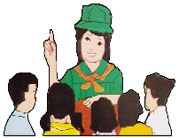
What’s New

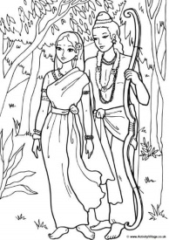
The Ramayana
By: Maharshi Valmiki

Dasharatha, King of Ayodhya, has three wives and four sons.
Rama is the eldest. Bharata is the second and the other two are twins,
Lakshmana and Shatrughna.

1.)

In a neighboring city the ruler's daughter is named Sita. When it is time for Sita to choose her bridegroom, at a certain ceremony called a swayamvara, Sita indicates she has chosen Rama as her husband by putting a garland around his neck. The disappointed suitors watch.
King Dasharatha, Rama's father, decides it is time to give his throne to his eldest son Rama. Everyone seems pleased. However, Rama's stepmother, the king's second wife, is not pleased. She wants her son, Bharata, to rule. Because of an oath Dasharatha had made to her years before, she gets the king to agree to banish Rama for fourteen years and to crown Bharata, even though the king, on bended knees, begs her not to demand such things.
Rama, always obedient, is as content to go into banishment in the forest as to be crowned king. Sita convinces Rama that she belongs to his side and his brother Lakshmana also begs to accompany them. Rama, Sita and Lakshmana set out for the forest.

Questions:

1. What is the main idea of the text?
___________________________________________________
2. What are some significant details that support the main idea?
___________________________________________________
___________________________________________________
2.)

Years pass and Rama, Sita and Lakshmana are very happy in the forest. One day a rakshasa princess tries to seduce Rama, and Lakshmana wounds her and drives her away. She returns to her brother Ravana, the ten-headed ruler of Lanka, and tells her brother (who has a weakness for beautiful women) about lovely Sita.
Ravana devises a plan to abduct Sita. He sends a magical golden deer which Sita desires. Rama and Lakshmana go off to hunt the deer, first drawing a protective circle around Sita and warning her she will be safe as long as she does not step outside the circle. As they go off, Ravana (who can change his shape) appears as a holy man begging alms. The moment Sita steps outside the circle to give him food, Ravana grabs her and carries her off to his kingdom in Lanka.
Rama is broken hearted when he returns to the empty hut and cannot find Sita. A band of monkeys offers to help him find Sita. Ravana has carried Sita to his palace in Lanka, but he cannot force her to be his wife so he puts her in a grove and alternately sweet-talks her and threatens her in an attempt to get her to agree to marry him. Sita will not even look at him but thinks only of her beloved Rama. Hanuman, the general of the monkey band, can fly since his father is the wind, and Hanuman flies to Lanka and, finding Sita in the grove, comforts her and tells her Rama will soon come and save her.
Ravana's men capture Hanuman, and Ravana orders them to wrap Hanuman's tail in cloth and to set it on fire. With his tail burning, Hanuman hops from house-top to house-top, setting Lanka afire. He then flies back to Rama to tell him where Sita is. Rama, Lakshmana and the monkey army build a causeway from the tip of India to Lanka and cross over to Lanka. A mighty battle ensues. Rama kills several of Ravana’s brothers and then Rama confronts ten-headed Ravana. Rama finally kills Ravana.

3. Are the ideas arranged in the most logical order?
__________________________________________________
4. Do the paragraphs present a clear and understandable idea of the subject?
Explain your answer.
___________________________________________________
___________________________________________________

Rama frees Sita. After Sita proves her purity, they return to Ayodhya and Rama becomes king. His rule, Ram-Rajya, is an ideal time when everyone does his or her dharma and "fathers never have to light the funeral pyres for their sons."

3.)

5. Does the paragraph tell a clear ending of the selection? Explain your answer.
___________________________________________________
___________________________________________________
6. How are the ideas presented in the text?
___________________________________________________
___________________________________________________

The Topic Sentence
The first part of the text contains the topic sentence that states the main idea.

The Supporting Sentences

The second part of the text is composed of supporting sentences and is usually found in the middle of the paragraph. They provide details such as explanations or examples that expand on or support the topic sentence.

The Concluding Sentence

The last part of the text is the concluding sentence which is sometimes used in longer paragraphs to sum up the ideas presented.

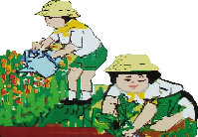
What is it

Let’s learn more about the basic features of the paragraph.

1. Unity
Unity in the paragraph means oneness of idea. A good paragraph possesses unity when all the sentences develop the main idea. Unity in the paragraph is achieved by the use of (a) a topic sentence that develops the idea, (b) supporting details, and a (c) clinching sentence.

2. Completeness
Completeness is achieved in a paragraph if it says all that is intended to say and it includes only enough examples.

3. Coherence
The word “coherence” is derived from “cohere” literally means “to hold together.” If the sentences in the paragraph should relate to the topic sentence to effect a unified whole, these sentences should further be arranged in an orderly sequence and linked to one another to ensure a smooth progression of ideas from one sentence to another. It means sentences move clearly from one idea to the next without gaps.

4. Emphasis / Order
Emphasis is achieved when sentences reveal an order that the reader can see and follow, such as, from general to specific, from whole to part, from cause to effect, from abstract to concrete, and so on.

Steps in Writing a Simple Paragraph

Steps in Writing a Simple Paragraph

Step 1: Choose a general topic.
Example: Elders

Step 2: Narrow down general topic to a specific topic.
Example: Respecting Elders

Step 3: Write up to three questions (how, when, where, why, who, what)
about your specific topic.
Examples: What are the different ways to respect elders?
Why do you respect your elders?
Who do you consider as your elders?

Step 4: Choose one question (from step 3) on which to focus your paragraph.
Example: What are the different ways to respect elders?

Step 5: Reword your question (from step 4) into a statement. This will be the
topic sentence for your paragraph.
Example: There are many different ways to respect our elders.

Step 6: Write down three sentences that help support your topic sentence.
In this example, these supporting sentences should tell what those
ways to respect elders are.
Examples: I often kiss their hands.
I especially like to listen to their pieces of advice.
They still love to do things at home, so I help them.

Step 7: Summarize your topic sentence and three supporting sentences with
a concluding sentence.
Example: I would continue respecting them to show that I appreciate
them very much.

What’s More

Activity 3: Fill Me In

Directions: Read the following sentences. Then write them in the organizer below
following the steps in writing a paragraph.

- They are a living book where we can read valuable stories and get lessons in life.

- Our young generation today must learn to value the wisdom of our elders.

- The wise elders are a fountain of good counsels that can never be compared to any material wealth in this world.

- The wisdom of our elders must then be treasured by our present generation.

- Our wise elders are a great source of knowledge, wisdom and information that will help us, the youths to be better persons.

Topic sentence:

Detail 3
Detail 2
Detail 1

Conclusion:

Activity 4: Logical Organization

Directions: The following sentences are part of a paragraph of which are presented in
scrambled order. Carefully read the sentence and decide the best order
in which to put the parts so they form a well-organized paragraph.

1.
A. A mother and her 14-year-old son were talking about his girlfriend.
B. “She thinks I’m handsome, fun, smart, and a good dancer.
C. “And what do you think you like about her?”
D. “What does she like about you?”

1. Which should be the first sentence? _____
2. Which should be the second sentence? _____
3. Which should be the third sentence? _____
4. Which should be the fourth sentence? ______

2.
A. It is at the heart of many emotional problems.
B. As a remedy, exercise is one of the common methods to reduce stress.
C. Stress is a part of society’s problem.
D. What many don’t realize is that it is also a contributory factor to many physical
problems.

1. Which should be the first sentence? _____
2. Which should be the second sentence? _____
3. Which should be the third sentence? _____
4. Which should be the fourth sentence? ______

What I Have Learned

Activity 5: Think and Write
Directions: Now, write your own composition about the important learnings on the basic parts of the paragraph. Follow the steps you have just learned. Be guided by the rubric below in accomplishing the task.
____________________________________________________________________________________________________________________________________________________________________________________________________________________________________________________________________________________________________________________________________________________________________________________________________________________________________________________________________________________________________________________________________________________________________________________________________________________________________________________________________________________________________________________________________________________________________________________________________________________________________________________________________________________________________________________________________________________________________________________________________________________________________________________________________________________________________________________________________________________________________

Simple Paragraph Rubric

Criteria | 5 | 4 | 3 | 2 | 1
Content | All sentences in the paragraph are related to the topic. | Only 5 sentences in the paragraph are related to the topic. | Only 4 sentences in the paragraph are related to the topic. | Only 3 sentences in the paragraph are related to the topic. | All sentences are not related to the topic.
Organization of Ideas | The paragraph shows a logical arrangement of ideas. | The paragraph shows 1-2 sentences which are not properly organized. | The paragraph shows 3-4 sentences which are not properly organized. | The paragraph shows 5 sentences which are not properly organized. | The paragraph has more than 5 sentences which are not properly organized.
Mechanics of Writing | All rules on capitalization, spelling, grammar, etc. are properly observed. | Any 1-2 rules are not properly observed. | Any 3-4 rules are not properly observed. | Any 5 rules are not properly observed. | More than 5 rules are not properly observed.

What I Can Do

Activity 6: Scrambled Paragraphs

Directions: Read the following scrambled paragraphs and arrange the parts to form a
well-organized composition. Write your answer on the space provided.

Land of the Morning
The country struggled and strived for self-rule and freedom. There were popular revolts and uprising against Spain. Dr. Jose P. Rizal was executed on December 30, 1896. The short-lived Philippine Republic was declared on June 12, 1898 with Gen. Emilio Aguinaldo as President of the Philippine Republic. Manuel L. Quezon was the first President of the Commonwealth, November 15, 1935. On July 4, 1946, the Philippines became independent. Freedom became a precious heritage.
The Philippines is like no other place. It has 7,000 or so islands. It is an archipelago that stretches from the North at the Southern tip of Taiwan to the tip ending close to Northern Borneo. It has a lot of variations in geographic, climatic, and vegetational conditions.
It has a long and painful history. Ferdinand Magellan accidentally discovered the Philippines for Spain in 1521. It was named after Philip II of Spain in 1541. The first Spanish settlement was established in Cebu in 1565. The Capital was moved to Manila in 1571. Spain ceded the country to America. America was involved in World War II. The country was invaded by the Japanese in 1941 and was liberated in 1945.

Introduction
_______________________________________________________________________________________________________________________________________________________________________________________________________________________________________________________________________________________________________________________________________________________________________________________

Supporting sentences
_______________________________________________________________________________________________________________________________________________________________________________________________________________________________________________________________________________________________________________________________________________________________________________________

Conclusion
__________________________________________________________________________________________________________________________________________________________________________________________________________________________________________________________________________________________________________

Activity 7: Identifying Parts of a Paragraph

Directions: Rewrite the following sentences using the given organizer.

A. Hawkers are people who move from one place to another and sell their goods by
shouting on the streets.

B. They work hard throughout the day.
C. They move on the street on their bicycle and sometimes on foot and sell their products.
D. We can see hawkers everywhere.
E. They move everywhere selling their goods without caring about the weather.

Topic Sentence:

Detail 1:

Detail 2:

Detail 3:

Conclusion:

Activity 8: Reflect and Compose

Direction: Using the rubric below, write a composition on a topic you are familiar with.

Simple Paragraph Rubric

Criteria | 5 | 4 | 3 | 2 | 1
Content | All sentences in the paragraph are related to the topic. | Only 5 sentences in the paragraph are related to the topic. | Only 4 sentences in the paragraph are related to the topic. | Only 3 sentences in the paragraph are related to the topic. | All sentences are not related to the topic.
Organization of Ideas | The paragraph shows a logical arrangement of ideas. | The paragraph shows 1-2 sentences which are not properly organized. | The paragraph shows 3-4 sentences which are not properly organized. | The paragraph shows 5 sentences which are not properly organized. | The paragraph has more than 5 sentences which are not properly organized.
Mechanics of Writing | All rules on capitalization, spelling, grammar, etc. are properly observed. | Any 1-2 rules are not properly observed. | Any 3-4 rules are not properly observed. | Any 5 rules are not properly observed. | More than 5 rules are not properly observed.
___________________________________________________________________________________________________________________________________________________________________________________________________________________________________________________________________________________________________________________________________________________________________________________________________________________________________________________________________________________________________________________________________________________________________________________________________________________________________________________________________________________________________________________________________________________________________________________________________________________________________________________________________________________________________________________________________________________________________________________________________________________________________________________________________________________________________________________________________________________________________________________________________________________________________________________________________________________________________________________________
____________________________________________________________________________________________________________________________________________________________________________________________________________________________________________________________________________________________________________

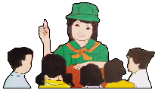
Assessment
Directions: Read each item carefully and circle the letter of the correct answer.

1. How can we achieve coherence in writing a paragraph?
A. It is achieved when sentences are written in a logical manner.
B. It is achieved when there is oneness of idea.
C. It is achieved when ideas are from general to specific.
D. It is achieved when ideas are arranged in a certain order.

2. Which of the basic features of a paragraph develops the main idea?
A. Coherence
B. Emphasis
C. Unity
D. Completeness

3. Which of the following statements BEST defines emphasis/order?
A. It attracts reader’s attention.
B. It provides examples that are related to the topic and controlling idea.
C. It discusses more than one idea.
D. It is achieved when sentence reveals an order from general to specific.

4. Which is NOT a basic feature of a paragraph?
A. Completeness C. Unity
B. Conclusion D. Coherence
5. Why is it important to observe unity in a paragraph?
A. It develops single idea thorouhgly and links it to the rest of the sentence.
B. It creates bridges and makes your writing understandable.
C. It presents ideas that support the topic.
D. It ties up all ideas presented.

Use the text below to answer item # 6.
“Dora the Explorer is an educational show for kids.”

6. Which detail BEST supports the topic sentence?
A. She has a cute monkey named Boots.
B. Dora’s purple backpack holds all of her tools.
C. Dora helps teach kids Spanish words.
D. She usually stops swiper from swiping.

Use the text below to answer item # 7.
“I hate doing laundry. It takes a long time to do. I do not like folding the clothes. I never get the wrinkles out.”

7. Which is the topic sentence of the paragrah?
A. I hate doing laundry.
B. I do not like folding the clothes.
C. It takes a long time to do.
D. I never get the wrinkles out.

8. What is the main purpose of the concluding paragraph?
A. To show the reader that the essay is complete.
B. To give some new and final points and information that will help the
reader understand the text.
C. To review the essential information and purpose of the paragraph to the reader.
D. To help the reader think or act in a different way.

Read the sentence below to answer item # 9.
It takes a lot of hardwork to become a professional athlete.

9. Which of the following details BEST supports the topic sentence?
A. The pros live the good life.
B. People like professional football players make a lot of money.
C. Professional athletes spend countless hours practicing their sports.
D. All of us can be professional athletes.

10. “And they lived happily ever after” is found in which part of a paragraph?
A. Topic sentence C. Body of the paragraph
B. Introduction D. Conclusion

Answer Key

WHAT I KNOW
Activity 1 WHAT’S NEW WHAT’S MORE Activity 4 ASSESSMENT
1. A Questions A. B. 1. A 6. C
2. B 1. Answers may vary 1. A 1. C 2. C 7. A
3. B 2. Answers may vary 2. D 2. A 3. D 8. C
4. A 3. Answers may vary 3. B 3. D 4. B 9. C
5. D 4. Answers may vary 4. C 4. B 5. A 10. D
5. Answers may vary
6. Answers may vary

WHAT’S MORE WHAT I HAVE LEANERD WHAT I CAN DO
Activity 3 Activity 5 Activity 7 Activity 8
Answers may vary Answers may vary Answers may vary Answers may vary

WHAT’S IN Activity 2 WHAT I CAN DO Activity 6

References:
Textbooks

Anama, Gina A.; Davide, Anna Lea A.; Dionisio, Ricardo Ador,; Flandez, Lerma L.; Fiangaan, Armi Victoria A.; Ibañez, Marcelino E.; Laud, V. Gizelle; Lita, Jovelyn A,; Mujal, Roselyn D.; Pepito, Christine H.; Sanoy, Prudencia m.; Sariano, Grace Annette B.; Tentoco, Peter III S.; Zuñiga,, Riza R. Voyages in Communication Learning Material. Pasig City: Department of Education, 2013, 81-82.

English 7 Learner’s Material, Department of Education-Bureau of Learning Resources, Republic of the Philippines, First Edition 2017, 8, 9, 82, 115.

Magallona-Flores, Magelende; Edna Montano-Dela Cruz; Helen Ponce De Leon-Ladera. Ventures in Communication. Quezon City: Rex Book Store, Inc., Book Media Press, Inc., and Mandaluyong City: Printwell, Inc., 153.

Image
http://nilayashokshah.wordpress.com/2018/03/11/lord-rama-pencil-sketches/amp/
istockphoto.com

Development Team

Writers: Maria Jocelyn D. Ramos, Basilan National High School

Marvin B. Manuel, Tandung Ahas National High School
Editor:
Language Editor:
Proofreader: Sayana S. Hasan, EPS
Illustrators: Maria Jocelyn D. Ramos, Marvin B. Manuel
and Christianvil T. Garcia
Layout Artist: Christianvil T. Garcia, Basilan National High School
Management Team:
Julieto H. Fernandez, Ed.D., CESO VI
SDS – Isabela City

Maria Laarni T. Villanueva, Ed.D., CESE
ASDS – Isabela City

Henry R. Tura
CID Chief

Elsa A. Usman
LR Supervisor

Helen D.R. De Leon, Ed.D.
EPS-English, Module Coordinator

Region IX: Zamboanga Peninsula Hymn – Our Eden Land
Here the trees and flowers bloom  Here the breezes gently Blow,  Here the birds sing Merrily,  The liberty forever Stays,  Here the Badjaos roam the seas  Here the Samals live in peace  Here the Tausogs thrive so free  With the Yakans in unity | Gallant men And Ladies fair  Linger with love and care  Golden beams of sunrise and sunset  Are visions you’ll never forget  Oh! That’s Region IX  Hardworking people Abound,  Every valleys and Dale  Zamboangueños, Tagalogs, Bicolanos, | Cebuanos, Ilocanos, Subanons, Boholanos, Ilongos,  All of them are proud and true  Region IX our Eden Land  Region IX  Our..  Eden...  Land...

My Final Farewell
Farewell, dear Fatherland, clime of the sun caress'd  Pearl of the Orient seas, our Eden lost!,  Gladly now I go to give thee this faded life's best,  And were it brighter, fresher, or more blest  Still would I give it thee, nor count the cost.  On the field of battle, 'mid the frenzy of fight,  Others have given their lives, without doubt or heed;  The place matters not-cypress or laurel or lily white,  Scaffold or open plain, combat or martyrdom's plight,  T is ever the same, to serve our home and country's need.  I die just when I see the dawn break,  Through the gloom of night, to herald the day;  And if color is lacking my blood thou shalt take,  Pour'd out at need for thy dear sake  To dye with its crimson the waking ray.  My dreams, when life first opened to me,  My dreams, when the hopes of youth beat high,  Were to see thy lov'd face, O gem of the Orient sea  From gloom and grief, from care and sorrow free;  No blush on thy brow, no tear in thine eye.  Dream of my life, my living and burning desire,  All hail ! cries the soul that is now to take flight;  All hail ! And sweet it is for thee to expire ;  To die for thy sake, that thou mayst aspire;  And sleep in thy bosom eternity's long night.  If over my grave some day thou seest grow,  In the grassy sod, a humble flower,  Draw it to thy lips and kiss my soul so,  While I may feel on my brow in the cold tomb below  The touch of thy tenderness, thy breath's warm power.  Let the moon beam over me soft and serene,  Let the dawn shed over me its radiant flashes,  Let the wind with sad lament over me keen ;  And if on my cross a bird should be seen,  Let it trill there its hymn of peace to my ashes. | Let the sun draw the vapors up to the sky,  And heavenward in purity bear my tardy protest  Let some kind soul o 'er my untimely fate sigh,  And in the still evening a prayer be lifted on high  From thee, 0 my country, that in God I may rest.  Pray for all those that hapless have died,  For all who have suffered the unmeasur'd pain;  For our mothers that bitterly their woes have cried,  For widows and orphans, for captives by torture tried  And then for thyself that redemption thou mayst gain  And when the dark night wraps the graveyard around  With only the dead in their vigil to see  Break not my repose or the mystery profound  And perchance thou mayst hear a sad hymn resound  'T is I, O my country, raising a song unto thee.  And even my grave is remembered no more  Unmark'd by never a cross nor a stone  Let the plow sweep through it, the spade turn it o'er  That my ashes may carpet earthly floor,  Before into nothingness at last they are blown.  Then will oblivion bring to me no care  As over thy vales and plains I sweep;  Throbbing and cleansed in thy space and air  With color and light, with song and lament I fare,  Ever repeating the faith that I keep.  My Fatherland ador'd, that sadness to my sorrow lends  Beloved Filipinas, hear now my last good-by!  I give thee all: parents and kindred and friends  For I go where no slave before the oppressor bends,  Where faith can never kill, and God reigns e'er on high!  Farewell to you all, from my soul torn away,  Friends of my childhood in the home dispossessed!  Give thanks that I rest from the wearisome day!  Farewell to thee, too, sweet friend that lightened my way; Beloved creatures all, farewell! In death there is rest!

I Am a Filipino, by Carlos P. Romulo
I am a Filipino–inheritor of a glorious past, hostage to the uncertain future. As such I must prove equal to a two-fold task–the task of meeting my responsibility to the past, and the task of performing my obligation to the future.  I sprung from a hardy race, child many generations removed of ancient Malayan pioneers. Across the centuries the memory comes rushing back to me: of brown-skinned men putting out to sea in ships that were as frail as their hearts were stout. Over the sea I see them come, borne upon the billowing wave and the whistling wind, carried upon the mighty swell of hope–hope in the free abundance of new land that was to be their home and their children’s forever.  I am a Filipino. In my blood runs the immortal seed of heroes–seed that flowered down the centuries in deeds of courage and defiance. In my veins yet pulses the same hot blood that sent Lapulapu to battle against the first invader of this land, that nerved Lakandula in the combat against the alien foe, that drove Diego Silang and Dagohoy into rebellion against the foreign oppressor.  The seed I bear within me is an immortal seed. It is the mark of my manhood, the symbol of dignity as a human being. Like the seeds that were once buried in the tomb of Tutankhamen many thousand years ago, it shall grow and flower and bear fruit again. It is the insignia of my race, and my generation is but a stage in the unending search of my people for freedom and happiness. | I am a Filipino, child of the marriage of the East and the West. The East, with its languor and mysticism, its passivity and endurance, was my mother, and my sire was the West that came thundering across the seas with the Cross and Sword and the Machine. I am of the East, an eager participant in its spirit, and in its struggles for liberation from the imperialist yoke. But I also know that the East must awake from its centuried sleep, shake off the lethargy that has bound his limbs, and start moving where destiny awaits.  I am a Filipino, and this is my inheritance. What pledge shall I give that I may prove worthy of my inheritance? I shall give the pledge that has come ringing down the corridors of the centuries, and it shall be compounded of the joyous cries of my Malayan forebears when first they saw the contours of this land loom before their eyes, of the battle cries that have resounded in every field of combat from Mactan to Tirad Pass, of the voices of my people when they sing:  “I am a Filipino born to freedom, and I shall not rest until freedom shall have been added unto my inheritance—for myself and my children and my children’s children—forever.”

