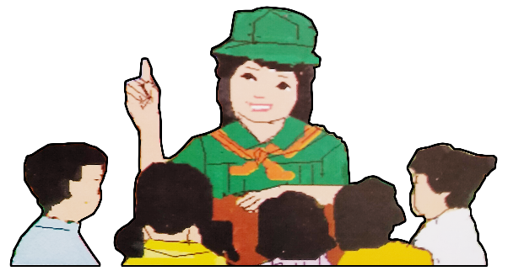
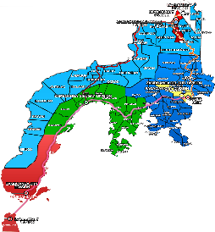
Quarter 4 – Module 7
Making Generalizations
English

Name of Learner: ___________________________
Grade & Section: ___________________________
Name of School: ___________________________
9

Zest for Progress
Zeal of Partnership
Republic of the Philippines
Department of Education
Regional Office IX, Zamboanga Peninsula

What I Need To Know

Making generalizations is one of the ways used when reacting or forming judgements on critical issues that an individual may hear or learn about. Specific details and evidences have to be considered to be able to draw general ideas or statements that are valid.

Oftentimes, people would clash and have misunderstanding because of the faulty generalizations that they make. Thus, it is significant for you to learn how to make generalizations as it helps you to be aware of using your logical thinking and to look for facts before giving your reaction or judgement on any issue.

In this module, you are expected to:
- React to lay value judgement on critical issues that demand sound analysis and call for prompt actions (UNCODED)
- Generalize statements based on critical issues presented.

What I Know

Activity 1: PRE-TEST
Directions: Read the selection in the box, then answer the questions that follow by encircling the letter of the correct answer.

If there is no communication, employees cannot know what their associates are doing, management cannot receive information inputs, and management cannot give instruction. Coordination of work is impossible, and the organization will collapse for lack of it. Cooperation also becomes impossible, because people cannot communicate their needs and feelings to others. We can say with some confidence that every act of communication influences the organization in some way.

Source:https://www.google.com/url?sa=t&source=web&rct=j&url=http://repository.ut.ac.id/3806/1/PBIS4208-M1.pdf&ved=2ahUKEwjP-uGBoL3uAhUQrpQKHYmPD-MQFjAAegQIARAB&usg=AOvVaw2YOgQIn2vrf1_aD3dHro9r

- What is the general idea of the text?
- Organization cannot exist without communication.
- When there is no communication, employees cannot know what their associates are doing.
- Coordination of work is impossible, and the organization will collapse for lack of communication.
- Every act of communication influences the organization in some ways.

- Which of the following do you need to consider when making a generalization?
- Supporting details based on facts
- Predictions
- Rumors
- Emotion

- Which of the following signals generalization?
- Generally…
- For example…
- The following are…
- However…

- How does a generalization become faulty?
- By providing facts/evidences
- By mere sharing your ideas/opinions and emotions
- By giving examples
- By using logic and sound analysis

- How do you make a valid generalization?
- By providing by facts, logic and reasoning, and with several examples
- By sharing mere opinions
- By expressing your feelings and emotions
- By going against the ideas presented

What’s in

Activity 2: A Matter of Perspective
Look at the editorial cartoon below. Then answer the questions that follow:

Source: A Journey Through Anglo-American Literature Learner’s Material English 9, page 217

- What can you say about the cartoon?
___________________________________________________________________________________________________________________________________________________________________________________________________________________________________________________
_________________________________________________________________________________

- What general idea does it convey?
___________________________________________________________________________________________________________________________________________________________________________________________________________________________________________________
_________________________________________________________________________________

What’s New

Activity 3: Digging the Text
Directions: Read and understand the paragraph below then answer the following questions.

Nicotine has various effects on the body. In small doses nicotine serves as a nerve stimulant, entering the bloodstream and promoting the flow of adrenaline, a stimulating hormone. It speeds up the heartbeat and may cause it to become irregular. It also raises the blood pressure and reduces the appetite, and it may cause nausea and vomiting. The known health risks associated with cigarette smoking, such as damage to the lungs and lung cancer, are thought to be caused by other components of cigarettes such as tars and other by-products of smoking, and by the irritating effects of smoke on the lung tissue. Addiction to smoking is caused by nicotine itself. Stopping smoking produces withdrawal symptoms within 24 to 48 hours, which commonly include irritability, headaches, and anxiety, in addition to the strong desire to smoke.

(taken from Microsoft®Encarta®Reference Library 2003)
Source:https://www.google.com/url?sa=t&source=web&rct=j&url=http://repository.ut.ac.id/3806/1/PBIS4208-M1.pdf&ved=2ahUKEwjP-uGBoL3uAhUQrpQKHYmPD-MQFjAAegQIARAB&usg=AOvVaw2YOgQIn2vrf1_aD3dHro9r

- What is the general word used in the paragraph? _________________________________________________________________________________
_________________________________________________________________________________

- What is the general idea of the paragraph? ________________________________________________________________________________
_________________________________________________________________________________

- Where can you find the general idea?
________________________________________________________________________________
_________________________________________________________________________________

- Does the author present the details to support the general idea by using specific facts or examples? Prove your answer.
_________________________________________________________________________________
_________________________________________________________________________________
________________________________________________________________________________
_________________________________________________________________________________

What Is It
Generalization
- A broad statement about a group of people or things.
- When you make a statement about all or most of the people or things together, you are
Making a generalization.
- It states something they have in common.
- There are certain words that signal or give us a clue to recognize generalizations.
– Sometimes  – Always | – Never  – Most | – Many  – All | – Generally  – Seldom | – None

- Some generalizations are valid or true, but some are faulty or invalid.
- Valid Generalizations
- Valid means true
- It is supported by facts.
- It agrees with what you know about the topic.
- It uses logic and reasoning.
- It is proven with several examples.
Example: All birds have wings. – VALID GENERALIZATION
- Faulty Generalizations
- Faulty means false
- It is not supported by facts.
- Watch for key words: none, all, always, never, everyone and nobody.
Example: All animals have four legs. – FAULTY GENERALIZATION
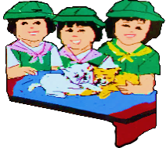
What’s More

Activity 4: Picture Analysis
Directions: Formulate general statements based on the issue presented on each picture below.
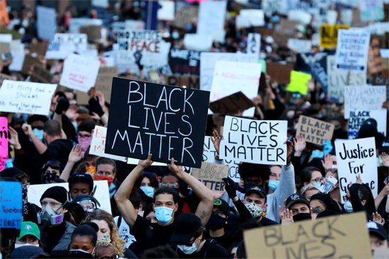

Source: https://www.britannica.com/topic/Black-Lives-Matter

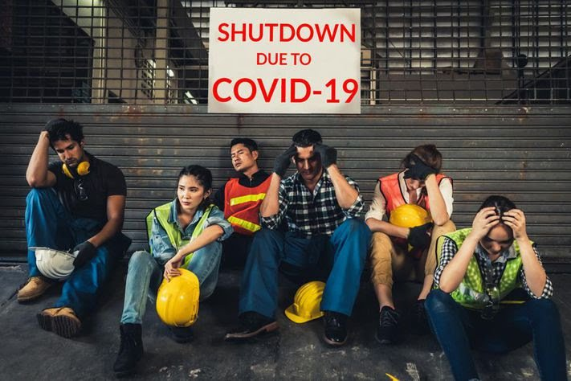

Source:https://www.google.com/amp/s/www.forbes.com/sites/advisor/2020/04/14/coronavirus-concerns-will-less-income-or-job-loss-hurt-your-credit-score/amp/

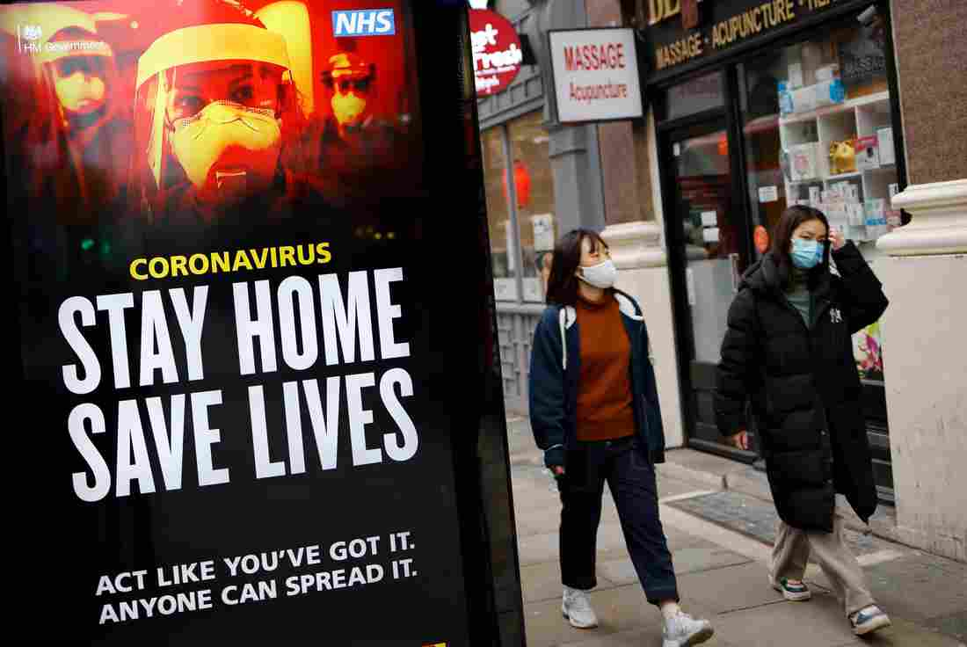

Source:https://www.npr.org/sections/goatsandsoda/2021/01/08/954967079/coronavirus-faq-how-do-i-protect-myself-from-the-u-k-variant

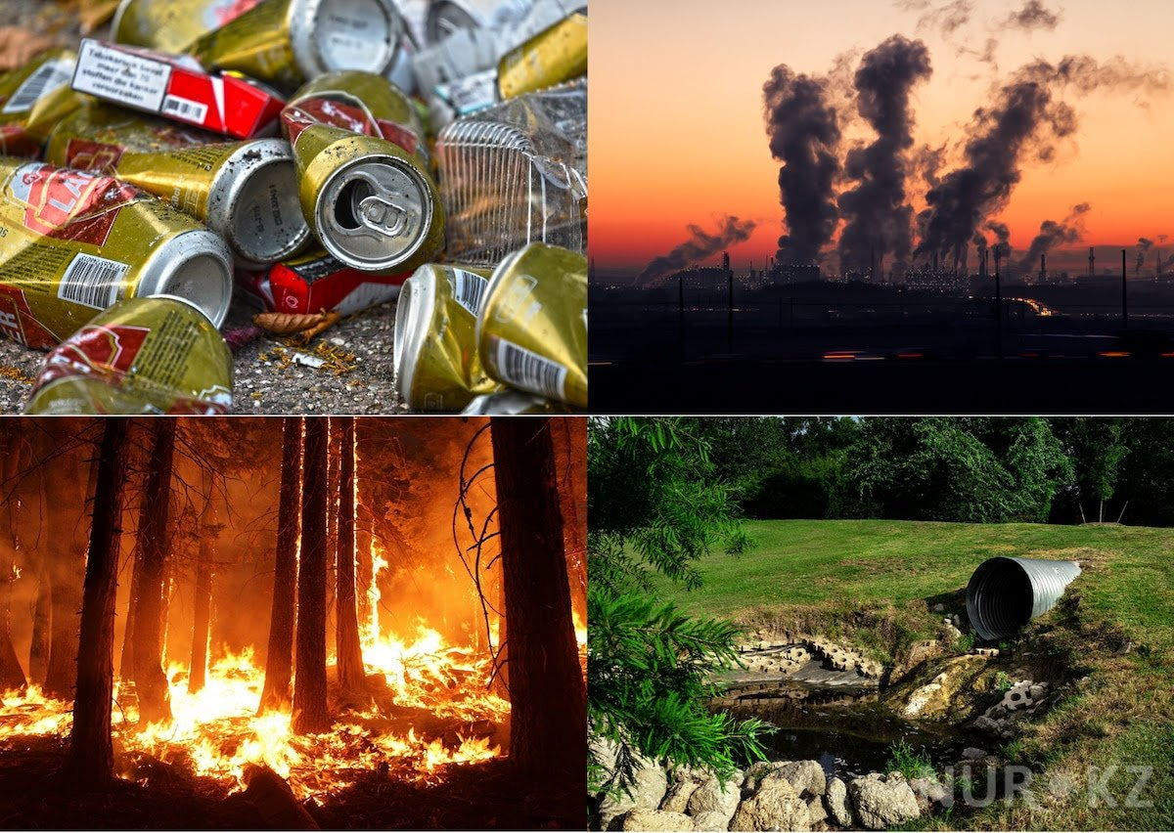

Source: https://www.google.com/amp/s/kami.com.ph/amp/111709-current-global-issues-ways-address-2020.html

Source: https://news.yale.edu/2020/06/22/study-shows-pandemics-impact-hours-worked-us-small-businesses

Activity 5: Making Generalization
Directions: Make a general statement on each of the following passages. Write your answer on the space provided.

- Each letter in Spanish generally represents one sound while a letter in English may represent many sounds. The letter in Spanish is always pronounced "ee" (as in the Spanish word isla). The same letter in English represents many sounds, as in the words island, Indian, and machine. In addition, Spanish has some symbols which English does not use. For example, Spanish includes accent marks on some vowels (television). English words do not have accent marks (television). Spanish has an upside-down question mark before questions (Vienes?), but English does not (Are you coming?).

Source:https://www.google.com/url?sa=t&source=web&rct=j&url=http://repository.ut.ac.id/3806/1/PBIS4208-M1.pdf&ved=2ahUKEwjP-uGBoL3uAhUQrpQKHYmPD-MQFjAAegQIARAB&usg=AOvVaw2YOgQIn2vrf1_aD3dHro9r
___________________________________________________________________________________________________________________________________________________________________________________________________________________________________________________
_________________________________________________________________________________

- Formal letters are written to businesses, schools, or government offices. Informal letters are for relatives, friends, or former teachers. You may write an informal letter by hand, but you should type a formal letter. An informal letter can be as long as you want it to be whereas a formal letter should be short, two or three paragraphs. You should use formal language in letters to businesses but informal language in letters to your friends. For example, in a formal letter you may say, "I would appreciate your sending me the materials which I have requested." In an informal letter you may say, "Please send me the papers I asked you for."

(taken from Skillful Reading:136)
Source:https://www.google.com/url?sa=t&source=web&rct=j&url=http://repository.ut.ac.id/3806/1/PBIS4208-M1.pdf&ved=2ahUKEwjP-uGBoL3uAhUQrpQKHYmPD-MQFjAAegQIARAB&usg=AOvVaw2YOgQIn2vrf1_aD3dHro9r
___________________________________________________________________________________________________________________________________________________________________________________________________________________________________________________
_________________________________________________________________________________

- First, some vitamins dissolve in water. When vegetables are cooked in water, the vitamins go into the water. If the water is thrown away, the vitamins are lost. In addition, heat, light, and oxygen change some vitamins. If vegetables are cooked, the heat changes some of the vitamins. Then these vitamins are no longer healthful. For instance, broiling grapefruit destroys some of its vitamin C. Finally, people sometimes throw away the part of a plant which has the most vitamins. For example, when flour is processed, the wheat germ, which is very rich in vitamins, is lost.

Source:https://www.google.com/url?sa=t&source=web&rct=j&url=http://repository.ut.ac.id/3806/1/PBIS4208-M1.pdf&ved=2ahUKEwjP-uGBoL3uAhUQrpQKHYmPD-MQFjAAegQIARAB&usg=AOvVaw2YOgQIn2vrf1_aD3dHro9r
___________________________________________________________________________________________________________________________________________________________________________________________________________________________________________________
_________________________________________________________________________________

What I Have Learned

Activity 6: Complete Me
Directions: Complete the statements below.

To be able to make my generalization valid, I need to _________________________________________
__________________________________________________________________________________________________________________________________________________________________________
________________________________________________________________________________________________________________________________________________________________________________________________________________________________________________________________________________________________________________________________________________________________________________________________________________________________________________________________________________________________________________________________________________________________________________________________________________________________________________________________________________________________________

To avoid making faulty generalization, it is important for me to ___________________________________
__________________________________________________________________________________________________________________________________________________________________________________________________________________________________________________________________________________________________________________________________________________________________________________________________________________________________________________________________________________________________________________________________________________________________________________________________________________________________________________________________________________________________________________________________________________________________________________________________________________________________________________________________________________

What I Can Do

Activity 7: Look for More
Directions: Look for an article listened from radio, watched from TV, or taken from online news report, or any informative talk or speech about a critical issue that the world faces today. Fill in the table with the complete information needed. You will be rated according to the rubrics.

RUBRICS
5 POINTS  (Excellent) | 4 POINTS  (Very Satisfactory) | 3 POINTS  (Satisfactory) | 2 POINTS  (Fair) | 1 POINT  (Did not meet expectations)
Student was able to give appropriate and complete information needed in all columns. | Student was able to give appropriate information only in 4 columns. | Student was able to give appropriate information only in 3 columns. | Student was able to give appropriate information only in 2 columns. | Student was able to give appropriate information only in 1 column.

Title of article  /news program/talk or speech | Source  (book, magazine, radio or TV station, web address or URL, with date and time) | General idea taken from what you’ve read or listened to | Details/evidences to support your general idea | Is it a valid or faulty generalization?

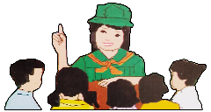
Assessment

Let us check how well you have mastered the lesson in this module.
Directions: Choose the letter of the best answer. Encircle the letter of the correct answer.

- Which of the following statements can be considered faulty generalization about the environmental issues that we face today?

- All people in this generation are to be blamed for all the calamities and disasters that the world faces today.
- Reckless people are the main cause of the world’s environmental problems.
- The worst environmental problems that we encounter in this generation are mainly brought by our selfish decision and careless actions.
- The truth is humans are greatly affected by the consequences of our own wrong doings.

- What valid generalization can you make from the image presented below?

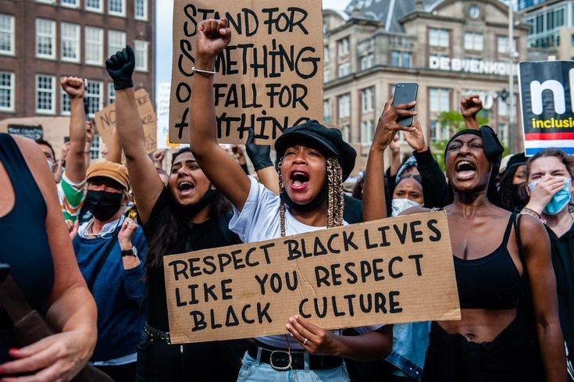

Source: https://www.bpin.it/3ZPpVTq

- People are protesting to fight for the rights of the black.
- Only those who are exceptionally brave among people can fight against injustice.
- Heroic people risk their lives to save others.
- Nobody cares about his/her life.

- Which of the following statements is the best generalization about the issue on gender equality?
- All human beings are equal regardless of their gender.
- Men have strengths that women don’t have.
- Women play vital roles that men can never do.
- One’s value is not defined by his/her gender.

- Which of the following details support the general statement below about COVID-19?

Coronavirus disease-19 (COVID-19) is one of the most infectious diseases that has ever hit mankind.

- Most people who fall ill due to COVID-19 experience mild to moderate symptoms and recover without special treatment.
- This virus can be transmitted through droplets generated when an infected person coughs, sneezes, or exhales.
- You can be infected by breathing in the virus if you are within close proximity of someone who has COVID-19, or by touching a contaminated surface and then your eyes, nose or mouth.
- Nobody is vulnerable to coronavirus disease.

For items 5 and 6, read the text below.
Ginger is one of my best friends. When I enter my home, she races to greet me with kisses and excited leaps. She acts like it’s been eight days since she’s seen me, instead of the actual eight hours. Her coat is honey born; her eyes are large and loving.
She’s a six-month old spaniel puppy, a breed originally intended to hunt birds in England. Her faithful companionship comforts me when I’m sad or sick. Her playfulness makes me laugh when she races after a toy I’ve tossed. All spaniels make perfect pets.
Source: https://www.slideshare.net/mobile/gherm6/making-generalizations-30100891

- What generalization is found in the passage? •
- All spaniels make perfect pets.
- Spaniel is a six-month old puppy.
- Spaniel is a breed originally intended to hunt birds in England.
- Spaniel is Ginger’s best friend.

- How does the author support her ideas?
- The author supports it by facts.
- The author expresses her own opinions.
- The author uses logic and reasoning.
- The author proves it with several examples.

- How do you make a valid generalization?
- We make valid generalization by using logic and reasoning.
- We make valid generalization by proving it with one example only.
- We make valid generalization by using different key words.
- We make valid generalization by not supporting it with facts.

- What is faulty with this generalization?
Chocolate is everyone’s favorite dessert.

- The speaker in the sentence claims that chocolate is loved by everyone which is not proven with evidence.
- The speaker is expressing his/her own opinions.
- The speaker uses logic and reasoning.
- The speaker supports his/her ideas with facts.

- What is the general idea in the paragraph below?

Man has always wanted to improve his appearance. Early man put on animal skins and hung strings of beads and stones around his neck. He decorated himself with paint, tattoos, and scars. Bark, leaves, straw, feathers, or whatever material were closest at hand were turned into clothing.

Source:https://www.google.com/url?sa=t&source=web&rct=j&url=http://repository.ut.ac.id/3806/1/PBIS4208-M1.pdf&ved=2ahUKEwjP-uGBoL3uAhUQrpQKHYmPD-MQFjAAegQIARAB&usg=AOvVaw2YOgQIn2vrf1_aD3dHro9r

- He decorated himself with paint, tattoos, and scars.
- Early man put on animal skins and hung strings of beads and stones around his neck.
- Man wants to improve his appearance.
- Bark, leaves, straw, feathers, or whatever material were closest at hand were turned into clothing

- What general idea could you draw from the passage below?

In 1928, Amelia Earhart became the first woman to cross the Atlantic Ocean as a passenger in an airplane. In 1932, she became the first woman pilot to fly solo across the Atlantic. Later that year, she was the first woman to fly the United States from New Jersey to California. Earhart set records in flying times and won many awards.
(taken from All About the USA)
Source:https://www.google.com/url?sa=t&source=web&rct=j&url=http://repository.ut.ac.id/3806/1/PBIS4208-M1.pdf&ved=2ahUKEwjP-uGBoL3uAhUQrpQKHYmPD-MQFjAAegQIARAB&usg=AOvVaw2YOgQIn2vrf1_aD3dHro9r

- Amelia Earhart was a famous woman in her time.
- Amelia Earhart barely achieved anything during her time.
- Amelia Earhart failed to achieve her dream.
- Amelia Earhart was an inspiration for all.

ANSWER KEY
What I Know
Activity 1: PRE-TEST
1. A
2. A
3. A
4. B
5. A

What’s In
Activity 2: A Matter of Perspective
Answers may vary.

What’s New
Activity 3: Digging the text
- Nicotine
- Nicotine has various effects on the body
- In the first sentence
- Yes, he does. The facts are: its speed ups the heartbeat, raises the blood pressure, reduces the appetite, and causes nausea and vomiting. Damage to the lungs and lung cancer. (Please allow other explanations of the students with the same idea.)

What’s More
Activity 4: Picture Analysis
Answers may vary.

Activity 5: Making Generalization
- English and Spanish used the same alphabet, but there are differences between their writing systems.
- A formal letter is different from an informal letter.
- There are three main ways that vitamins are lose from foods.
(Please allow other explanations of the students with the same idea.)

What’s I Have Learned
Activity 6: Complete Me
Answers may vary.

What I Can Do
Activity 7: Look for More
Answers may vary.

Assessment
- A
- A
- A
- C
- A
- B
- A
- A
- C
- A

References:

BOOKS
Almonte, Liza R. , Lerma L. Flandez, Nedia lagustan, Henone de Paz-langutan, Dream Rose O. Malayo, Liberty A. Mangaluz, Elenita R. Miranda, Lito A. Palomar, Adelia Chua-Soliaban, And Grace Annette B. Soriano. A Journey Through Anglo-American Literature Learner’s Material: Pasig City: Vibal Group Inc, 2014, 217

ONLINE SOURCES
Slideshare. “Making Generalizations”. Accessed January 28, 2021. https://www.slideshare.net/mobile/gherm6/making-generalizations-30100891

Iswahyuni, S.PD. “General and Specific Terms Module1-PDF”. Accessed January 28, 2021. https://www.google.com/url?sa=t&source=web&rct=j&url=http://repository.ut.ac.id/3806/1/PBIS4208-M1.pdf&ved=2ahUKEwjP-uGBoL3uAhUQrpQKHYmPD-MQFjAAegQIARAB&usg=AOvVaw2YOgQIn2vrf1_aD3dHro9r

IMAGES
Meyer, Maddie.“Black lives matter”. Britannica. Accessed January 28, 2021 https://www.britannica.com/topic/Black-Lives-Matter
Cummings, Mike. “Business Closure”. Yale News. Accessed January 28, 2021,https://news.yale.edu/2020/06/22/study-shows-pandamics-impact-hours-worked-us-small-businesses
Akmen, Tolga. “COVID-19”. Goats and Soda. Accessed January 28, 2021, https://www.npr.org/sections/goatsandsoda/2021/01/08/954967079/coronavirus-faq-how-do-i-protect-myself-from-the-u-k-variant
Osoro, Yul Vincent. “Environmental Issue”. Kami. Accessed January 28, 2021, https://www.google.com/amp/s/kami.com.ph/amp/111709-current-global-issues-ways-address-2020.html
Black Michelle. “Loss of Job/Income”. Forbes. Accessed January 28, 2021 https://www.google.com/amp/s/www.forbes.com/sites/advisor/2020/04/14/coronavirus-concerns-will-less-income-or-job-loss-hurt-your-credit-score/amp/
DEVELOPMENT TEAM

Writers: Nhor-Ana H. Asakil, Malamawi National High School
Nesrien K. Pantaran, Baluno National High School
Editor:

Language Editor:
Proofreader: Sayana S. Hasan, EPS
Illustrators:
Layout Artist: Marco David N. Codera
Management Team:
Julieto H. Fernandez, Ed. D., CESO VI
SDS-Isabela City
Maria Laarni T. Villanueva, Ed. D., CESE
ASDS-Isabela City
Henry R. Tura, CID Chief
Elsa A. Usman, LR Supervisor
Helen De Leon, EPS-English, Module Coordinator

Region IX: Zamboanga Peninsula Hymn – Our Eden Land
Here the trees and flowers bloom  Here the breezes gently Blow,  Here the birds sing Merrily,  The liberty forever Stays,  Here the Badjaos roam the seas  Here the Samals live in peace  Here the Tausogs thrive so free  With the Yakans in unity | Gallant men And Ladies fair  Linger with love and care  Golden beams of sunrise and sunset  Are visions you’ll never forget  Oh! That’s Region IX  Hardworking people Abound,  Every valleys and Dale  Zamboangueños, Tagalogs, Bicolanos, | Cebuanos, Ilocanos, Subanons, Boholanos, Ilongos,  All of them are proud and true  Region IX our Eden Land  Region IX  Our..  Eden...  Land...

My Final Farewell
Farewell, dear Fatherland, clime of the sun caress'd  Pearl of the Orient seas, our Eden lost!,  Gladly now I go to give thee this faded life's best,  And were it brighter, fresher, or more blest  Still would I give it thee, nor count the cost.  On the field of battle, 'mid the frenzy of fight,  Others have given their lives, without doubt or heed;  The place matters not-cypress or laurel or lily white,  Scaffold or open plain, combat or martyrdom's plight,  T is ever the same, to serve our home and country's need.  I die just when I see the dawn break,  Through the gloom of night, to herald the day;  And if color is lacking my blood thou shalt take,  Pour'd out at need for thy dear sake  To dye with its crimson the waking ray.  My dreams, when life first opened to me,  My dreams, when the hopes of youth beat high,  Were to see thy lov'd face, O gem of the Orient sea  From gloom and grief, from care and sorrow free;  No blush on thy brow, no tear in thine eye.  Dream of my life, my living and burning desire,  All hail ! cries the soul that is now to take flight;  All hail ! And sweet it is for thee to expire ;  To die for thy sake, that thou mayst aspire;  And sleep in thy bosom eternity's long night.  If over my grave some day thou seest grow,  In the grassy sod, a humble flower,  Draw it to thy lips and kiss my soul so,  While I may feel on my brow in the cold tomb below  The touch of thy tenderness, thy breath's warm power.  Let the moon beam over me soft and serene,  Let the dawn shed over me its radiant flashes,  Let the wind with sad lament over me keen ;  And if on my cross a bird should be seen,  Let it trill there its hymn of peace to my ashes. | Let the sun draw the vapors up to the sky,  And heavenward in purity bear my tardy protest  Let some kind soul o 'er my untimely fate sigh,  And in the still evening a prayer be lifted on high  From thee, 0 my country, that in God I may rest.  Pray for all those that hapless have died,  For all who have suffered the unmeasur'd pain;  For our mothers that bitterly their woes have cried,  For widows and orphans, for captives by torture tried  And then for thyself that redemption thou mayst gain  And when the dark night wraps the graveyard around  With only the dead in their vigil to see  Break not my repose or the mystery profound  And perchance thou mayst hear a sad hymn resound  'T is I, O my country, raising a song unto thee.  And even my grave is remembered no more  Unmark'd by never a cross nor a stone  Let the plow sweep through it, the spade turn it o'er  That my ashes may carpet earthly floor,  Before into nothingness at last they are blown.  Then will oblivion bring to me no care  As over thy vales and plains I sweep;  Throbbing and cleansed in thy space and air  With color and light, with song and lament I fare,  Ever repeating the faith that I keep.  My Fatherland ador'd, that sadness to my sorrow lends  Beloved Filipinas, hear now my last good-by!  I give thee all: parents and kindred and friends  For I go where no slave before the oppressor bends,  Where faith can never kill, and God reigns e'er on high!  Farewell to you all, from my soul torn away,  Friends of my childhood in the home dispossessed!  Give thanks that I rest from the wearisome day!  Farewell to thee, too, sweet friend that lightened my way; Beloved creatures all, farewell! In death there is rest!

I Am a Filipino, by Carlos P. Romulo
I am a Filipino–inheritor of a glorious past, hostage to the uncertain future. As such I must prove equal to a two-fold task–the task of meeting my responsibility to the past, and the task of performing my obligation to the future.  I sprung from a hardy race, child many generations removed of ancient Malayan pioneers. Across the centuries the memory comes rushing back to me: of brown-skinned men putting out to sea in ships that were as frail as their hearts were stout. Over the sea I see them come, borne upon the billowing wave and the whistling wind, carried upon the mighty swell of hope–hope in the free abundance of new land that was to be their home and their children’s forever.  I am a Filipino. In my blood runs the immortal seed of heroes–seed that flowered down the centuries in deeds of courage and defiance. In my veins yet pulses the same hot blood that sent Lapulapu to battle against the first invader of this land, that nerved Lakandula in the combat against the alien foe, that drove Diego Silang and Dagohoy into rebellion against the foreign oppressor.  The seed I bear within me is an immortal seed. It is the mark of my manhood, the symbol of dignity as a human being. Like the seeds that were once buried in the tomb of Tutankhamen many thousand years ago, it shall grow and flower and bear fruit again. It is the insignia of my race, and my generation is but a stage in the unending search of my people for freedom and happiness. | I am a Filipino, child of the marriage of the East and the West. The East, with its languor and mysticism, its passivity and endurance, was my mother, and my sire was the West that came thundering across the seas with the Cross and Sword and the Machine. I am of the East, an eager participant in its spirit, and in its struggles for liberation from the imperialist yoke. But I also know that the East must awake from its centuried sleep, shake off the lethargy that has bound his limbs, and start moving where destiny awaits.  I am a Filipino, and this is my inheritance. What pledge shall I give that I may prove worthy of my inheritance? I shall give the pledge that has come ringing down the corridors of the centuries, and it shall be compounded of the joyous cries of my Malayan forebears when first they saw the contours of this land loom before their eyes, of the battle cries that have resounded in every field of combat from Mactan to Tirad Pass, of the voices of my people when they sing:  “I am a Filipino born to freedom, and I shall not rest until freedom shall have been added unto my inheritance—for myself and my children and my children’s children—forever.”

