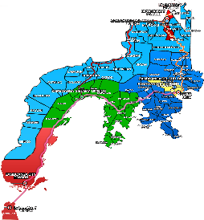
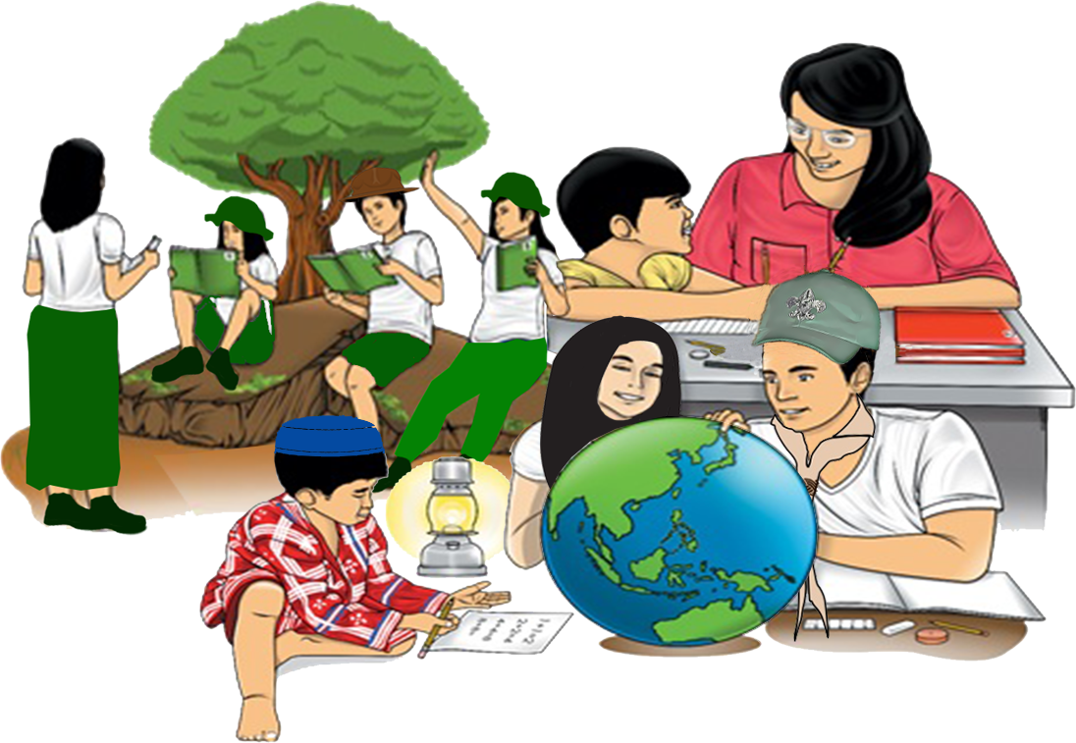
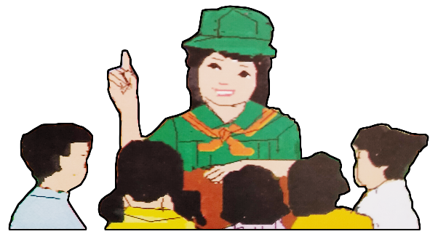
English

Quarter 4 - Module 8:
Taking a Stand on Critical Issue
Zest for Progress
Zeal of Partnership
9

Name of Learner: ___________________________
Grade & Section: ___________________________
Name of School: ___________________________
Republic of the Philippines
Department of Education
Regional Office IX, Zamboanga Peninsula

What I Need to Know

Expressing our opinion on a certain issue is one of the toughest things to do for there are times that our ideas are in conflict with the others. However, it is our responsibility to discern what to follow and what to believe in. When you want to change people's points of view or to persuade people to a particular action or behavior, your thoughts have to be clarified and articulated honestly and accurately and to consider the ideas of others in a respectful and critical way. We have to take a stand no matter how small the issue is because by doing so, it will bring change.
This module, provides you with the tools you need to argue effectively in the classroom and beyond, allowing you to use your skills soundly. This module empowers you to find your voice and create positive change through argumentation in everyday life.
After going through this module, the learner is expected to:
- React to lay value judgment on critical issues that demand sound analysis and call for prompt actions . (UNCODED)
- Take a stand on critical issues brought up in the materials presented or read.

What’s In
Activity 1: Express Your Feelings
Directions: Analyse the picture below. As a student, what realization were you able to come up?
Realization: __________________________________________________________________________________________________________________________________________________________________________________________________________________________________________________________________________________________________________________________________________

What’s New
Activity 2: Ponder On Me
Directions: Read the song “Heal the World” and ponder on the message it conveys by answering the questions that follow. You may use another sheet of paper if needed.

Heal the World
Michael Jackson
There's a place in your heart
And I know that it is love
And this place could be much
Brighter than tomorrow
And if you really try
You'll find there's no need to cry
In this place you'll feel
There's no hurt or sorrow
There are ways to get there
If you care enough for the living
Make a little space
Make a better place
Heal the world
Make it a better place
For you and for me
And the entire human race
There are people dying
If you care enough for the living
Make it a better place
For you and for me
If you want to know why
There's love that cannot lie
Love is strong
It only cares of joyful giving
If we try we shall see
In this bliss we cannot feel
Fear of dread
We stop existing and start living
The it feels that always
Love's enough for us growing
So make a better world
Make a better place

Heal the world
Make it a better place
For you and for me
And the entire human race
There are people dying
If you care enough for the living
Make a better place for you and for me
And the dream we were conceived in
Will reveal a joyful face
And the world we once believed in
Will shine again in grace
Then why do we keep strangling life
Wound this earth, crucify its soul
Though it's plain to see
This world is heavenly
Be god's glow
We could fly so high
Let our spirits never die
In my heart I feel you are all my brothers
Create a world with no fear
Together we cry happy tears
See the nations turn their swords into plowshares
We could really get there
If you cared enough for the living
Make a little space
To make a better place

Source: https://www.azlyrics.com/lyrics/michaeljackson/healtheworld.html

Guide Questions:
1.What is the message of the song?
______________________________________________________________________________________________________________________________________________________________________________________________________________________________________________________
2. What does the composer of the song want us to do?
______________________________________________________________________________________________________________________________________________________________________________________________________________________________________________________
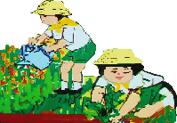
What is It

How to Make Your Stand
1. Get the “Lay of the Land” - It’s crucial to understand where your key stakeholders stand on the issue that tells you where you will need to do some pre-work ahead of time and damage control after the fact. But now it’s time to be more systematic in thinking it through.
2. Link to the Common Goal- When you’re taking a stand, it’s most powerful when you can bring others along with you. This is also how you create the best chance of making change and not ending up as the ineffective voice in the wilderness.
3. Back it up with Data- This will appeal to those detail-oriented people who are only persuaded by analysis and logic.
4. Create a Compelling Narrative- Just because something makes sense in your mind doesn’t mean it will instantly make sense to everyone. You have to craft your case so it’s easy for others to get right away. Putting together your case in the form of a storyline will help you ensure that your rationale is clear in your own mind and that your logic is impeccable.

Remember!
- An argument is a piece of writing which is sometimes called persuasive writing because it aims to convince the reader about a certain stand on debatable issue.
- Argumentative essay conveys opinions that are proposed as true and justifiable. It is for this reason that an editorial is the most outstanding example of argumentative writing, although persuasion is also really identified in campaign speeches or even print advertisements.
- A controversial issue always lies at the heart of argumentative essay . The argument may be in favour of (pro) or against (con) the said issue.

To persuade the readers through logical reasoning and analysis, use the techniques suggested in the box.
Techniques in Argumentation
1. Analogy. There is an assumption that two things similar in one aspect are alike in another aspect.
Example: Capitalists are like vampires.
2. Comparison-Contrast. This teaching presents the similarities and/or differences of two major concerns.
Example: Beauty versus Brawn
Beauty ensures permanent and remarkable success, Brawn ensures temporary success.
3. Definition. These techniques give a meaning or several meanings to a concept that forms the argument.
Example: Feminism Feminism is not about hating men. It is about celebrating the power of women side by side with men.
4. Analysis. It is a technique that takes a part from the whole and scrutinizes it to prove the point.
Example: career choice
One’s personal interest determines her choice of a career because it is her natural response
to life in general (personal interest apart from the skills, resources, etc.
Source: Romero, J.P & Delos Reyes A.D., Exploring Life through English and American Literature

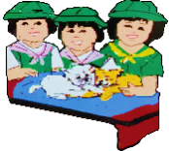
What’s More
Activity 3: Standing Up for Good
Directions: Study the picture below and answer the questions that follow.

SOCIAL MEDIA ADDICTION

1. What is your stand regarding the issue presented in the picture?
Answer: _________________________________________________________________________________________________________________________________________________________________________________________________________________________________________________________________________________________________________________________________________________________________________________________________________________________________________________________________
2. What helped you decide in making your stand?
Answer: _________________________________________________________________________________________________________________________________________________________________________________________________________________________________________________________________________________________________________________________________________________________________________________________________________________________________________________________________

Activity 4: I Believe
Directions: Pick out the issue presented on the lines taken from a particular songs. Give your stand and explain why you say so.

SONG | ISSUE PRESENTED | STAND
“Who is the girl I see staring straight back at me. When will my reflection show who I am inside.”

-From the movie Mulan
“Little child, you must show the way to a better day for all the young.’Cause you were born for the world to see that we all can live with light and peace ”

- When the Children Cry by White Lion
“I see the kids in the streets with not enough food to eat.Who am I to be blind, pretending not to see their needs”

- Man in the Mirror by Michael Jackson

What I Have Learned

Activity 5: Feel Me
Directions: Study the sample speech then answer the questions that follow.
Speech: “We must be united to end racism as well as gender inequality”

Remarks by Phumzile Mlambo-Ngcuka, UN Under-Secretary-General and UN Women Executive Director, at the urgent debate on current racially inspired human rights violations, systemic racism, police brutality and the violence against peaceful protest during the 43rd session of the Human Rights Council.

Date: Wednesday, June 17, 2020
[As delivered]
Madam President, distinguished delegates, UN Women believe that women are part of their lived experiences. These experiences impact on who they become, as well as on their families. These experiences may be religious, racial, cultural, or related to sexual orientation.

The Working Group of Experts on People of African Descent have highlighted that girls and women of African Descent are likely to be poorer, to be less educated and to have fewer opportunities everywhere in the world.

We are now seeing an outpouring of solidarity, with people protesting in the streets against systemic and brutal racism.

We need to fight against racism, too, in our own institutions and everywhere in the world; because only if we are united, we will build back together after COVID-19.

In fighting apartheid, it took people of the world also to be in solidarity and to fight together and help to end apartheid.

This time has come again. We must be united to end racism as well as gender inequality in the world.

QUESTIONS:

1. What issue is being raised in the speech?
_______________________________________________________________________________________________________________________________________________________________________________________________________________________________________________________________________________________________________________________________________________________________________________________

2. Which of the techniques in argumentation was being used by the speaker? Why do you say so?
_______________________________________________________________________________________________________________________________________________________________________________________________________________________________________________________________________________________________________________________________________________________________________________________

3. What is your stand in the issue presented?
_______________________________________________________________________________________________________________________________________________________________________________________________________________________________________________________________________________________________________________________________________________________________________________________

4. If you were to assess the speech, did the speaker deliver her points effectively? Why or why not?
_______________________________________________________________________________________________________________________________________________________________________________________________________________________________________________________________________________________________________________________________________________________________________________________

What I Can Do
Activity 6: Right Shop
Directions: Write a persuasive text on the subject “Allow Smoking in all Public Places”. You will be guided with the rubrics below.
RUBRICS IN WRITING
Criteria | Beginning  5 | Developing  10 | Accomplished  15 | Score
Language Use | The writer uttered more  than three grammatical  mistakes and had poor word choice. | The writer uttered one to three grammatical mistakes and had somewhat sophisticated word choice. | The writer had flawless  grammar and 18 had  sophisticated word choice.
Organization of Discussion | More than one instance  wherein the discussion went off-tangent. | There was one  Instance wherein the  discussion went  off-tangent. | The flow of discussion was structured and  smooth.
Use of  Communication  Strategies | The writer did not use effective communication  strategies to achieve  the communication  objective. | The writer did not use effective communication  strategies that helped achieve the  communication  objective. | The writer used effective  Communication strategies that helped the  group achieve the  communication  objective.
Total Score

A persuasive paragraph states and supports an opinion or a stand. It contains an introduction followed by reasons and a conclusion.
__________________________________________________________________________________________________________________________________________________________________________________________________________________________________________________________________________________________________________________________________________________________________________________________________________________________________________________________________
__________________________________________________________________________
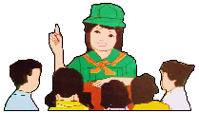
Assessment
Let us check how well you have mastered the lesson in this module.
Directions: Choose the letter of the best answer. Write your answer on the space before each
number.

____1. Which of the following techniques in argumentation is an assumption that two
things similar in one aspect are alike in another aspect?
- Analogy
- Definition
- Analysis
- Comparison-contrast

____2. In listening to an argumentation, if you heard the speaker presenting the similarities
and/or differences of the two major concern, which of the following techniques is
being used?
- Analogy
- Definition
- Comparison-contrast
- Analysis

____3. When you want to persuade your readers through logical reasoning, which
among the following must you consider?
- Steps
- Techniques
- Grammar
- Form

____4.
There might be life on Mars because it has an athmosphere that contains oxygen just like the Earth.

Which among the techniques in argumentation is used in writing the text above?
- Analogy
- Comparison-contrast
- Definition
- Analysis

____5. When someone argue that NCAA basketball players should be defined as professional
players and therefore, should be paid. What techniques in argumentation is
manifested?
- Analogy
- Comparison-contrast
- Definition
- Analysis
____6.
This novel is suppose to have a similar plot like the other one we have read, so probably it is also very boring.

Which among the techniques in argumentation is used in the text above?
- Analogy
- Comparison-contrast
- Definition
- Analysis

For items no. 7-8, refer to the argument inside the box.
Marijuana are drugs that can kill a person if used illegally and abusively. However, this can also be used for medical purposes as approved by the authority.

____7. How will you assess the argument above?

- It is good argument since the speaker clearly states how marijuana should be used.
- It is a strong argument that the listener would agree about and surely accept it.
- It is reliable argument since the speaker made mention of reliable sources.
- It is valid argument for many would have agree to the speaker.

____8. Which techniques in argumentation is being used?

- Analogy
- Comparison-contrast
- Definition
- Analysis

For items no. 9-10, refer to the given options below.

- Secondhand smoke is as dangerous as the smoke being inhaled by the first hand smoker.
- Man are much stronger than women physically, mentally but emotionally weak.
- Women are like butterfly. Soft and delicate.
- Womanizer is a man who engage in numerous casual sexual affairs with women.

____9. Which among the statements above uses definition techniques in argumentation?

____10. Which of the statements above DOES NOT use comparison- contrast technique in
argumentation?

Answer Key

What I Have Learned
Activity 5: Feel Me
Answers may vary.

What I Can Do
Activity 6: Rightshop
Answers may vary.

Assessment
- A
- C
- B
- C
- C
- A
- A
- C
- D
- D

What’s In
Activity 1: Express Your Feelings
Answers may vary.

What’s New
Activity 2: Ponder on Me
- Answers may vary
- Answers may vary

What’s More
Activity 3: Standing Up for Good
Answers may vary about social media addiction.

Activity 4: I Believe
Answers may vary.

References:

BOOK

Almonte, Liza R.,Lerma L. Flandez, Angelina Lourdes A. Hermosa, Nedia Laguztan, Liberty A. Mangaluz, Elenita R. Miranda, Paul Anthony B. Mendoza, Lito A. palomar, Grace B. Annette Barradas-Soriano, and Karen B. Villanueva, Celebrating Diversity Through Word Literature;Pasig City :REX Bppk Store,Inc,2015,259-260

ONLINE SOURCES

Critical thinking web, “Analogical Arguments” accessed January 30, 2021 https://philosophy.hku.hk/think/arg/analogy.php#:~:text=To%20argue%20by%20analogy%20is,oxygen%20just%20like%20the%20Earth

MayBUSCH Creating Leaders, “How to Take a Stand”, accessed February 09, 2021, https://maybusch.com/how-to-take-stand/

“UNWOMEN” June, 2020, https://www.unwomen.org/en/news/stories/2020/6/speech-ed-phumzile-debate-on-current-racially-inspired-human-rights-violations, January 30, 2021

AZ, “Michael Jackson Lyrics Man in the Mirror”, accessed February 09, 2021, https://www.azlyrics.comcom/lyrics/michael.jackson/maninthemirror.html

AZ, “Michael Jackson Lyrics Heal the World”, accessed January 28, 2021 ,https://www.azlyrics.com/lyrics/michaeljackson/healtheworld.html

IMAGES

Iconicbestiary, Social Media Addiction, freepikcompany, https://www.freepik.com/free-vector/bended-man-carrying-big-heavy-mobile-phone_1311230.htm, 2019

Spukkato, Discrimination against women, freepikcompany, https://www.freepik.com/premium-photo/woman-was-wrapping-her-mouth-by-adhessive-tape-concept-freedom-speech-human-rights-day_2634562.htm, 2019

DEVELOPMENT TEAM

Writers: Nurhainie H. Baraluddin, Kumalarang National High School
Naser A. Barahim, Baluno National High School
Editor:

Language Editor:
Proofreader: Sayana S. Hasan, EPS
Illustrators:
Layout Artist: Marco David N. Codera
Management Team:
Julieto H. Fernandez, Ed. D., CESO VI
SDS-Isabela City
Maria Laarni T. Villanueva, Ed. D., CESE
ASDS-Isabela City
Henry R. Tura, CID Chief
Elsa A. Usman, LR Supervisor
Helen De Leon, EPS-English, Module Coordinator

Region IX: Zamboanga Peninsula Hymn – Our Eden Land
Here the trees and flowers bloom  Here the breezes gently Blow,  Here the birds sing Merrily,  The liberty forever Stays,  Here the Badjaos roam the seas  Here the Samals live in peace  Here the Tausogs thrive so free  With the Yakans in unity | Gallant men And Ladies fair  Linger with love and care  Golden beams of sunrise and sunset  Are visions you’ll never forget  Oh! That’s Region IX  Hardworking people Abound,  Every valleys and Dale  Zamboangueños, Tagalogs, Bicolanos, | Cebuanos, Ilocanos, Subanons, Boholanos, Ilongos,  All of them are proud and true  Region IX our Eden Land  Region IX  Our..  Eden...  Land...

I Am a Filipino, by Carlos P. Romulo
I am a Filipino–inheritor of a glorious past, hostage to the uncertain future. As such I must prove equal to a two-fold task–the task of meeting my responsibility to the past, and the task of performing my obligation to the future.  I sprung from a hardy race, child many generations removed of ancient Malayan pioneers. Across the centuries the memory comes rushing back to me: of brown-skinned men putting out to sea in ships that were as frail as their hearts were stout. Over the sea I see them come, borne upon the billowing wave and the whistling wind, carried upon the mighty swell of hope–hope in the free abundance of new land that was to be their home and their children’s forever.  I am a Filipino. In my blood runs the immortal seed of heroes–seed that flowered down the centuries in deeds of courage and defiance. In my veins yet pulses the same hot blood that sent Lapulapu to battle against the first invader of this land, that nerved Lakandula in the combat against the alien foe, that drove Diego Silang and Dagohoy into rebellion against the foreign oppressor.  The seed I bear within me is an immortal seed. It is the mark of my manhood, the symbol of dignity as a human being. Like the seeds that were once buried in the tomb of Tutankhamen many thousand years ago, it shall grow and flower and bear fruit again. It is the insignia of my race, and my generation is but a stage in the unending search of my people for freedom and happiness. | I am a Filipino, child of the marriage of the East and the West. The East, with its languor and mysticism, its passivity and endurance, was my mother, and my sire was the West that came thundering across the seas with the Cross and Sword and the Machine. I am of the East, an eager participant in its spirit, and in its struggles for liberation from the imperialist yoke. But I also know that the East must awake from its centuried sleep, shake off the lethargy that has bound his limbs, and start moving where destiny awaits.  I am a Filipino, and this is my inheritance. What pledge shall I give that I may prove worthy of my inheritance? I shall give the pledge that has come ringing down the corridors of the centuries, and it shall be compounded of the joyous cries of my Malayan forebears when first they saw the contours of this land loom before their eyes, of the battle cries that have resounded in every field of combat from Mactan to Tirad Pass, of the voices of my people when they sing:  “I am a Filipino born to freedom, and I shall not rest until freedom shall have been added unto my inheritance—for myself and my children and my children’s children—forever.”

My Final Farewell
Farewell, dear Fatherland, clime of the sun caress'd  Pearl of the Orient seas, our Eden lost!,  Gladly now I go to give thee this faded life's best,  And were it brighter, fresher, or more blest  Still would I give it thee, nor count the cost.  On the field of battle, 'mid the frenzy of fight,  Others have given their lives, without doubt or heed;  The place matters not-cypress or laurel or lily white,  Scaffold or open plain, combat or martyrdom's plight,  T is ever the same, to serve our home and country's need.  I die just when I see the dawn break,  Through the gloom of night, to herald the day;  And if color is lacking my blood thou shalt take,  Pour'd out at need for thy dear sake  To dye with its crimson the waking ray.  My dreams, when life first opened to me,  My dreams, when the hopes of youth beat high,  Were to see thy lov'd face, O gem of the Orient sea  From gloom and grief, from care and sorrow free;  No blush on thy brow, no tear in thine eye.  Dream of my life, my living and burning desire,  All hail ! cries the soul that is now to take flight;  All hail ! And sweet it is for thee to expire ;  To die for thy sake, that thou mayst aspire;  And sleep in thy bosom eternity's long night.  If over my grave some day thou seest grow,  In the grassy sod, a humble flower,  Draw it to thy lips and kiss my soul so,  While I may feel on my brow in the cold tomb below  The touch of thy tenderness, thy breath's warm power.  Let the moon beam over me soft and serene,  Let the dawn shed over me its radiant flashes,  Let the wind with sad lament over me keen ;  And if on my cross a bird should be seen,  Let it trill there its hymn of peace to my ashes. | Let the sun draw the vapors up to the sky,  And heavenward in purity bear my tardy protest  Let some kind soul o 'er my untimely fate sigh,  And in the still evening a prayer be lifted on high  From thee, 0 my country, that in God I may rest.  Pray for all those that hapless have died,  For all who have suffered the unmeasur'd pain;  For our mothers that bitterly their woes have cried,  For widows and orphans, for captives by torture tried  And then for thyself that redemption thou mayst gain  And when the dark night wraps the graveyard around  With only the dead in their vigil to see  Break not my repose or the mystery profound  And perchance thou mayst hear a sad hymn resound  'T is I, O my country, raising a song unto thee.  And even my grave is remembered no more  Unmark'd by never a cross nor a stone  Let the plow sweep through it, the spade turn it o'er  That my ashes may carpet earthly floor,  Before into nothingness at last they are blown.  Then will oblivion bring to me no care  As over thy vales and plains I sweep;  Throbbing and cleansed in thy space and air  With color and light, with song and lament I fare,  Ever repeating the faith that I keep.  My Fatherland ador'd, that sadness to my sorrow lends  Beloved Filipinas, hear now my last good-by!  I give thee all: parents and kindred and friends  For I go where no slave before the oppressor bends,  Where faith can never kill, and God reigns e'er on high!  Farewell to you all, from my soul torn away,  Friends of my childhood in the home dispossessed!  Give thanks that I rest from the wearisome day!  Farewell to thee, too, sweet friend that lightened my way; Beloved creatures all, farewell! In death there is rest!

